Demonstrating Excellence Celebrating Achievement

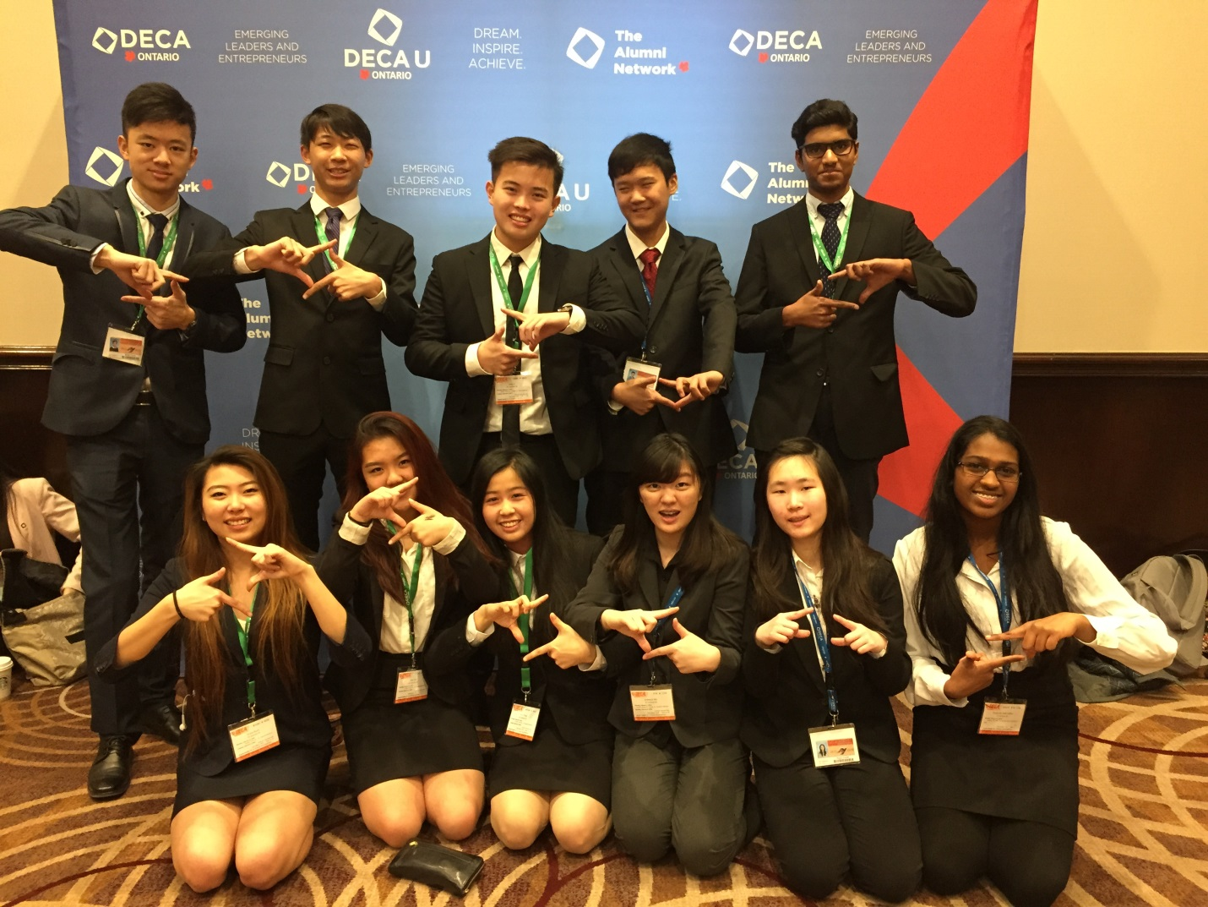

A.Y. Jackson students
showcasing their business skills
at this year's
DECA competition.

