A. Y. JACKDSON SECONDARY SCHOOL WINNERS
OF THE GRADE 12
SCIENCE FAIR

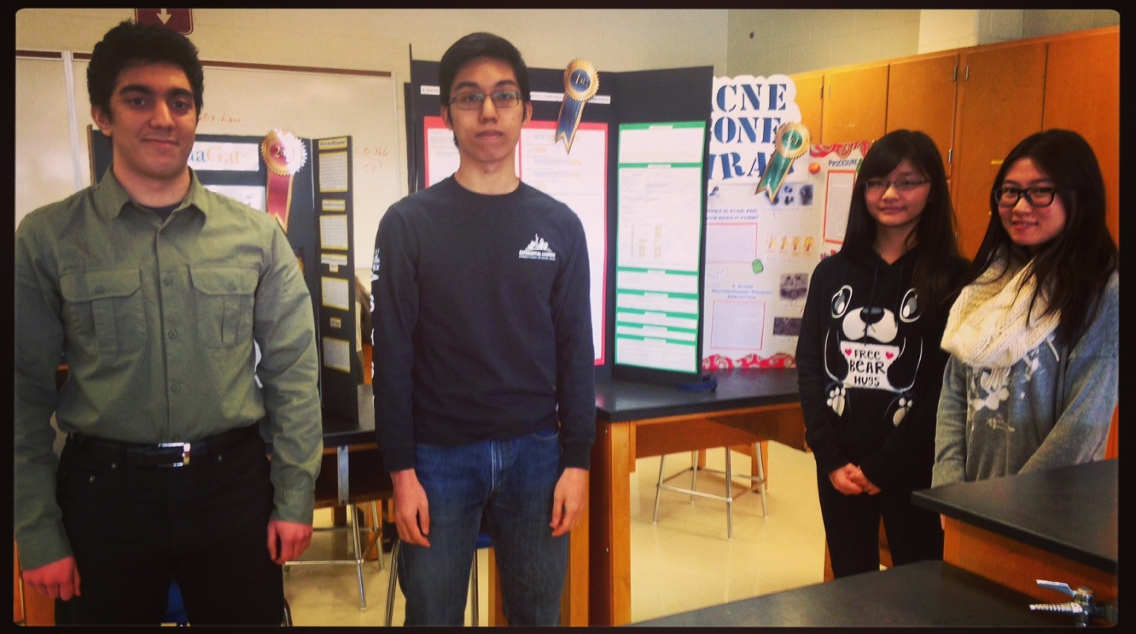

1ST Place – Martin Ho
2nd Place – Kiarash Jamali
3rd Place – Jenny Wang & Cindy Su

