Sleeping Children Around the World
(SCAW)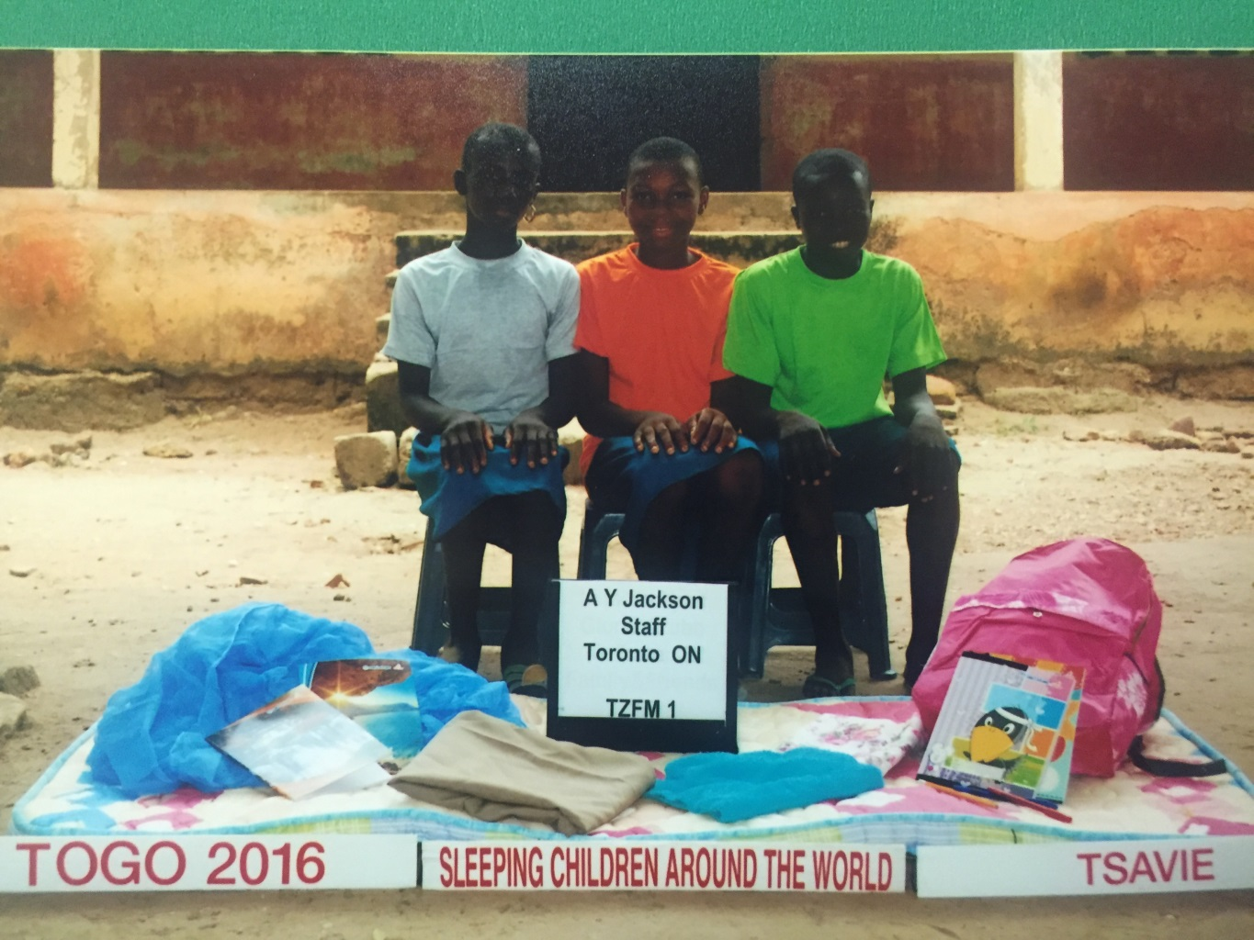
Sleeping Children Around the World is a charitable organization, founded in 1970 by Murray and Margaret Dryden, headquartered in Toronto, Canada, providing bedkits to children in developing countries. SCAW is operated by volunteers, from the processing of donations to the distribution of bedkits – no government funds are involved. All administrative costs are covered by a legacy account so that 100% of every bedkit donation reaches a needy child.
Each $35 donation provides a bedkit that consists of a mat or mattress, pillow, sheet, blanket, mosquito net, clothes outfit, towel and school supplies. Bedkit contents vary from country to country depending upon local needs.
Three bedkits were donated on behalf of the AY Jackson staff by the AY Jackson Administration.

