Co-op Students attended the Sunnybrook Hospital Awards Ceremony on May 24th, 2016
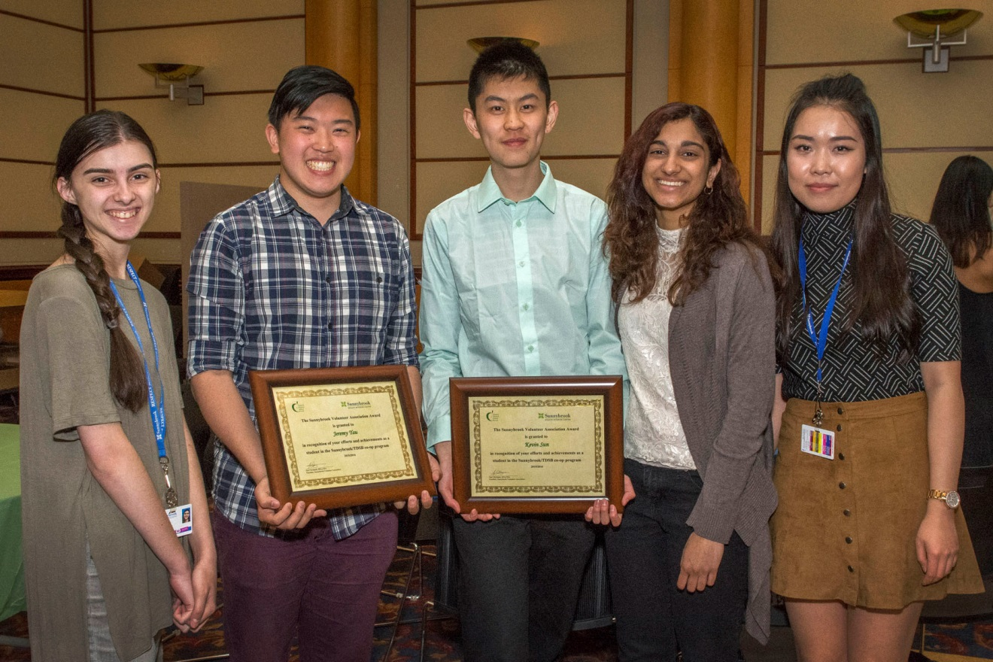
Left to right:
Ervisa Behri, Jeremy Yau (Award Recipient), Kevin Sun (Award Recipient),
Simran Badalera, Jia Ying Li

