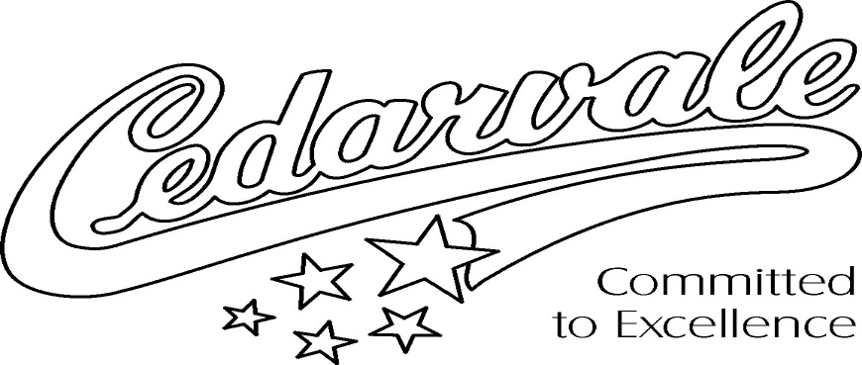

School Motto: Committed to Excellence
School Spirit Logo: Cedarvale “Stars”

A Message from the Principal

Welcome to a great year of learning and growth at Cedarvale Community School! At Cedarvale our aim is to develop global-minded learners who recognize that a collective global humanity and shared stewardship of the planet creates a healthy, safe and inclusive world.

I look forward to working with Cedarvale staff and parents to help our students to learn and grow by supporting and encouraging their success this year. Important ways that students can set themselves up for success is to have a growth mindset, demonstrate respect for themselves and others, actively participate, and work towards achieving their personal best through goal setting and effort. A strong partnership between home and school, through ongoing communication with your child’s teacher is another key part of student success.

Along with our school’s commitment to providing Cedarvale students with a solid academic foundation, we encourage students to participate in the wide variety of arts, athletics and academic extra-curricular activities that are offered throughout the school year. These valuable and personal growth opportunities are organized and led by a very talented, energetic and dedicated group of staff members and the parents of our School Advisory Council.

If you have any questions, please do not hesitate to contact the school and we will endeavour to answer your inquiries throughout the school year.

On behalf of the entire Cedarvale staff, we wish all students a wonderful year of learning!

David Sonenberg

David Sonenberg
Principal

