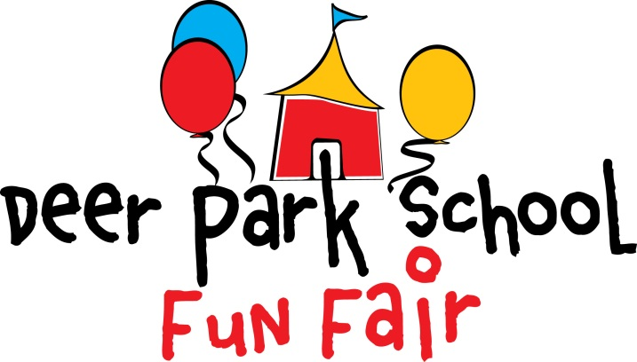

This year’s Fun Fair is on June 4! Fun Fair is our biggest fundraiser. The money raised is put right back into our children’s classrooms and school.

This year we will hold a raffle instead of the usual silent auction. To hold a successful raffle we are asking families to donate $5 or more per student.

Volunteers will use these funds to purchase items and prepare them for the raffle. We hope this new approach will result in more desirable and affordable items being available for our supportive families.

Please give cash donations to your child’s teacher by Friday, May 22.

Hope to see you at Fun Fair!

Elizabeth MacLachlan
elizabeth@artform.com
Deer Park Fun Fair Committee

