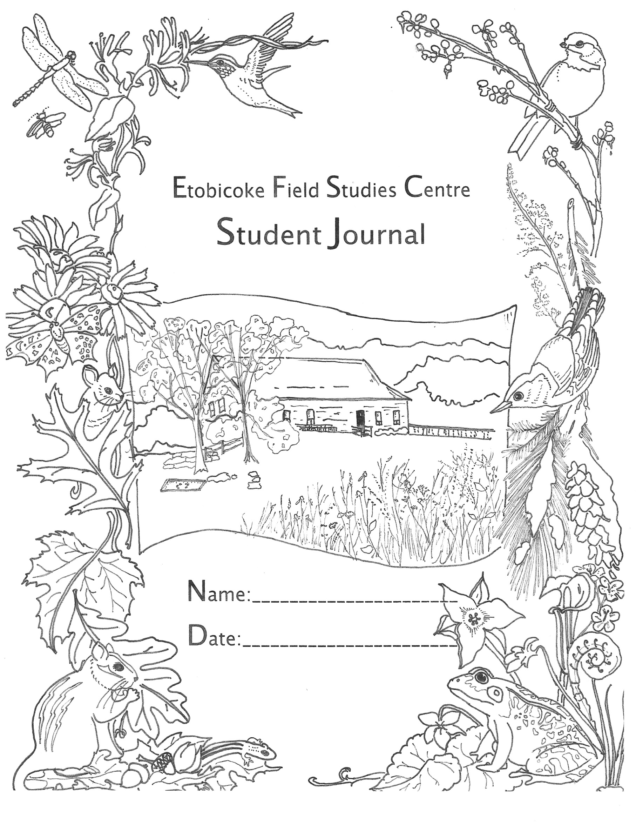

**Etobicoke Field Studies Centre**

**Student Journal**

**Grades 1-3**

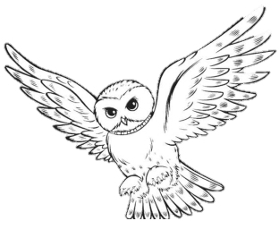

**NATURE EXPLORER LOG:**

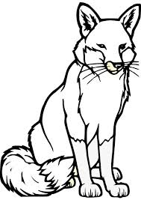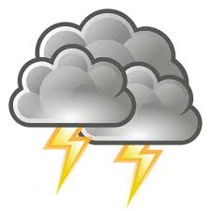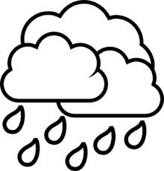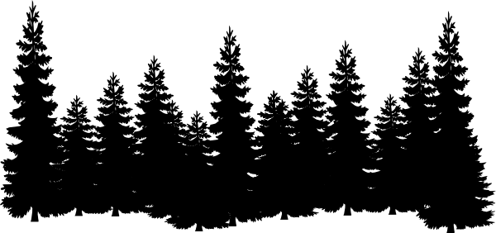

**FUN FACT:**

Water can be found in three different states: liquid, solid or gas.

Draw pictures of what you did at the Etobicoke Field Studies Centre!

*Afternoon:*

*Morning:*

Sunny

Snowing

What is the weather like today?

Thunder Storm

Raining

Cloudy

Windy

 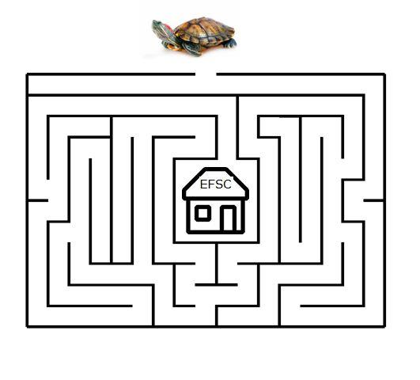

**Help Toby find his way back to the Centre!**

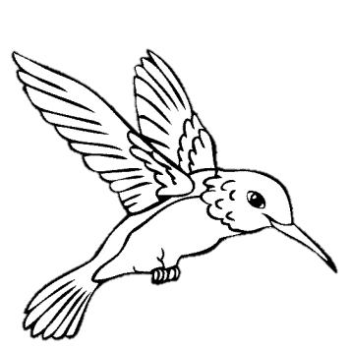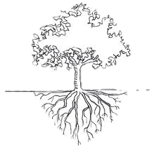  

**Joke Time:**

Q: What type of flower grows on your face?

A: Tulips (Two lips)

**DID YOU KNOW?**

Trees can live for hundreds of years. You can determine the age of a tree by counting the growth rings found on the inside of the tree.

**Did you see or hear any animals today?**

**Draw them here!**

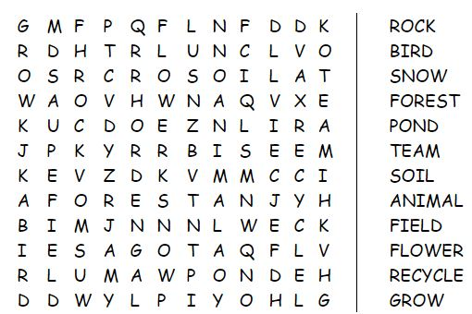

**Wild Word Search:**



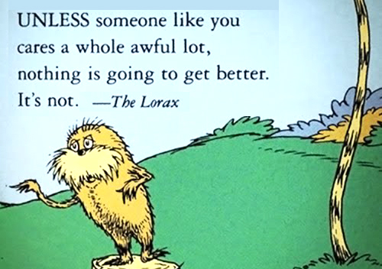

**Joke Time:**

Q: How do trees get on the internet?

A: They log in!

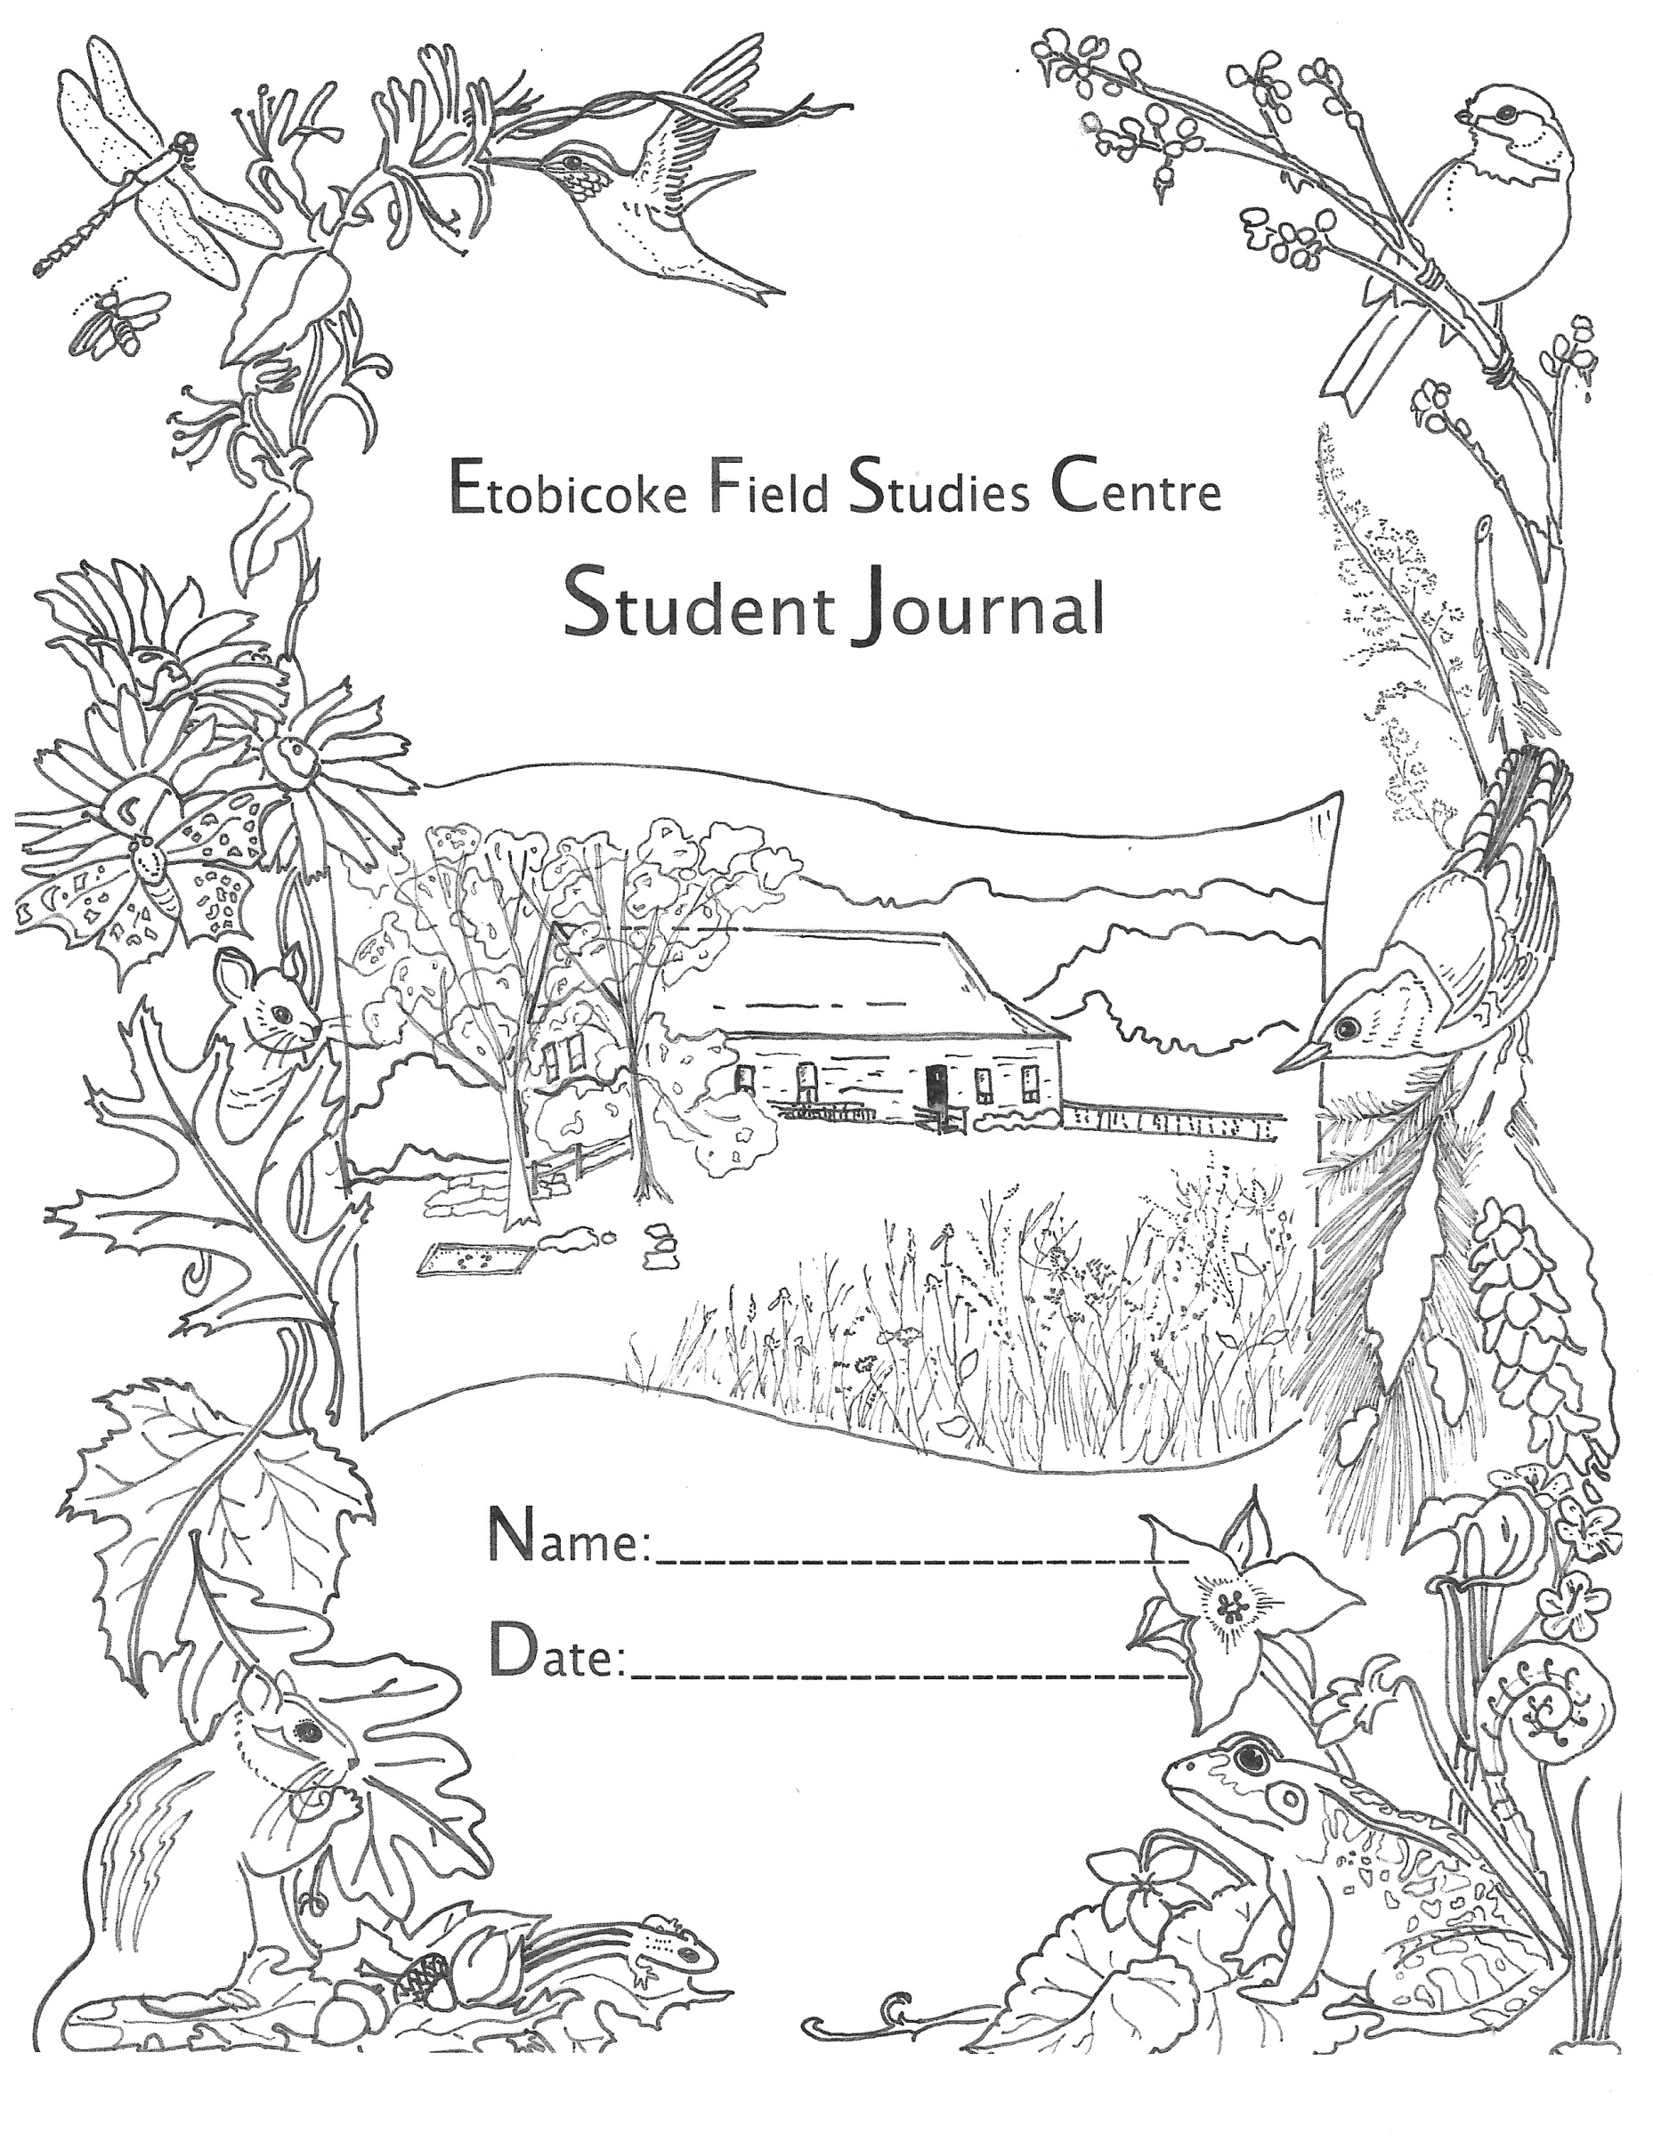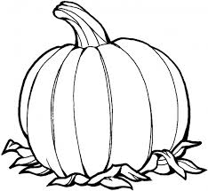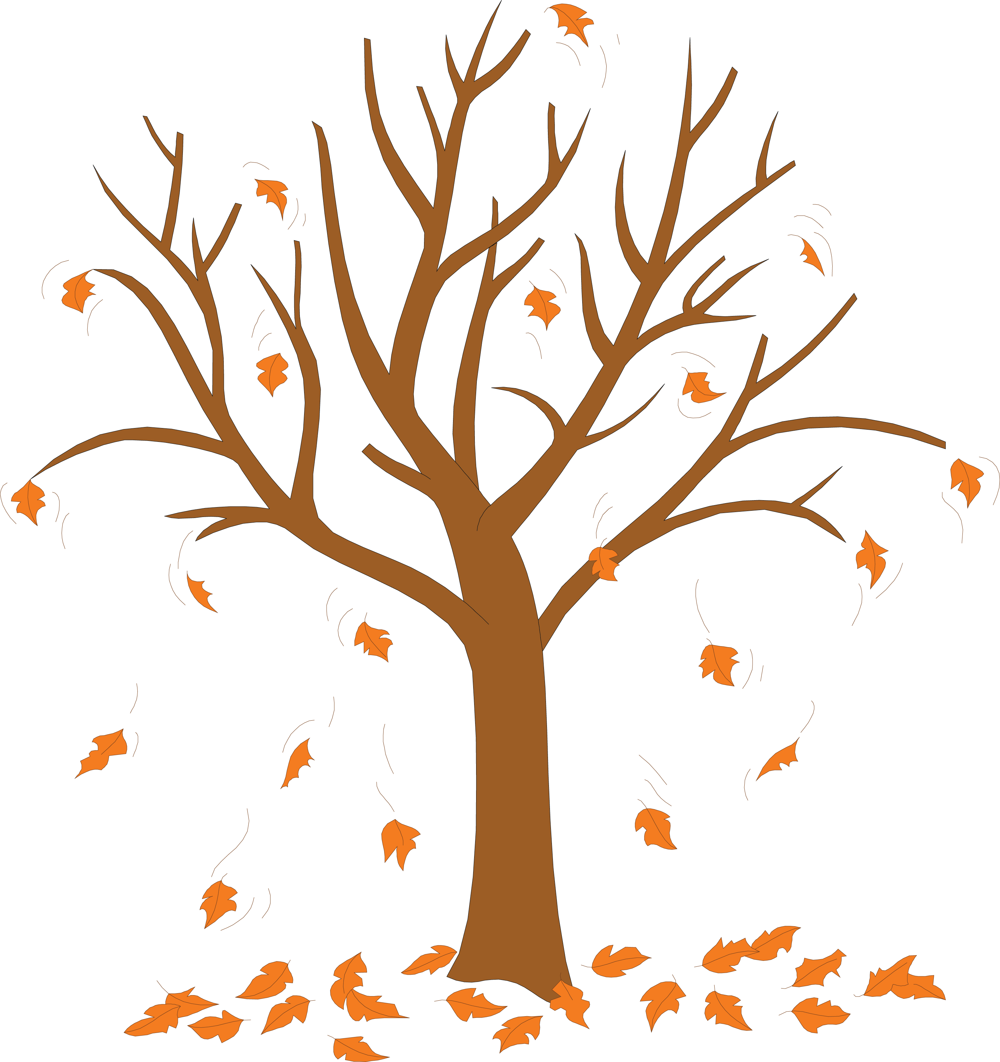

**\* CRACK THE CODE \***

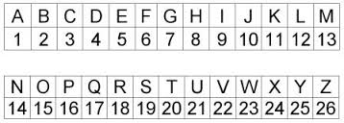

_ _ _ _ _ _ _ _ _ _ _ _ _ _ _ _ _ _ _ _ _

12 9 20 20 12 5 3 8 1 14 7 5 19 3 1 14 13 1 11 5 1

_ _ _ _ _ _ _ _ _ _ _ _ _ !

2 9 7 4 9 6 6 5 18 5 14 3 5

**Draw the home for your favourite animal!**

Make sure to include sources of shelter, food, and water.

**Joke Time:**

Q: What did the cloud say to the lightning bolt?

A: You’re shocking

**For more information, check out our website:**

**http://toes.tdsb.on.ca/**

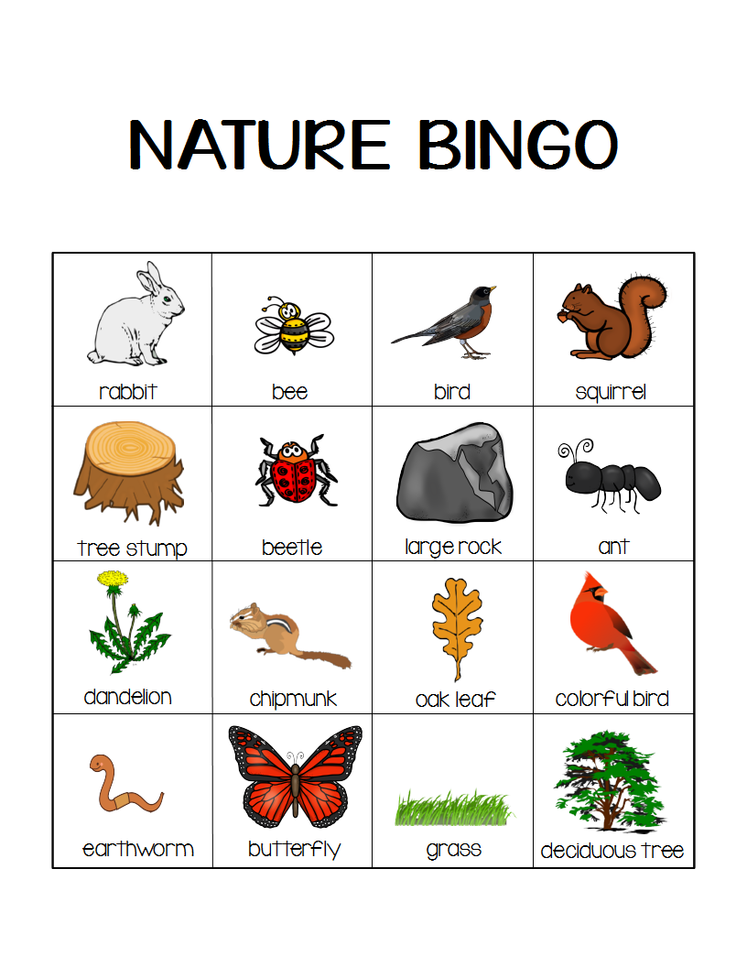



While you were at the EFSC how many of these did you see? Check them off of your BINGO card!



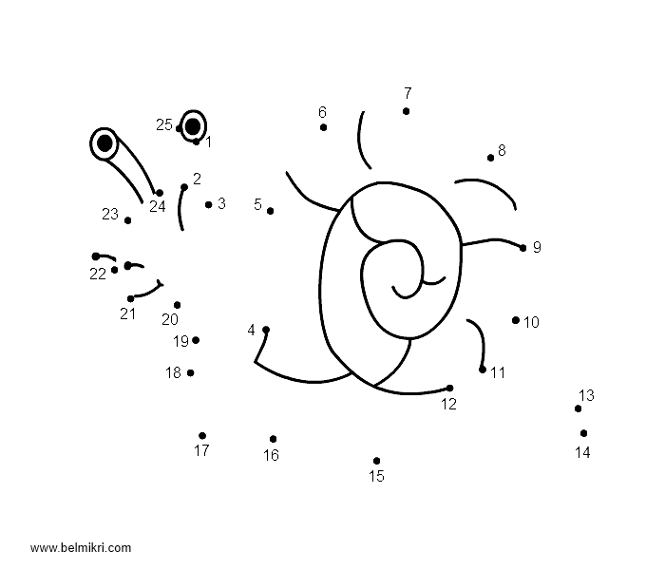

**Connect the dots. What do you see?!**

Create your own tree! Decorate it with leaves, animals, flowers, or fruit!