Etobicoke
Collegiate Institute
__________________________________________________________

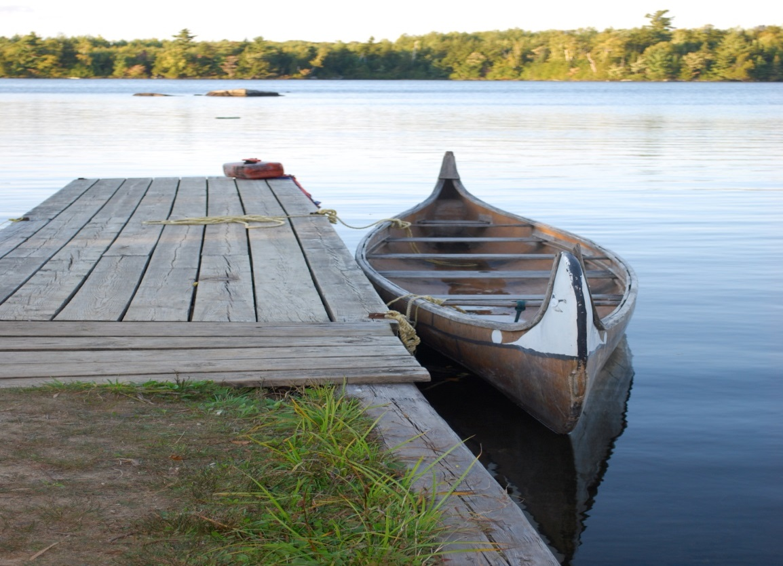
Grade 10 Leadership Camp
White Pine 2016

(Photograph by Ms. P. Bell Camp White Pine September 2011)

Address: 1335 Camp White Pine Court, Haliburton, ON K0M 1S0 (705) 457-2131
Visit: www.campwhitepine.com for a virtual tour of the camp’s facilities.

White Pine Mission Statement for Students

To foster interpersonal skills such as communication, creativity and confidence
- To develop future leaders
- To reinforce our roles as contributing members of our diverse community
- To learn to make decisions and choices that benefit all
- To build valuable positive relationships and lifelong memories
- To promote appreciation and respect for the environment
- To promote, embrace, and encourage diversity

Participants
Any students currently enrolled in grade 9 at Etobicoke Collegiate Institute are eligible to go to White Pine as campers. They will be accompanied by a group of senior students and teachers.

Cost
Although the Toronto District School Board contributes considerable funds for teacher coverage, the cost of the program is $350.00 per student. This includes accommodations, meals and transportation to and from camp.

Payment must be made in either cash, or certified cheque/money order made payable to Etobicoke Collegiate Institute. Personal cheques will not be accepted.

Organizing a camp for our students involves expenditures well in advance of the camp on transportation, materials, instructors and accommodations. While we recognize that unforeseeable situations can arise that may prevent a student from attending camp, we are unable to refund the full amount of the fees after our cut-off date. Any requests for a refund after this date will be the $350 less $125 for costs that cannot be recouped by the school.

Parents in need of financial assistance should speak to our vice-principal, Ms. Greeley, for information regarding payment plans. You can contact her at the school at (416) 394-7840.

- Friday June 3rd, 2016 – White Pine Fee of $350 is due
- Friday June 24th, 2016 – Last day for a full refund.

Arrival and Departure
Transportation to the camp will be provided.
- White Pine Leaders in Grade 11 and Grade 12 will depart from the ECI parking lot on Monday, September 12th, 2016 at 7 am.
- Grade 10 campers and designated Grade 11 and 12 leaders will depart from the front of ECI on Monday, September 12th, 2016 at 9:30 am.
- Students who are late for departure from the school and miss the bus will have to find their own transportation to camp. Bus fees will not be refunded.
- All students will return on buses and arrive back at ECI between 3:30-4:30 pm on Friday, September 16th, 2016.

First Aid on Site
There is a first aid station in the Infirmary building and a nurse will be available 24/7 during the camp. If necessary, students will be taken by staff to the nearby Haliburton hospital which is a 15 minute drive from the camp.

Attendance
Students are expected to be on time and to attend and take an active part in all aspects of all sessions/programs at Camp White Pine Program. Sessions will proceed, rain or shine, so students should ensure that they have adequate clothing for all types of weather.

Rules and Expectations
Students are expected to be respectful, polite, considerate and co-operative with each other, the student leaders and the staff and to abide by the following rules:

- Drugs and alcohol are absolutely forbidden. Prescription drugs are to be given to staff prior to departure from the school. They will be issued as prescribed by the nurse at camp. Anyone found with drugs or alcohol, or with anyone associated with the use of these substances, will be sent home at their parents’ or guardian’s expense. Registration fees will NOT be refunded.
- Smoking, vaping and e-cigarettes are not permitted at anytime, anywhere during the duration of this trip.
- Absolutely no nut products are to be brought to camp.
- Curfew is 11:00 pm. Students are to be in their sleeping bags and cabins silent by 11:30 pm.
- No hatchets, axes, knives, guns, ammunition, bows and arrows, or other potentially dangerous objects may be brought to camp.
- Boys will be accommodated in one section and the girls in another section. Boys are not allowed in girls' cabins and vice-versa.
- IPods & cell phones will not be allowed during the sessions.
- Wandering from the group is not allowed and students must remain on the property unless accompanied by staff.
- Visitors are not allowed.
- It is everyone’s job to keep the camp clean, pick-up any garbage and to be aware of the limitations of the septic system.

Swimming Test
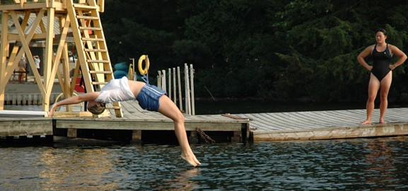
With regard to water safety, staff and students must be able to show the ability to swim in order to participate in the lakefront activities at the camp. This will be demonstrated during a supervised session with certified White Pine staff, a teacher and student leaders on the first day of camp.

In order to pass the swim test students must be able to:
- complete a 50 metre swim without a Personal Floatation Device (PFD) and
- tread water for 5 minutes without a PFD.

Students who fail to demonstrate these skills will not be able to participate in any waterfront activities and will participate in alternate activities instead.

Sample Daily Timetable
Time | Activity
7:15 am | “Rise and Shine” and Cabin Clean-up
8:00 am | Breakfast
9:00 - 11:30 am | Morning Program
12:00 pm | Lunch
1:00 - 3:30 pm | Afternoon Program
3:30 - 5:30 pm | Organized Recreational Activities
5:30 pm | Dinner
7:30 - 10:00 pm | Evening Program, snack at 10:00pm
10:15 pm | Cabins/Showers/Quiet time
11:15 pm | Lights Out

Sample Student Timetable for the Week
Time | Morning Program | Afternoon Program | Evening Program
Monday | Travel to Camp | Unpack, Lunch,  Team Building  Swim Tests | Team Building  Skits
Tuesday | Ropes Course | Arts and Crafts | Talent Show
Wednesday | Swimming/Canoeing | Stomp | Gym Riot, Campfire
Thursday | Outdoor Recreation | Olympine | Dance
Friday | Pack up, Debrief | Travel back to ECI

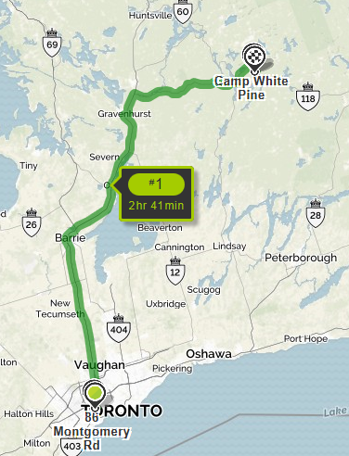

Equipment and Clothing Checklist

Toiletries | Optional Items
- Comb/Brush | - Camera
- Toothbrush and toothpaste | - iPods
- Soap in a plastic container | - Shorts
- Towels | - Bug Repellent
- Deodorant | - Musical Instruments
- Sunscreen | - Quiet games (ex. Cards)
- Lip Balm
General Clothing Items | Bedding
- Pajamas | - Sleeping bag OR
- Slippers/spare indoor shoes | 2 Sheets and very warm blanket(s)
- Running shoes
- Socks and underwear (5 of each)
- Sweaters/sweatshirts (3+) | Spirit Wear!!
- Jeans/heavy pants (3+) | - Colour team clothing and accessories
- Shirts (7) | - Theme Clothing:
- Rain boots/rain jacket | Tuesday night: Pyjama Jam
- Bathing suit | Thursday night: Western Theme
- Warm jacket (mornings/evenings are cold)
- Hat for sun protection

It is our recommendation that students do not bring items of value to camp. If students choose to bring valuables please be advised that they are responsible for the security of their own devices and belongings. Students are encouraged to ensure that their belongings are visually identifiable as a preventative measure against loss or theft. Neither the school staff nor the camp staff can be held responsible for missing items.

