Predator and Prey

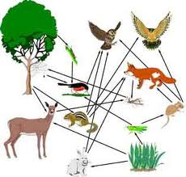

1. a. Which role did you enjoy playing the best?
b. Why?

2. What was different about the second season?

3. How did this affect the game?

4. As a result of what you learned from the game, what might you do differently at home and/or at school?

5.

