Sun | Mon | Tue | Wed | Thu | Fri | Sat
Upcoming Dates:  January 8th » Back to school – Day 1  January 19th » PA Day  January 22nd » Vision & Hearing Clinic |  |  |  |  | 1 Day 0  PA DAY   | 2
3  Advent begins | 4 Day 1 | 5 Day 2  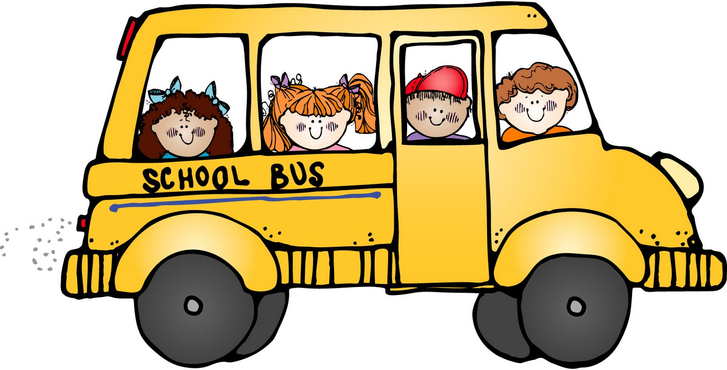  Grades 3 – 6 trip to Raptors game at ACC | 6 Day 3 | 7 Day 4 | 8 Day 5  Red Nose  Fundraiser  ENDS   | 9
10 | 11 Day 1 | 12 Day 2 | 13 Day 3    Hanukkah begins | 14 Day 4  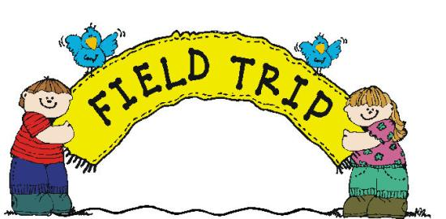  Grade 5/6 trip to Ryerson | 15 Day 5  Grade 5/6 trip to Ryerson | 16
17 | 18 Day 1 | 19Day 2  6:30 p.m.  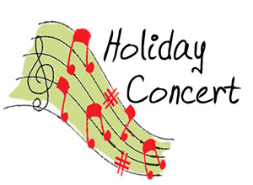  In GYM | 20 Day 3  Hanukkah ends | 21 Day 4    9:00 am  Holiday Sing-a-Long in Gym | 22 Day 5   | 23  
24   | 25 Day 2   | 26 Day 3    Kwanzaa begins | 27 Day 4 | 28 Day 5 | 29 | 30
31


LORD ROBERTS Jr. PS P.S.
December 2017
Kindness & Caring

