Trail Mix
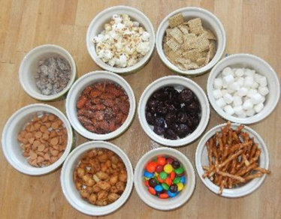
Math Strand: Number Sense and Numeration
Grades: JK-SK
This mix teaches counting. There is no hard set recipe for this. Just assemble a lot of different ingredients. Make sure they are small... not too sticky... and go along with any dietary restrictions you might face.

Ingredients
• Cereal Squares (10) • Fruit Loops (7)
• pretzel sticks (15) • raisins (9)
• dried cranberries (12) • Chocolate chips (6)
• goldfish crackers (21)

School Instructions:
1. Put on gloves.
2. Give your child a baggie do their mixing.
3. Child places the appropriate number of ingredients in his/her container.
4. Once child is done... shake or stir.... then eat

Home Instructions
1. Put each individual ingredient in a small bowl.
2. Next to the bowl you can write a number... this is how many of the item your child can take.
3. Give your child a baggie or cup to do their mixing.
4. Let him or her go down the line putting a specific number of each ingredient in his/her container.
5. Once child is done... shake or stir.... then eat.

