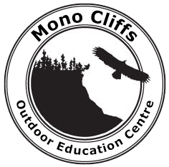

# MONO CLIFFS PROGRAM PLANNING

3.5 Day Program

School: Phone:

Principal’s Cell Number: Grade: Number of Students:

Date(s) of Trip(s):

Teacher in Charge of Trip at Mono Cliffs:

Supervision: Home school must provide supervision for both male and female students of the same gender as the students at the ratio of one teacher for every fifteen students (as per TDSB Excursion Policy).

Female Teachers:

Male Teachers:

(See program list & program descriptions on our website: <http://schoolweb.tdsb.on.ca/monocliffs> )

Day Programs for 3.5 day visit: (6 programs) Evening Programs: (3 programs)

|  |  |
| --- | --- |
|  | 1. |
|  | *2.* |
|  | 3. |
|  |  |
|  |  |
|  |  |

Related to your program choices, what curriculum will your students be studying in your classroom(s) at the time of your visit?

Your objectives for this overnight outdoor education field trip:

General comments about the academic, physical, and social nature of this group:

General comments about special learning, language, behavioural needs, and medical concerns: