e-Reg Quick Start

About

e-Reg is the TDSB student course request & guidance counsellor approval web app. E-Reg is now used for both e-Learning and Continuing Education programs. This Quick Start guide takes you step-by-step through the basic functions of this online tool. If you have further questions about using e-Reg, please email Elizabeth.hilchey@tdsb.on.ca

Login

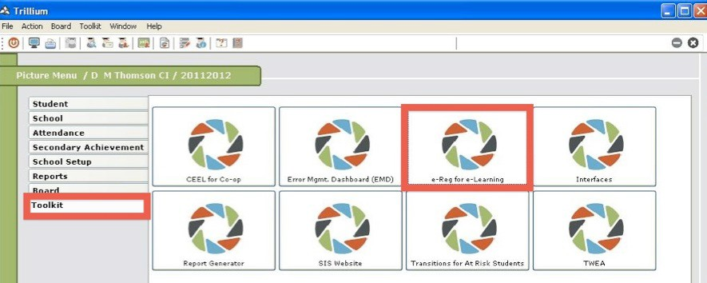
- Access e-Reg via Trillium > Toolkit > e-Reg for e-Learning icon Note: this is correct!

News Pop Up

- When there’s important information, a news item will pop up when you launch e‐Reg
- Click the Continue button when you’ve finished reading the message
- Older news items are archived on the News tab

Guidance Approvals

- This page is the main action area of the app
- There are two tabs at this location: one for e-Learning; one for ConEd
- Select the tab for Con Ed for summer school and night school approvals
- The default status of requests is Pending Approval
- Filter student records by Grade, Status, Student Number or Student Name

Select a Session
- Click on the Session drop down menu bar; a listing of available sessions appears
- Select a session from the menu (e.g. e-­‐Con EdSummer School 2015)
- Click Search
- All of the pending course requests for the selected session appear

Approve or Deny
- Select the student you wish to work with and click Approve or Deny in the Action column
- Click on the REASON button and select the appropriate choice. It is important to make this selection correctly as the reason for approval/denial is emailed to the student.
- Click Save Changes to confirm the actions

Remove
- In the Search Options area click the Status drop down menu and select Enrolled
- Select the student you wish to work with and click Remove in the Action column
- Click Save Changes to confirm the demit

Re-Enroll
- In the Search Options area click the Status drop down menu and select Removed
- Select the student you wish to work with and click Re‐Enroll in the Action column
- Click Save Changes to confirm the re‐enrolment

Student History

- This page is the main viewing and reporting area of the app
- This view defaults to display records of All status for all of the students at your school
- Filter student records by Grade, Status, Student Number or Student Name

Find a Student

- In the Search Options area in the Student Name field type in any part of a student’s name
- Or in the Student Number field type in their 9 digit Trillium student number
- Click Search to find the records for this specific student
- To see detailed student information, click on the student’s Trillium number that is blue and underlined (see Student History point 3 Student Overview)

Student Overview
- A hyperlink goes to the Student Overview page for this specific student
- The Student Overview minibar has two tabs:

- e-Reg displays student information from Trillium
- Trillium information cannot be edited in e‐Reg
- Three fields can be edited by both students and counsellors: Email Address, Special Education Needs, and ConEd Information
- Counsellors can see all information about a specific student’s course requests on this tab
- To add a course request for a student click Add New Course Request and follow the onscreen instructions

Course Counts

- The Course Count page shows the current enrolment levels for the courses in a selected session
- As with the Guidance Approval and Student History pages, there is both an Export to PDF and Export to Excel function

