Mental Health and Mindfulness Resources

New Leaf Yoga
Guided meditation, yoga, stretching exercises
https://www.youtube.com/channel/UCNn8CzdQ4tRwC2sOezKTKeQ

Youthspace
https://youthspace.ca/about-us/

Good to Talk
https://good2talk.ca/

TDSB Covid-19 and Mental Health Resources
https://www.tdsb.on.ca/Elementary-School/Supporting-You/Mental-Health-Well-being/Mental-Health-and-Well-Being-Resources

Chrome Music Lab
https://musiclab.chromeexperiments.com/

YMCA: Your virtual YMCA experience
https://www.youtube.com/channel/UCOGt_IpceP_xQhhCMCrut_A/videos

STRONG by Zumba
https://www.youtube.com/channel/UCQkaczRlyBjl3UKBH59W3XQ/videos

Mental Health Commission of Canada: Taking Care of Each Other During Pandemic
https://www.mhfa.ca/en/covid19-mhfa

Free Online Meditations
https://www.headspace.com/

Experience the Art Gallery of Ontario from home
https://ago.ca/agoinsider/experience-ago-from-home?utm_source=New+AGO+Master+List&utm_campaign=b21129feab-AGOfromHome_Apr1&utm_medium=email&utm_term=0_d4ab708299-b21129feab-248459017

Discover these 12 Famous Museums From Home
https://www.travelandleisure.com/attractions/museums-galleries/museums-with-virtual-tours?fbclid=IwAR3f-M2KggcKWjE6nLyC1-FDJDURLf2Mgj74qImaXLwMQXf_lFNRwZ9XlYk

Scribed. Free 30 day book downloads
https://www.scribd.com/subscribe-now?utm_medium=cpc&utm_source=adwords_brand&utm_campaign=Google_Search_Alpha_Brand_Canada&utm_term=scribd&utm_device=c&gclid=CjwKCAjwsMzzBRACEiwAx4lLG2gKlg7SJJrGNdDciOO6o-Y6_-ISW-aGmYIfYG7VEDGooFuME4pTYRoCNIAQAvD_BwE

Crisis lines
- Crisis Text Line is free and available 24/7
  - Canadians text “686868”
  - Text HOME to 741741 to connect with a (COVID-19) Crisis Counselor
- Toronto Distress Centre
  - GTA: 416-408-4357 (HELP)
    - Emotional support service for those with chronic mental health problems; Support & crisis intervention services for those currently experiencing distress or in crisis; Family violence response; Suicide prevention services; Emergency intervention and response
- Kids Help Phone - text, phone, chat and other forms of support for young people, 24/7 and in English and French
  - 1-800-668-6868
- Assaulted Women’s Helpline, free at 1-866-863-0511 or TTY 1-866-863-7868
  - #SAFE (#7233) on your Bell, Rogers, Fido or Telus Mobile
- National Aboriginal Circle Against Family Violence
- Senior Safety Line - 1-866-299-1011 (toll-free)
- The Gerstein Centre (non-medical mental health crisis supports): 416-929-5200
- GTA Crisis Resources
- Mental Health Crisis Line (Canada Wide): 1-888-893-8333
- Canadian, US and, International mental health hotlines

If you’re in immediate danger, please call 911

Students may be encouraged to express their thoughts and feelings through illustration and/or journals
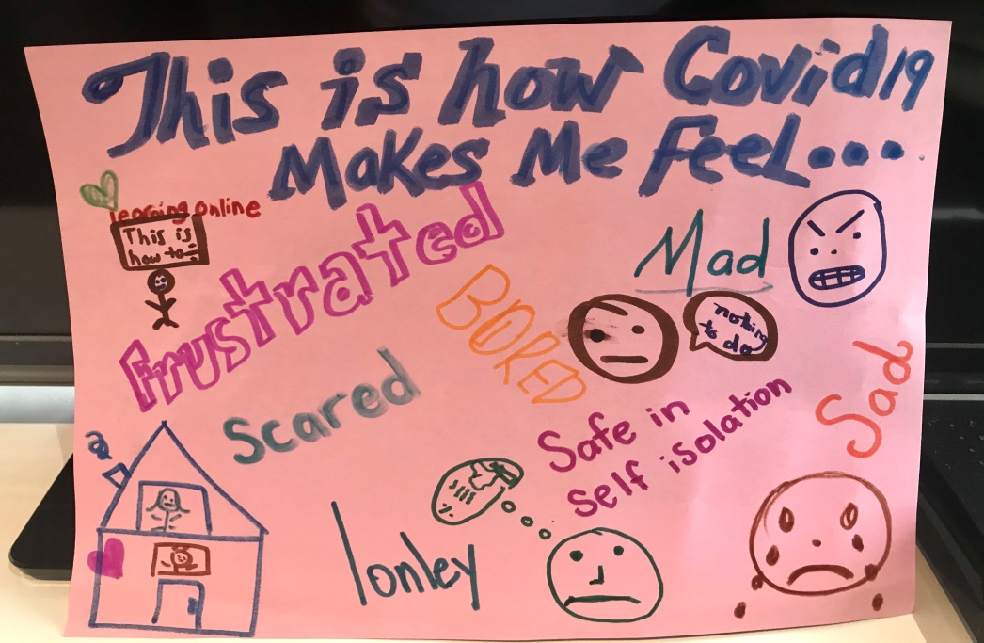

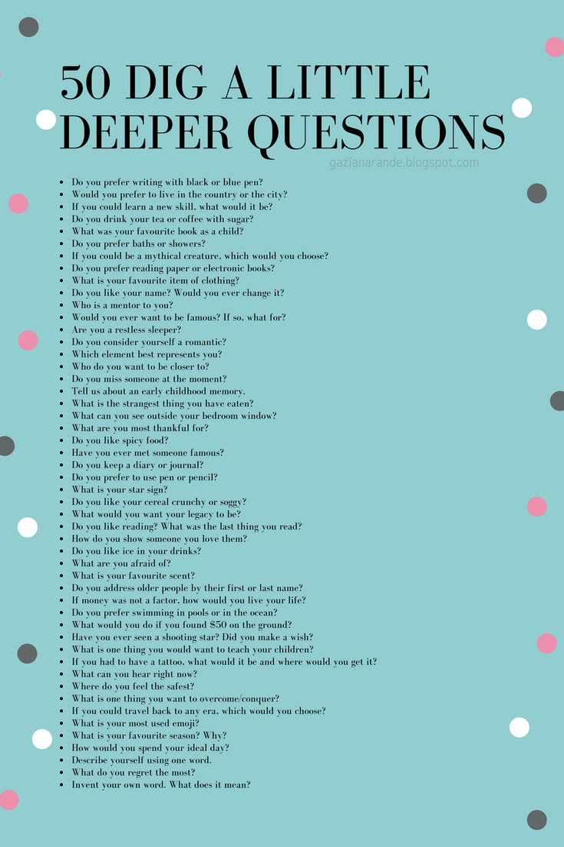

Paint a special message of love and gratitude on a rock. Leave it in someone’s garden, a sidewalk or school.
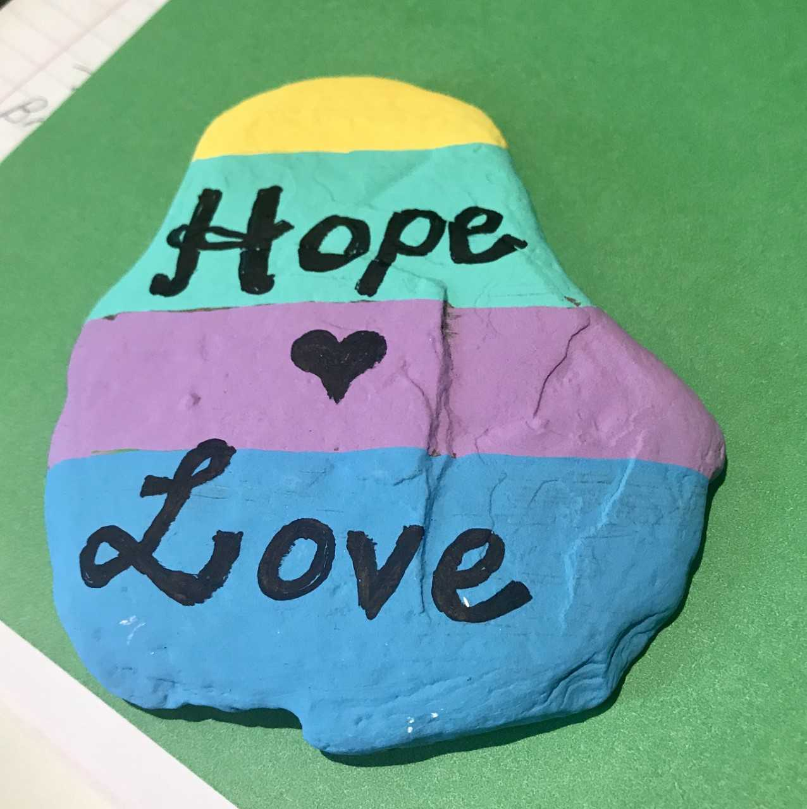

Breathing is the body’s way to destress, resetting the brain towards restoring calm and concentration. Try this very simple exercise for youth of all ages.

