RICHVIEW COLLEGIATE INSTITUTE
FSF 1P Course Outline 2015-2016

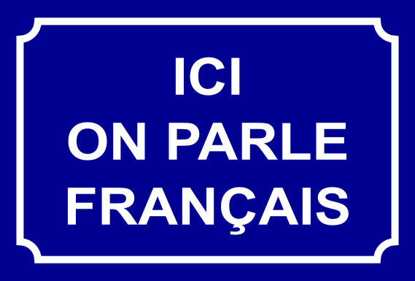

Course Name: Core French, Grade 9 | Course Code: FSF 1P
Pre-requisite: Minimum of 600 hours of French instruction, or equivalent | Course Destination: Applied
School: Richview Collegiate Institute | Department: Moderns
Phone#: 416-394-7980 ext. 20130 | CL/ACL: O. Bourgeois
Course Description:
This course provides opportunities for students to communicate and interact in French in structured situations, with a focus on everyday topics, and to apply their knowledge of French in everyday situations. Students will develop listening, speaking, reading, and writing skills introduced in the elementary Core French program, through practical applications and concrete examples, and will use creative and critical thinking skills in various ways. They will also enhance their understanding and appreciation of diverse French-speaking communities, and will develop skills necessary for lifelong language learning.

Overall Expectations:
Strand | By the end of FSF 1P, students will......
Listening | A1. Listening to Understand: determine meaning in a variety of authentic and adapted oral French texts, using a range of listening strategies;  A2. Listening to Interact: interpret messages accurately while interacting in French for a variety of purposes and with diverse audiences;  A3. Intercultural Understanding: demonstrate an understanding of information in oral French texts about aspects of culture in diverse French-speaking communities and other communities around the world, and of French sociolinguistic conventions used in a variety of situations and communities.
Speaking | B1. Speaking to Communicate: communicate information and ideas orally in French, using a variety of speaking strategies, appropriate language structures, and language appropriate to the purpose and audience;  B2. Speaking to Interact: participate in spoken interactions in French for a variety of purposes and with diverse audiences;  B3. Intercultural Understanding: in their spoken communications, demonstrate an awareness of aspects of culture in diverse French-speaking communities and other communities around the world, and of the appropriate use of French sociolinguistic conventions in a variety of situations.
Reading | C1. Reading Comprehension: determine meaning in a variety of authentic and adapted French texts, using a range of reading comprehension strategies;  C2. Purpose, Form, and Style: identify the purpose(s), characteristics, and aspects of style of a variety of authentic and adapted text forms in French, including fictional, informational, graphic, and media forms;  C3. Intercultural Understanding: demonstrate an understanding of information in French texts about aspects of culture in diverse French-speaking communities and other communities around the world, and of French sociolinguistic conventions used in a variety of situations and communities.
Writing | D1. Purpose, Audience, and Form: write French texts for different purposes and audiences, using a variety of forms and knowledge of language structures and conventions of written French appropriate for this level;  D2. The Writing Process: use the stages of the writing process – including pre-writing, producing drafts, revising, editing, and publishing – to develop and organize content, clarify ideas and expression, correct errors, and present their work effectively;  D3. Intercultural Understanding: in their written work, demonstrate an awareness of aspects of culture in diverse French-speaking communities and other communities around the world, and of the appropriate use of French sociolinguistic conventions in a variety of situations.

Course Materials:
Textbooks(s)/Resources:
*Quoi de neuf textbook, workbook, videos, audio program;
*films and television programs;
*songs and games;
*articles, selected readings, apps, websites and other relevant internet sites.

Note: Textbooks and readers are lent to students and must be returned by the end of the course.
Units of Study:

Time Frame | Title
September | Unité 1:Zone amis
November | Unité 2:La bonne bouffe
January | Unité 3:Musique-mania!
March | Unité 4:Inspir-action!
May-June | Summative tasks
NB: Grammar, including a review of major language structures studied throughout the Core French program, will be embedded throughout the studied units and resources, according to the needs of the students.
The objectives may include formation and use of: le présent, verbes suivis d’un infinitive, futur proche, future simple, passé compose, pronoms, mots interrogatifs, conjonctions.

Assessment and Evaluation Strategies:
The primary purpose of assessment and evaluation is to improve student learning. In order to ensure that assessment and evaluation are valid and reliable, and lead to improvement of student learning, teachers of this course use a variety of the following strategies to assess student learning and to provide them with feedback:

- teacher observation
- oral presentations, interviews
- essays, reports, reviews, critiques, letters, journals, creative writing,
- computer lab work
- media works
- quizzes, tests, examinations
- performance tasks, dramatic presentations
- portfolios, design projects, lab work
- self-assessment, peer assessment
- check lists, rubrics
- questions and answers
- students are encouraged to participate in all activities to allow them to practice their oral, reading and writing skills in French

Learning Skills: The report card provides a record of the learning skills, demonstrated by the student in every course in the following six categories: Works Independently, Teamwork, Organization, Work Habits/Homework, Initiative, and Self-Regulation. The learning skills are evaluated using a four-point scale (E-Excellent, G-Good, S-Satisfactory, N-Needs Improvement).
Achievement Categories/Strands  Listening 25%  Speaking 25%  Reading 25%  Writing 25%  The weighting of evaluate is by strand and the categories of the Achievement Chart are addressed in a balanced manner within the various tasks. | Calculation of Final Mark  Term Evaluation: 70 %  Final Evaluation: 30 %  A more detailed description of the final evaluation will be distributed in class in May.

Communication:
- Students are welcome to discuss the course work, their progress, their marks, or any other matter at any time. Making an appointment will ensure that the teacher is available. Appointments may be made before or after school, or during the lunch hour.
- Parents or guardians may contact the teacher at any time to discuss student work. Parents/guardians can reach the Moderns Department directly by calling 416-394-7980 ext. 20130 or emailing Jane.Fontes@tdsb.on.ca
- Extra help can be arranged by contacting the subject teacher directly or attending Study Hall.

