MODERNS

Immersion, Extended, Core and Spanish

French Study Hall

# C:\Users\086428\Desktop\moderated marking.jpegC:\Users\086428\AppData\Local\Microsoft\Windows\Temporary Internet Files\Content.IE5\8G0MLARG\library-books-clip-art[1].jpg

Students are invited to attend French Study Hall every Thursday between 3:30-4:30 pm in room 141. Teachers and peer tutors assist students with homework and assignments, encouraging healthy study habits and success!

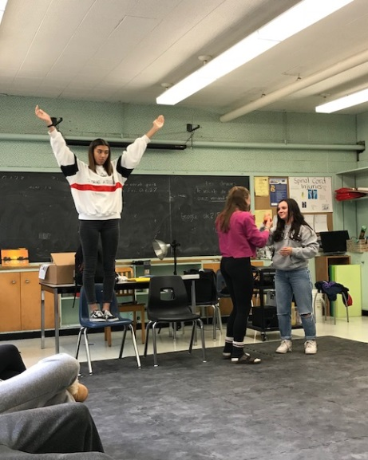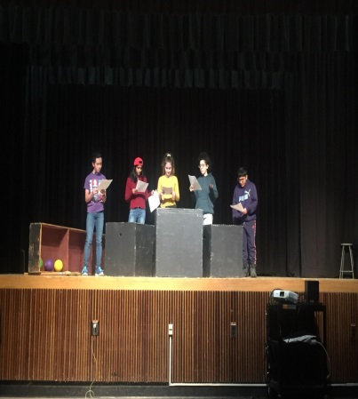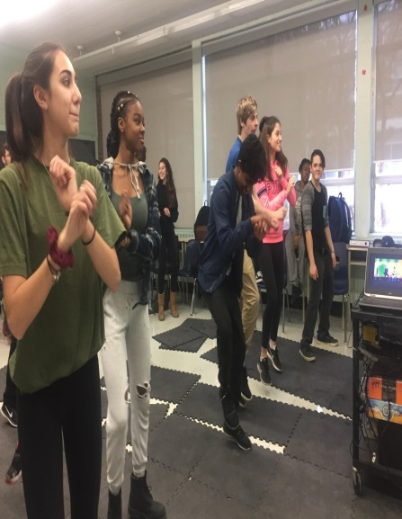

Drama

This dance unit project builds on cooperation, movement, comfort on stage, creativity and spatial awareness.

A Reader's Theatre drama project based on the film *Inside Out*.

Mimez-le! Students demonstrating movements, emotions, actions through miming.

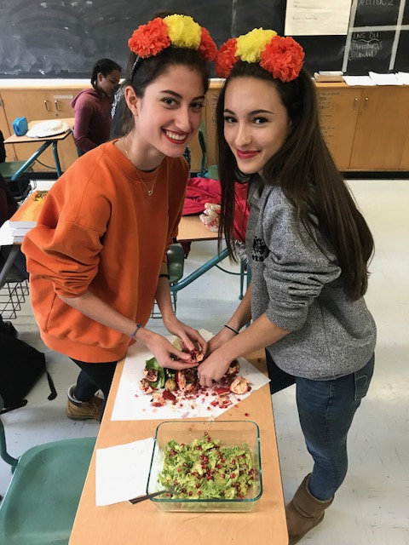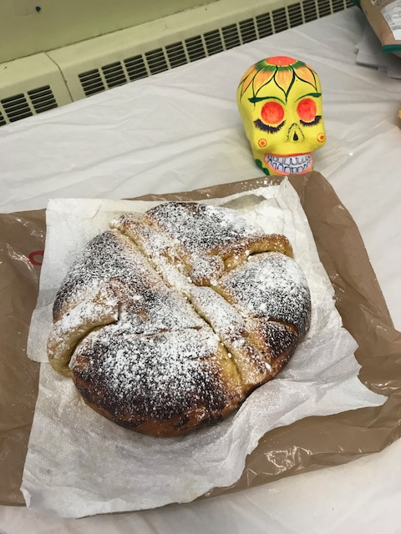

Spanish

Learning about the celebration that draws on Indigenous traditions – *El Día de los Muertos.*

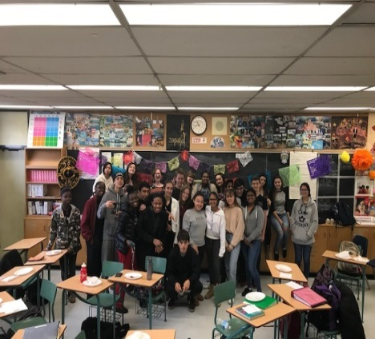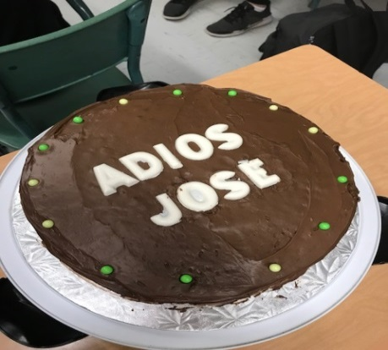

Our class welcomed students from Spain participating in a three month exchange. The experience was insightful and beneficial for all. We now wish our Richview students an unforgettable adventure as they embark on their journey to France and Spain. [www.ceef.ca](http://www.ceef.ca)

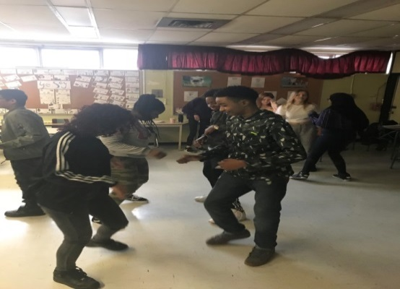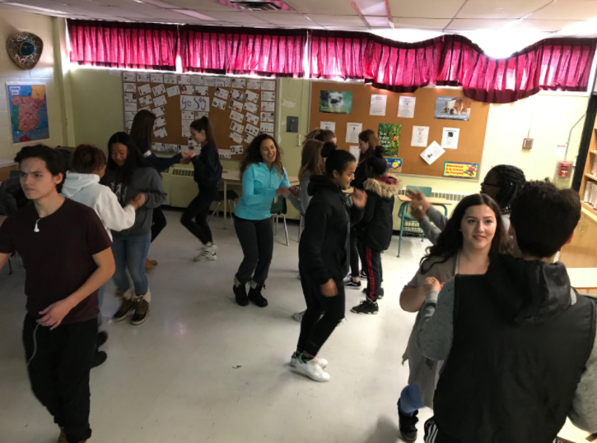

Students in year one, two and three Spanish classes enjoyed a period of Latin dancing – mastering the art of merengue, salsa and bachata!

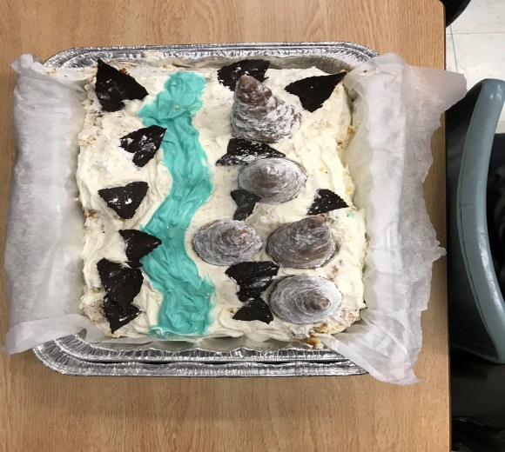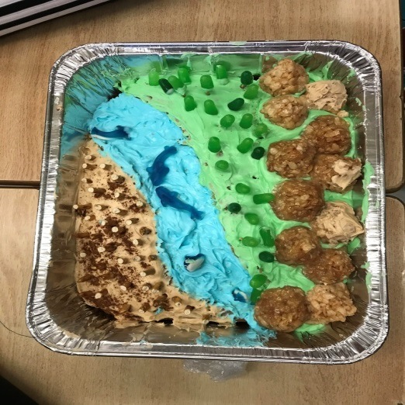

Geography

Grade nine geography students made cakes to represent Canadian landform regions which turned out to be lots of fun and delicious!

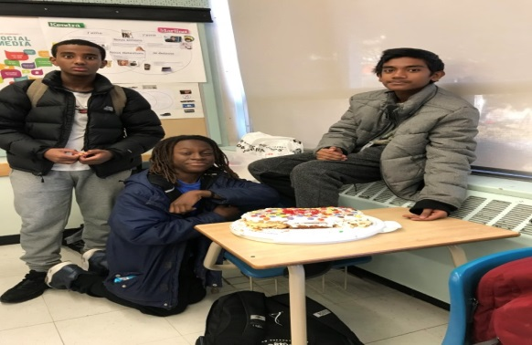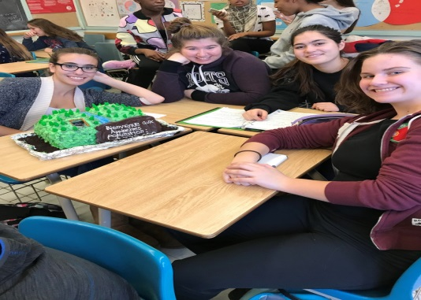

Technology in the classroom

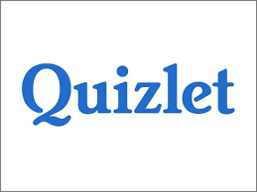

Students are accessing Duolingo, Quizlet, Google Classroom, Kahoot (and many more) from their phones, tablets and computers, to enhance language learning. Teachers and students alike are motivated to incorporate these very useful tools in their classrooms!

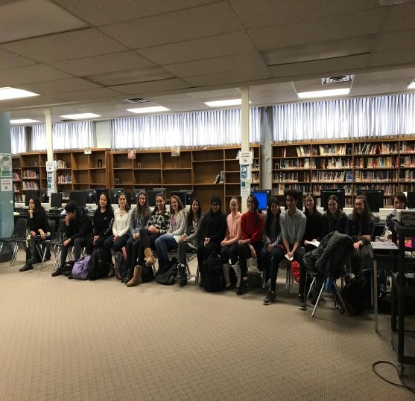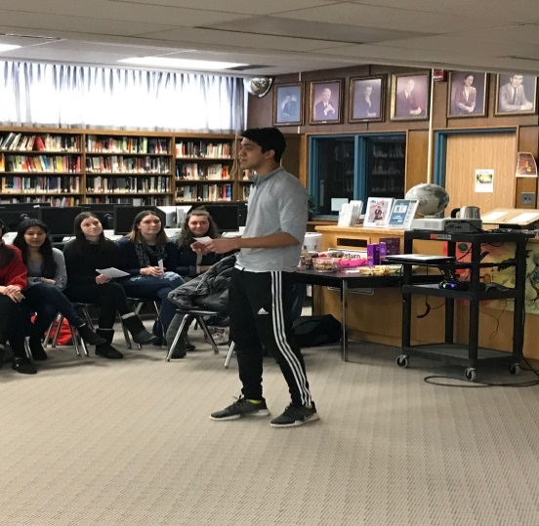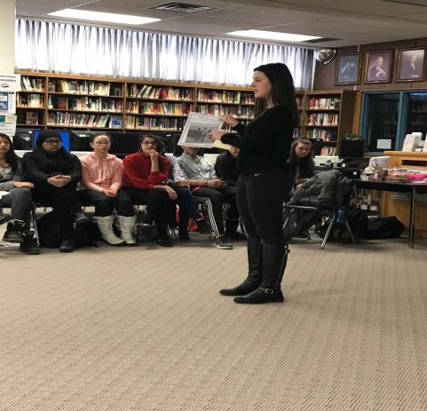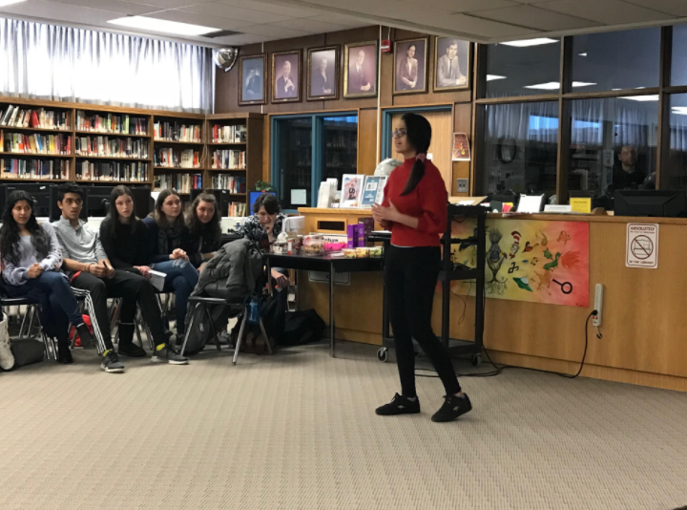

Félicitations aux élèves qui ont participé au Concours d’art oratoire le 22 février. Ça prend du courage pour s’exprimer devant les camarades, les amis, les profs et les juges. Merci, les élèves, d’avoir partagé vos pensées et vos discours avec nous!

Félicitations à Ivana Milicevic, Jessica Song, Dior Hamja, Muskan Malek et Iliya Karac qui vont représenter notre école au niveau régional. Bonne chance!

Concours d'art oratoire

Concours within the community oratoire



On Friday, February 23rd, a few teachers from Richview’s Moderns Department spent some time at Hilltop Middle School as judges of the *Concours d’art oratoire*. The teachers heard students speak in French on a variety of topics, from “*Le monde de changement*” to “*Les oies sur mon toit*”, and were asked to select one student in each category to move on in the contest. The experience was a wonderful opportunity for our teachers to form ties within the community, and to draw inspiration from the dedication and creativity of Hilltop’s students and staff.

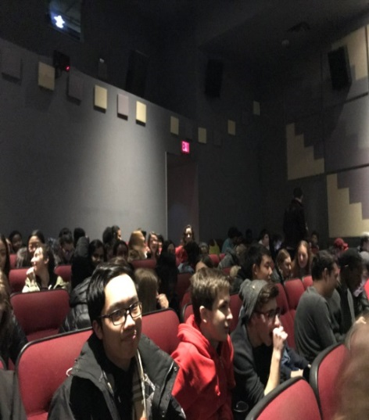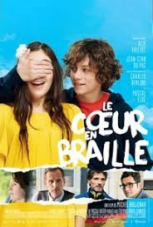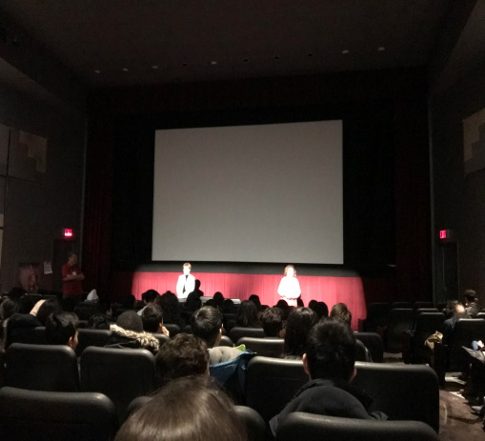

Students attended a screening of the French film  at Ciné Franco film festival. The students were touched by this uplifting story about two young teens falling in love despite major obstacles.

Ciné Franco

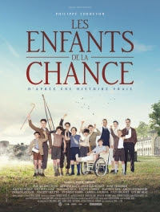

On March 1st the Grade 10 French Immersion students will take part in an annual cultural excursion to Ciné Franco.  ***Les Enfants de la chance*** is a film which touches on the true story of the lives of children at a hospital in France during the Second World War. Students will listen to authentic French and discuss elements related to our unit of study.