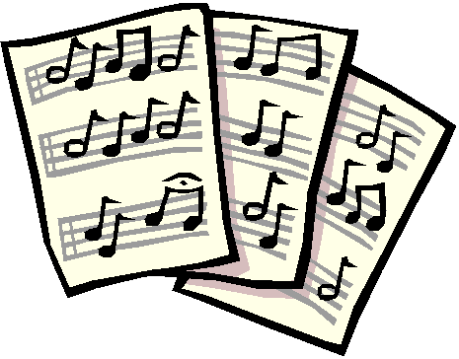
Music Department
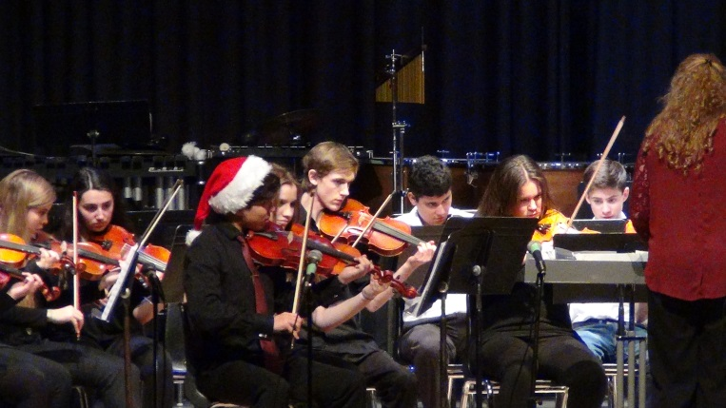
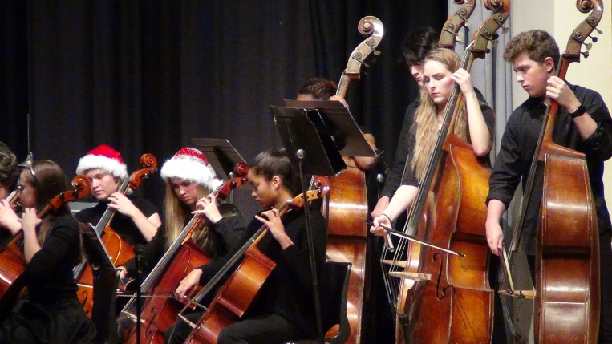
The annual Christmas Concert in December went on despite the snow storm, even Santa and Mrs. Claus showed up! Nine ensembles entertained the audience, emceed by Mr. Bruce Boyd, with works ranging from the Baroque era to the 20th Century. Something for everyone! The evening was followed up by a time of refreshments and good conversation.

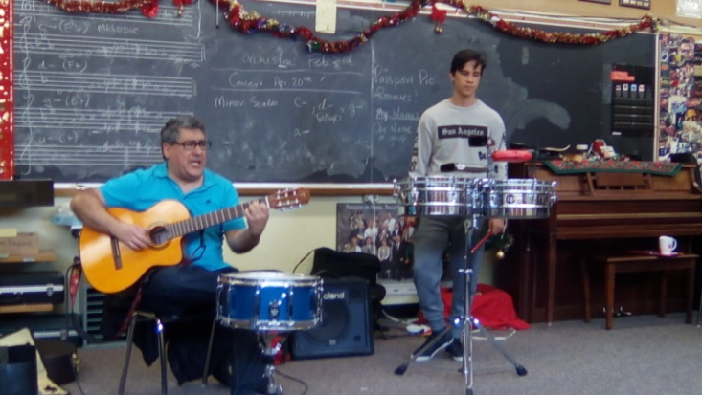
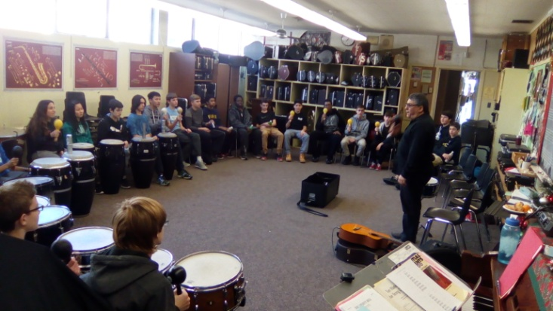
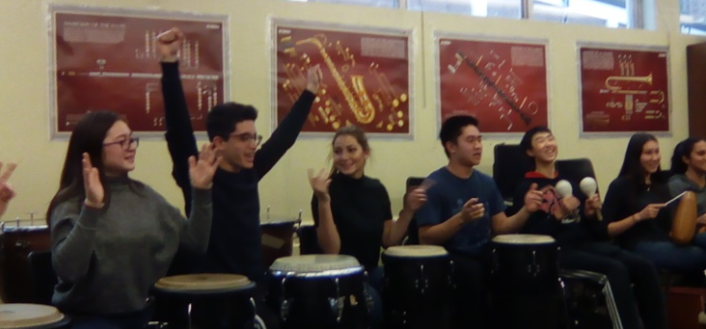
January’s focus was on rhythm, counting, feeling the beat and performing. We had a guest Percussionist in to provide a workshop for the students on Latin Music. Mr. Rodrigo Chavez, a local Artist originating from Peru, brought insight to the world of Latin Music and the rhythms that are used and performed, as well as allowing the students to perform on the native instruments. The Salsa and Cha-Cha were two of the favourite rhythms.
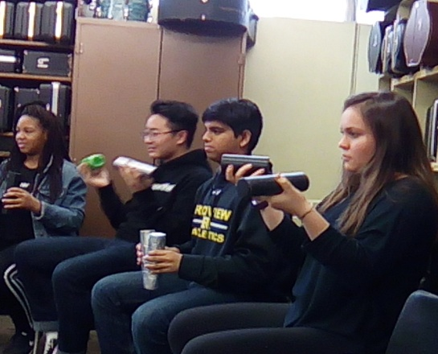
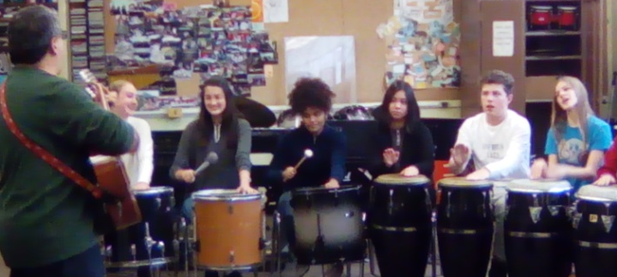
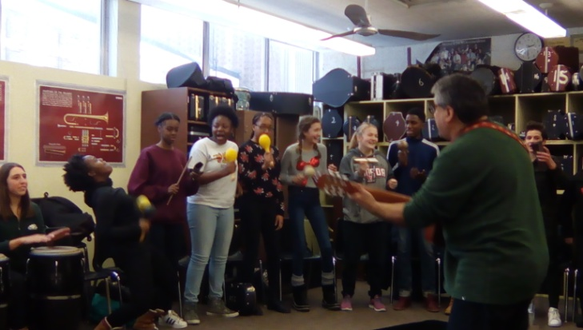
In Early February, Senior Students were given the opportunity to attend an open rehearsal of the Toronto Symphony Orchestra. They were seated in the choir loft directly above the orchestra. A fantastic experience.
Our Annual Spring Symphonia will take place on April 20th this year, a week earlier than scheduled due to our trip.
On April 26-29th, fifty students from grades 10-12 and three chaperones will be attending the Atlantic Band Festival in Halifax Nova Scotia, and will be performing Tchaikovsky’s 1812 Overture and Johann Strauss’ Tales from the Vienna Woods. http://www.atlanticfestivals.com/

