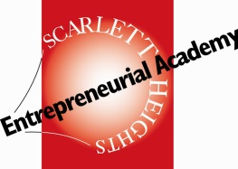

April 13, 2016

Dear Parent/Guardians and Students:

Young innovators and entrepreneurs are invited to the second Young Innovators Boot Camp and Showcase from Wednesday, May 11 to Friday, May 13 to be held at Scarlett Heights Entrepreneurial Academy. Detailed information about the Boot Camp is outlined in the attached flyer. During the Boot Camp, students from across the TDSB will work with mentors from the University of Toronto’s Ideas Hatchery (i2H) to develop solutions to problems of the next millennium. At the Showcase, student innovators will present their pitches to a panel of judges to determine a winner. This highly successful Boot Camp was piloted in December and received accolades from participants and observers. Please see our website for videos of the showcase. (www.Scarlettheights.ca)

Students interested in attending the Boot Camp are asked to complete an Excursion Form as well as a Media Release for TDSB and i2H provided to your school. Please note the following:

- Students are not accompanied by teachers from their school.
- Travel arrangements are the responsibility of student/parent/guardian.
- Attendance is taken each day and students must remain on school property during the Boot Camp.
- All participants are expected to comply with TDSB Code of Conduct.
- Parents/Guardians are invited to the Showcase to be held on Friday, May 11 in the afternoon.

For more information, please contact rizwana.jafri@tdsb.on.ca. Spaces are limited. Please register using the following link: Boot Camp Registration Form http://goo.gl/forms/8jVvfFXPrT

Yours truly,

Rizwana

Rizwana Jafri
Principal
Scarlett Heights Entrepreneurial Academy

