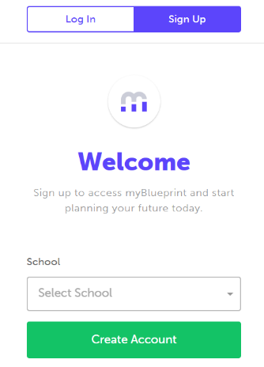
- CREATE YOUR PARENT ACCOUNT
- Visit www.myblueprint.ca/TDSB
- Click Sign Up in the top right corner
- Select your child’s school and click Create Account
- Click Not a Student? Teachers, Counsellors, and Parents sign up here
- Select Parent/Guardian/Advisor
- Fill out the sign up form
- Click Create My Account

- LINK WITH YOUR CHILD (Optional)
You can link with your child to view their myBlueprint account by following these steps:
- From the account sign up page, click on Link to a Student
- Enter your child’s email address associated to their myBlueprint account and click Find Student
- Click + Add This Student
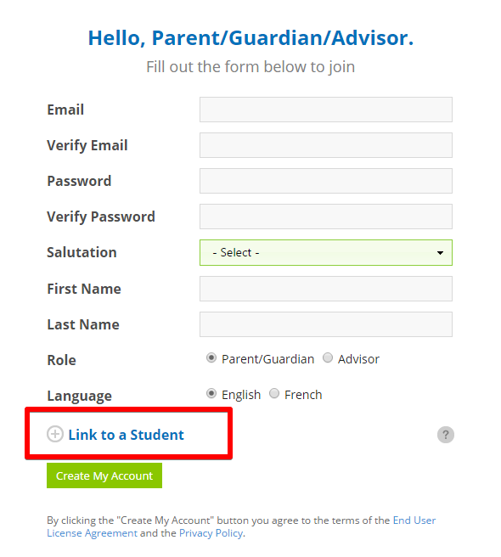

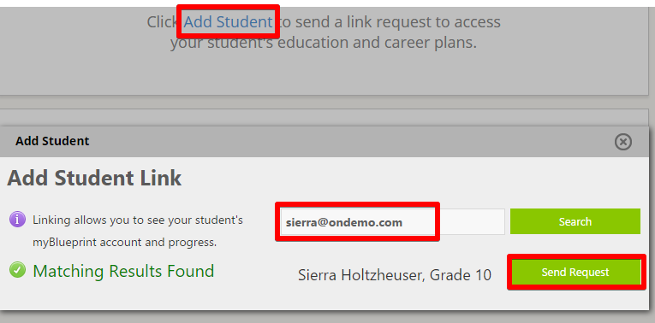
Don’t know your child’s email address?
You can always link to them later by following these steps:
- Log in to your account
- Click Add Student
- Enter their email address and click Search
- Once matches are found, click Send Request

- EXPLORE YOUR STUDENT DEMO ACCOUNT
From your Dashboard, click Go to Student View to access a demo student account to explore the features of myBlueprint.

- Click Go to Student View in the top right corner of your account
- Complete the five (5) Who Am I surveys
- Go to Match Results tab > Complete two (2) Compatibility Surveys
- Go to Home > Goals > Add a goal
- Go to Post-Secondary > Select a Pathway (e.g., College & University) > Favourite a program
- Go to Work > Occupations > Favourite two (2) occupations
- Go to Work > Job Search > Look up and favourite a job posting in your area
- Go to Home > Portfolios > Add a Portfolio > Name your portfolio
- Add an Avatar and a Banner image
- + Add Box > Add Media > Upload a picture/image that represents who you are
    - + Reflection > Give an explanation of how the image represents who you are
- + Add Box > Add Recent > Favourites > An occupation that you favourited
- + Add Box > Add Recent > Favourites > A post-secondary program related to the occupation you favourited
