Where to find valuable transition information:

www.tdsb.on.ca/goingtohighschool

The **Choices for 9** Guide is coming soon

until then, keep checking the link below for the updated version (on-line)

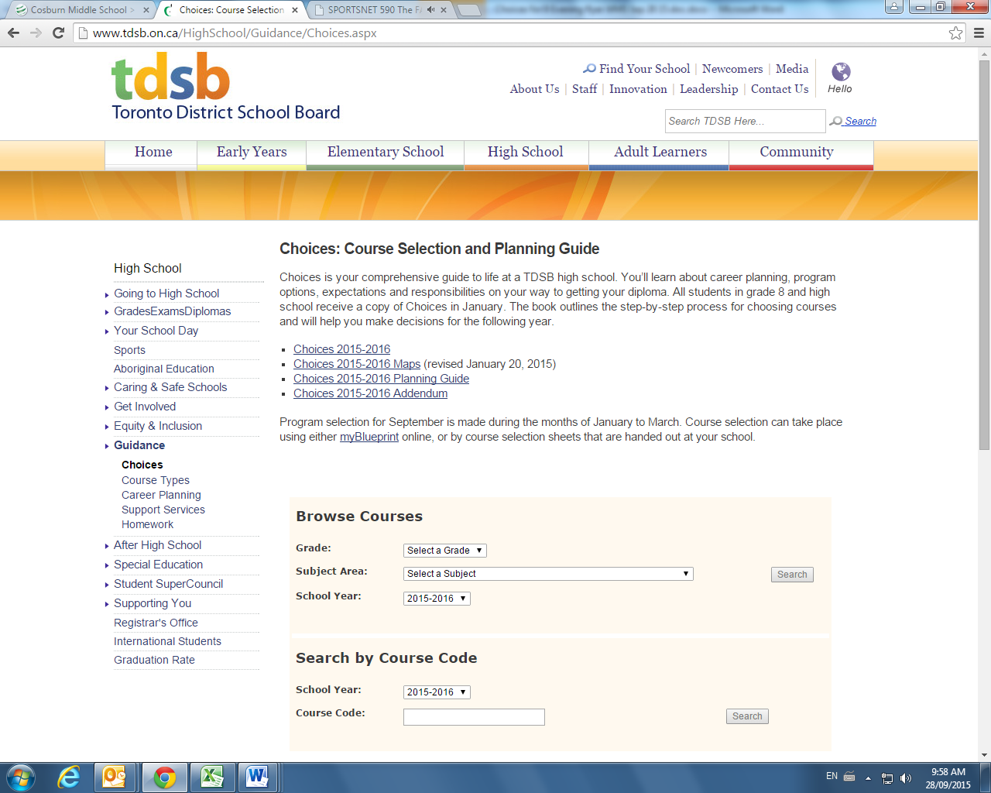

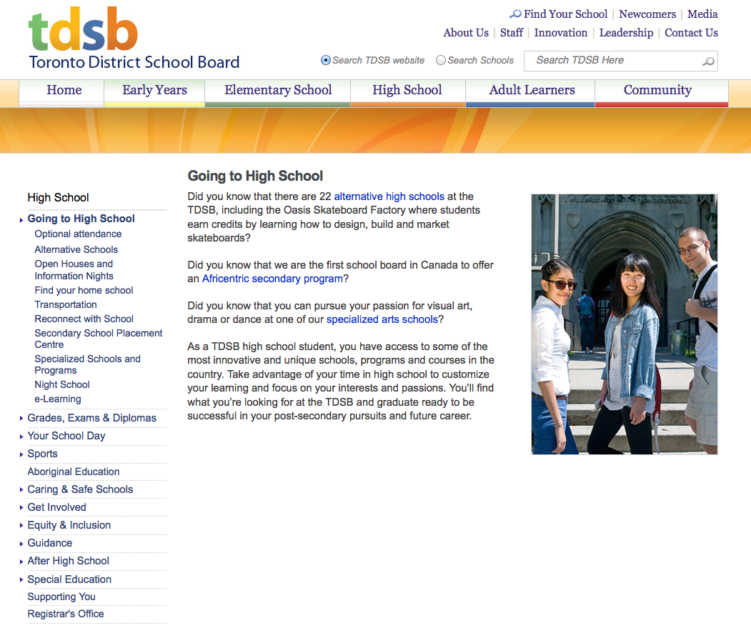

To do list:

🗹 Visit and explore the TDSB site: [www.tdsb.on.ca/goingtohighschool](http://www.tdsb.on.ca/goingtohighschool); all the information for “Choices for 9” is there!

🗹 Visit the East Region Guidance Blog [www.eastregionguidance.blogspot.ca](http://www.eastregionguidance.blogspot.ca)

🗹 Create parent account on myBlueprint1

🗹 Sign up for “Remind” App1

🗹 Complete Transition Profile Card

🗹 Plan to visit Open Houses at High Schools

🗹 Find Grade 7 June Report Card

🗹 Grade 8 students Logon to myBlueprint to begin surveys

🗹 Update your Agenda/Calendar for key dates

🗹 ASK QUESTIONS!

🗹 Understand Course Types: Academic, Applied and Locally Developed

Visit our LC3 Guidance Blog for High School Information and more:

[www.eastregionguidance.blogspot.ca](http://www.eastregionguidance.blogspot.ca)

High School Information evenings.

**The updated list is now available on our website!**

**St. Andrews PS**

**Mrs. Sandra MacInnis~Teacher/ Counsellor**

Sandra.MacInnis@tdsb.on.ca

*St. Andrews PS Schedule:*

*Day 4 PM*

Timeline

High School Information Evenings

Optional Attendance

Specialized Schools/Programs

Student Success

Promotion, Transfer, Retention

myBlueprint.ca

Course Selection

Information

Guidance

CHOICES FOR 9

Transition Planning for Grade 8 Students.

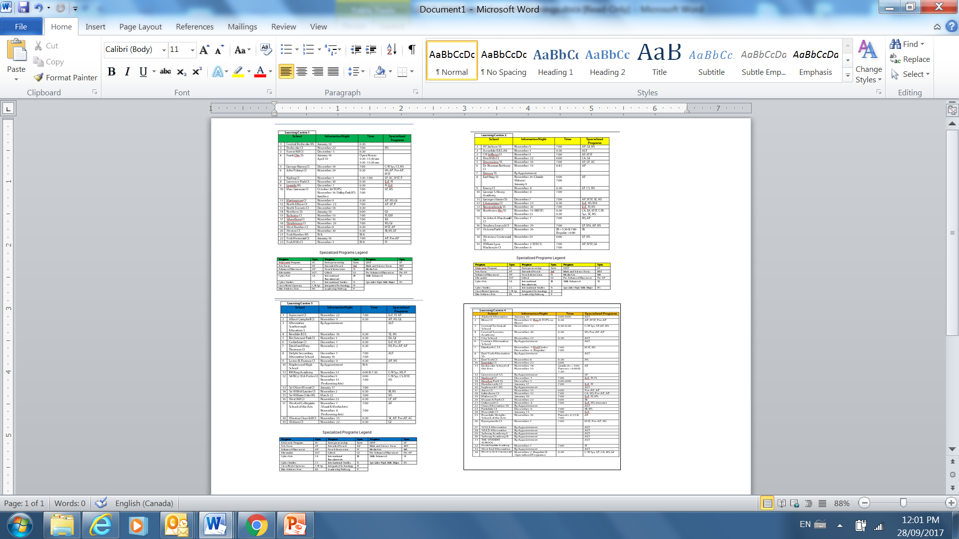

**Specialized Schools/Programs**

Students are allowed a ***maximum of 2 choices*** beyond their Home Schools and Optional Attendance options.

* These programs have specific and unique application requirements and due dates.
* Visit school websites to download and print application packages

**Optional Attendance** – Students interested in schools other than their Home School(s)

* Forms will be available week of December 11/17 ***(maximum of 2 choices per student)***
* Parents/guardians must deliver forms to selected schools ***no later than 4pm Feb. 2/18***
* High Schools render decisions by ***Friday, February 16/2018***

**Final Choices for 9 and Course Selection Form**

* Students who have been accepted by Specialized schools/programs, must adhere to those respective timelines and application requirements
* For students who don’t intend to apply to Optional Attendance or Specialized Schools/Programs, final Course Selection Forms must be completed online using MyBlueprint.ca and paper copy by ***Tuesday, February 20/2018***
* Students waiting for Optional Attendance or Specialized Schools/Programs decisions, must complete course selection by ***Friday, February 23/2018***
* Final Course Selection Forms delivered by Guidance to respective schools no later than

**Friday, March 2/2018**