Vision Clinic

Vision Screening Forms for student that require follow up were sent home before the Holiday Break. These forms should be returned back to the school by January 19, 2018
The follow up clinic is scheduled for Tuesday, Feb 27th 2018 at 9:30am at Parkdale PS.

Pizza Day

This month pizza day will be on Tuesday January 30, 2018 and February 27, 2018

Professional Activity Day

Friday January 19 is a PA day.

Report Cards/Parent Teacher Interviews
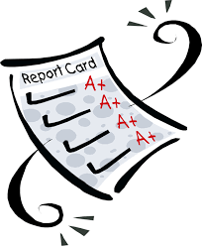
Term 1 Report Cards will be sent home on Monday February 12.

Parent-Teacher Interviews will be on Thursday February 15, 2018 in the evening and Friday February 16 in the morning.

JK/SK Registration

JK/SK Registration becomes “live” on February 1, 2018. Please see the link below for our JK/SK registration and more information.

http://www.tdsb.on.ca/EarlyYears/KindergartenMonth

Swimming
Ryerson and DVMA students are fortune to have the opportunity to go swimming once a week to learn water safety and develop their swimming skills. As it is part of the school programming, it is expected that students come prepared with the equipment (bathing suit, towel, goggles) each time their class is scheduled for swimming. If your child is not coming prepared repeatedly, you will be notified by their teacher. Your support allows us to continue to offer this important program.

Lost and Found

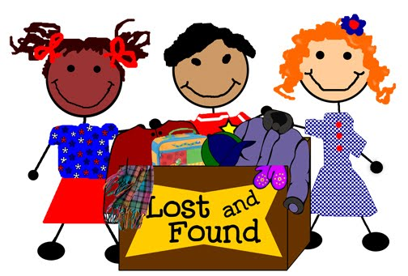
The lost and Found is filling up. Please be sure to check for your child’s belongings next time you are into the school. Labeling lunch bags, backpacks and coats can help get lost items returned quickly.

MJKO Boxing

MJKO boxing program will resume on Tuesday January 16, 2018.

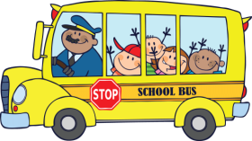
School Bus Information
If your child rides a school bus to school, please check https://www.torontoschoolbus.org/ for information about bus delays.

Safe Arrival

One measure of keeping our students safe is to ensure we can account for any absences or reasons for being late to school. We would like to remind you that if your child is going to be absent or late for any reason, we ask that you contact the school immediately and report the reason for the absence. If we are not informed about the absence, we will make attempts to contact you through our automated call-out system to determine the reason for the absence. To find out how this automated system works please visit

http://www.tdsb.on.ca/HighSchool/CaringSafeSchools/SafeArrivalProgram.aspx

Please let the office know by calling the school if your contact information, including phone number, changes at any time throughout the school year.

Thank you for your continued cooperation to keep your children safe and accounted for.

GATE TIMES

The gate connecting our school grounds to Alexandra Park is locked during the school day. It is locked from 9:00 am until 3:00 pm to accommodate school start and end times.

Nut Free School
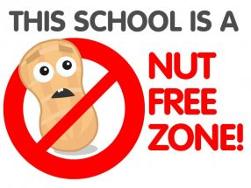
Families are asked to be careful not to send food with nuts of any kind to school. We have a number of students with life threatening allergies. Thank you for helping to keep students safe.

Making the Best of Winter Weather at our School

Fresh air and exercise are important for children. It keeps them physically fit, and helps them stay alert all through the school day. Parents can help by making sure their children come to school prepared to spend time outdoors. Hats, mitts, boots and a warm jacket are important to keep students comfortable during lunch and recess.

But extreme cold can be dangerous, and parents want to know that their children will be safe. When the temperature is predicted to drop below -15C, the City of Toronto may declare a cold weather alert. Schools are very sensitive to the needs of our students and pay close attention to the weather, especially when the windchill is below -20 C. When temperature and wind chill measure -28C or lower, students are kept indoors. Recesses and lunch hour may be shortened if the temperature and wind chill reading is between -20C and -28C. Canadian winters can be wonderful but when the weather is cold, school staff keep one eye on the thermometer and the other eye on the needs of our students - a perfect balance of fun and safety.

