Postcards from the Perfect Plot

Grade level: 4
Subject: Language
Keywords: writing, postcards, habitat

Description
Based on the book “Meerkat Mail” and referencing the information collected from your habitat explorations at Warren Park Outdoor Education Centre, students create
postcards from a traveling ani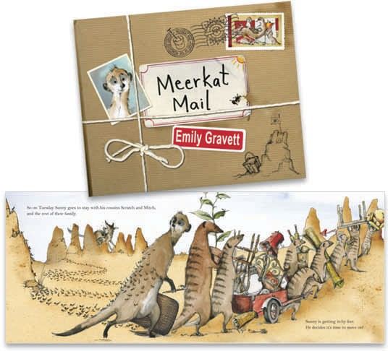mal that visits your school ground
looking for a new place to live.

Curriculum Framework Topic: Writing and Reading Strand: Reading, Writing, Oral and Visual Communication

Preparation
Preparation time: 5 minutes
Length of lesson: 20 to 30 minutes

Resources required:
- 1 blank postcard per student (3x5 cardstock or recipe card),
- rough draft paper, pencils,
- erasers,
- media of choice for postcard front,
e.g. pencil crayons, markers,
- Meerkat Mail, Emily Gravett, Mac- millan Children's Books (4 Aug 2006) ISBN-10: 1405052155,
- authentic sample postcards if
possible.
- Optional: Diary of a Worm, Doreen Cronin, Publisher: Joanna Cotler (August 14, 2003) ISBN-10: 006000150X

Procedure
- Discuss with students their experience receiving or sending postcards. Show authentic postcards and discuss purpose, interesting features, style of writing etc.

- Read Meerkat Mail, by Emily Gravett to the class. Discuss how the author used the post- cards to reveal the problems the Meercat was facing in each location. Include a discussion about the structure, form and style of the postcard writing.

- With the students, compare the Meerkat’s experiences with those of the wildlife living at Warren Park. What situations might occur for the wildlife to need a new place to live? Think what it might be like for one of the Warren Park animals to relocate to your schoolyard or neighbourhood.

- Have students choose an area of your schoolyard as the new location for one of the animals that normally lives at Warren Park.

- In the style of Meerkat Mail, invite students to create a postcard from an animal’s perspective complete with picture, address, return address and letter. Have students describe the habitat in which the animal finds itself, including the reactions to the location and troubles the animal may be having. Ask students to design a postcard picture that represents the habitat.

- Offer students opportunities to draft and revise their postcards using self, peer and teacher conferences to present their work effectively.

Discussion and Questions
- Ask students to compare postcards to letters or emails. Which one do they like receiving and why?

- Discuss with the students how has the author used text forms such as first-person record of events, thoughts and feelings and elements of style such as humour, alliteration, and descriptive words to help convey the mood or sensory impressions.

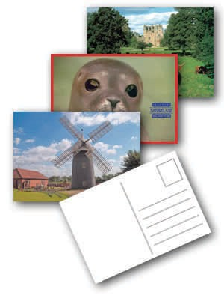Student Assessment and Evaluation
- Through this writing, students communicate the connections between animals and their habitat.

- Brainstorm with students criteria to evaluate the postcards from its literary style, visual communication and its content.

- Observe how the students communicate effectively the various environmental factors that affect animals through both the picture and the writing.

- Ask students to reflect and share in which ways they have used text forms such as first person record of events, thoughts and feelings and elements of style such as humour, alliteration, and descriptive words to help convey the mood or sensory impressions.

Enrichment and Extension Activities
- Use the collections of postcards to create a class book.

- Design an inquiry to determine what actually lives in your schoolyard or neighbourhood from vertebrates to invertebrates.

- As students learn about other living creatures that live in the schoolyard, continue to write postcards in role. Have students respond to each other’s postcards.

- Have students experiment with other media to create postcard picture, e.g. digital photos, watercolours, charcoal sketches etc.

* Adapted from The Etobicoke Field Studies Centre

