Library Plan and Budget Meeting Agenda
February 12th 630-730pm - Virtual

- Welcome and Attendance

Parents: Andrea Thompson, Brittani Jarivs, Sarah Welstead, Nicole,
Brenda S, Ashley M, Krista Speller, Telma, Farah H-M

Staff: Graydon

- Land Acknowledgment
We acknowledge we are hosted on the lands of the Mississaugas of the Anishinaabe, the Haudenosaunee Confederacy and the Wendat. We also recognize the enduring presence of all First Nations, Métis and the Inuit peoples.
- Library Update Plan and Budget Review

  - Proposed Budget
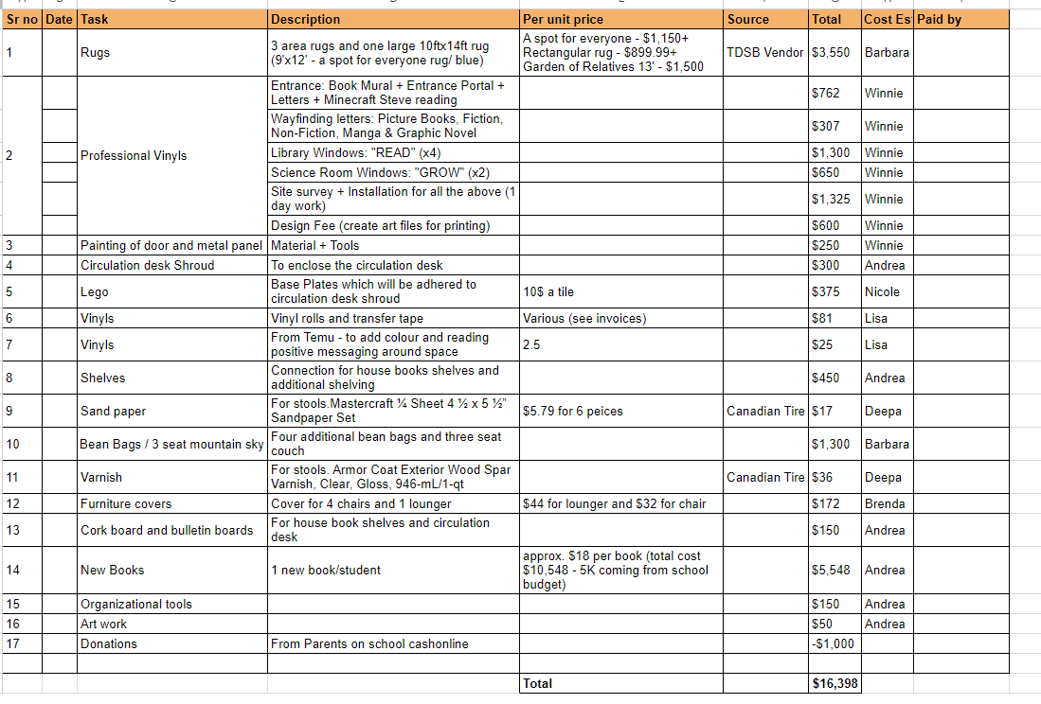

  - Design Plan
  - Tinlids – hope is to buy one new book per student. Suggestion box for kids to request. Will purchase about 1 book per student.
  - Student and Caregiver Engagement – peaking interest of many new parents.
  - Staff Feedback

Priority/Focus is on the books.

January 1st Overview - $19,000 that has not yet been allocated or spent.
Upcoming pizza day and Fun Fest are fundraisers. Purpose of Grade 5.

Discussion about whether we can do this in increments, with vinyls coming later. We will move the discussion/voting of the vinyls to March, when we have a better sense of exactly where they will go and what will be needed. (Ms Graydon indicates, for example, that she may need to double-check as to what we can place on the windows.)

Budget for library, without the vinyls, is unanimously approved.
We will revisit the vinyls expenditure in March meeting.

