MEETING MINUTES
October 23rd 630-730
Virtual

- Welcome and Attendance

Parents:
Andrea Thompson; Sana Ali; Ashley Mehta; Sarah Welstead; Brenda; Farah Hasham -Mackinnon, Nicole, Marjeta Linadi, Nkem Ononiwu, Tenika Francis, Indira, Melissa K,
Asvini K, Christina Miklosi, Jamaa, Robin Goyal, Tarush Goradia, Andrea, Sarah Kelleher,
Esmeralda Ismaili, Telma

Staff:
Ms. Graydon, Mr. Marrone, Mr. Allen,

Special welcome to our incoming Principal Barbara Graydon!

2. Land Acknowledgement
We acknowledge we are hosted on the lands of the Mississauga’s of the Anishinaabe, the Haudenosaunee Confederacy and the Wendat. We also recognize the enduring presence of all First Nations, Métis and the Inuit peoples.

- Principal’s Report - Barbara Graydon – (Inserted Remarks)

Windows
Checked in with the installers today and everything is going according to schedule. The classroom relocation has been working well when we have checked in. The new windows span the entire classroom and let in lots of natural light.

CCAT 7
Grade 3 testing is complete. Families will be contacted once results come in

Parent Concern Protocol
To support parent/guardian concerns the TDSB has outlined a parent concern protocol with 4 steps. This will promote positive problem solving - as always we encourage families to reach out to their child’s classroom teacher as a first point of contact. We will be sharing this protocol in an upcoming newsletter.

Safe and Caring
School-Based Caring, Safe and Accepting Schools Teams
Looking for a parent volunteer - Team will meet every other month or as concerns arise. Support items such as the creation of a school based code or conduct / bullying intervention plan (prevention, intervention and postvention)

- Treasurer’s Report (Ashley and Telma)
- Budget Summary and Projections

Approx 60K in the bank and the following expenses have been allocated for the 2023-2024 school year:
- Scientists in School (1 per classroom) ($7000)
- RAZ kids ($4000)
- Staff allocation ($150/teacher)
- Skate program ($800)
- Grade 5 Graduation ($1500)
- Movie license ($450)
In addition to Pizza expenses which is 21K

Available funds after allocations: $14,777

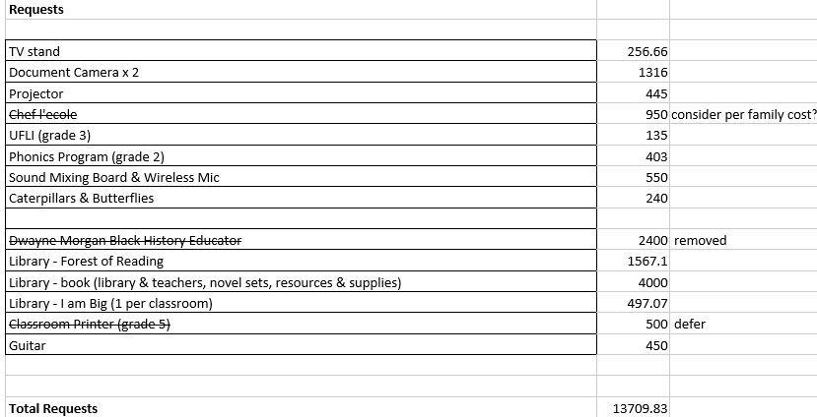

Detail to some of the above requests:
- Forest of Reading – Canadian Authors which is a reading book club.
- Broken musical instruments Mr. Zalameda
- Chef lecole – culinary experience for grade 5’s
- Literacy program for grade 2s – manipulatives – University of Florida Institute
- Document Camera – demonstrate procedures – projects on to big screen - for all staff
- “I am Big” about a boy venturing into hockey – equity text – ask from equity committee

WFSA Vote on additional spend as per spreadsheet above.

Fall Fest anticipated: $5000.00

- Health and Safety Update (Sarah K.)

- Equity Committee (Andrea)
- Errol Lee performance overview - not making the connection with the children. Most parents expressed it was to long and boring and missed the mark. We want to create the message of community and respect, and we will need to brainstorm on what we can do next.

- Fundraising & Events Committee
- Ms. Shergill’s School Supply Drive – Will discuss next meeting.
- Grad Committee – discussed fundraising for cookies earlier in the year so it can go towards grad trip.
- Fall Fest - thank you to organizers!
- Movie Night Overview - Thanks to Ashley! It was a great free community event that all enjoyed!

- General Business

- Community Fund Allocation - Increase Community Fund and ensure people are aware of it. We had $1500.00 – this was used to buy fruits and snacks for the school for those children that don’t have these items. We did not use much of the funding for trips. Overall – we spent about $620 but we will still allocate ethe $1500 for this year.
- Skating Program - $800 allocated to this program.
- Send permission forms home soon!
- Get fittings done in November and possibly no sharpening this time.

- Adjournment

