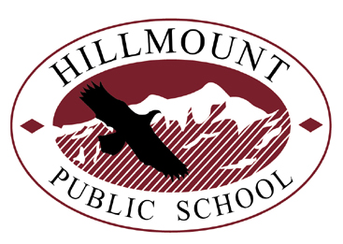

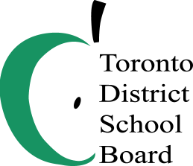

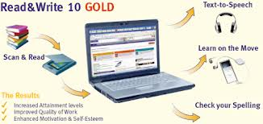
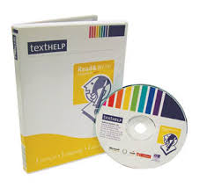
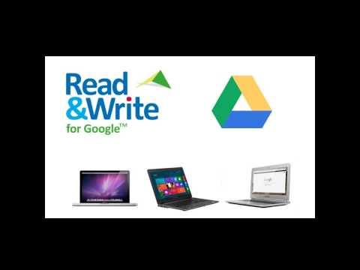

IMPROVE YOUR CHILD’S STUDY AND LITERACY SKILLS:

Read and Write Gold uses a simple floating toolbar to provide all the necessary tools to support students in their reading, writing and research skills.

Some of the Features of Read & Write Gold include:

*word prediction

*text-to-speech

*grammar and vocabulary builder

*picture and word dictionary

*research skills

*pronunciation tutor

and many more…

Instructions and password will be provided to download this program free of cost on your PC or Mac computers.

Cayla Biderman
& Monica Joshan
Presenters:
:
Date: Wednesday, June 4, 2014
Location: Arbor Glen Public School
55 Freshmeadow Drive
Time: 6:00 - 7:00P.M.
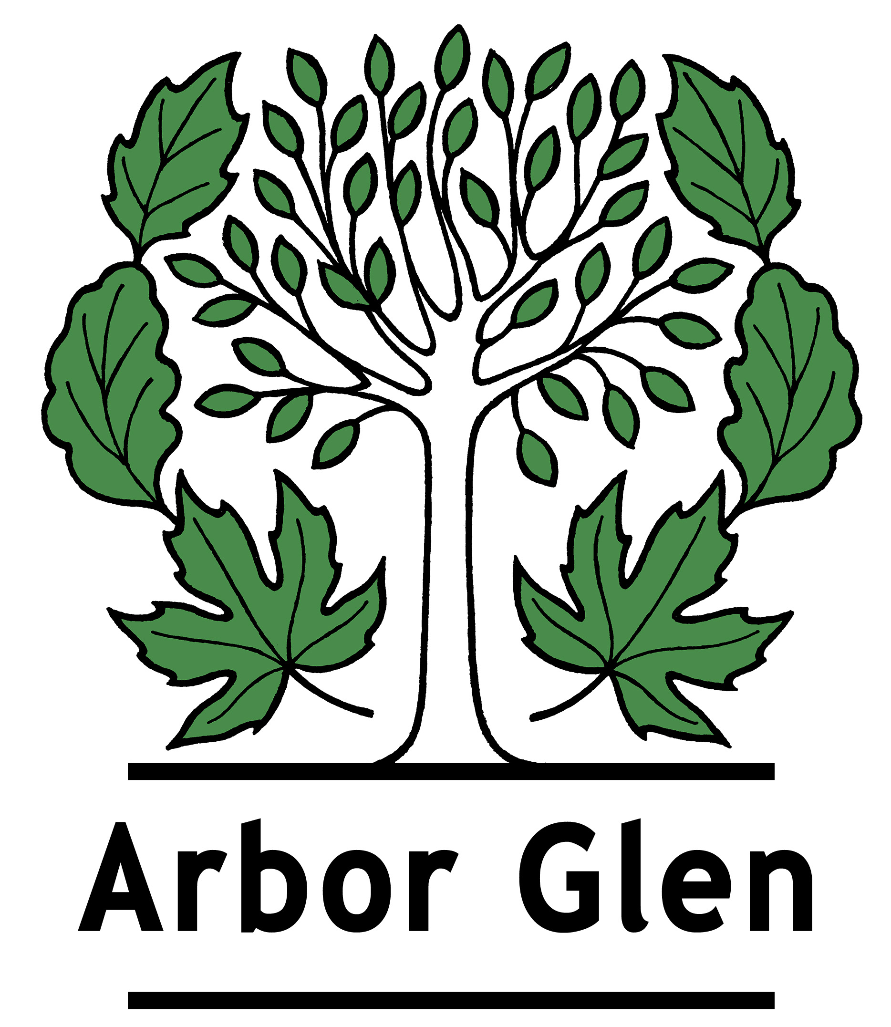

Please contact Monica Joshan
to confirm attendance
+ babysitting needs

Monica.Joshan@tdsb.on.ca
(416) 395-2020

