Pan Am Games Art Project
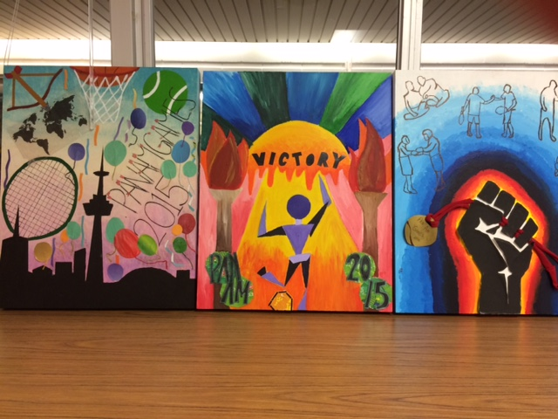
This year Zion Heights along with 11 others in the TDSB created artwork for the 2015 Pan Am Games in Toronto. 3 panels were chosen and were created collaboratively by our grade 9 Visual Arts students.
This work will be featured and displayed in the players’ lounge at the games and may also be featured on billboards around the city.
Congratulations to our fabulous art students who once again have made Zion proud!
Dadmehr D,
Amara S.,
Stirling C.
Crystal C.,
Michael L.,
Leran L.
Cassie L.
Arron L.
Ms. Horvath

