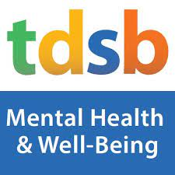

Winter Well-Being Guide

In this Guide..

Supports for Mental Health and Well-Being

TDSB Professional Support Services Mental Health and Well-Being Winter Programs

Supports and Resources for Youth

Winter Programs and Activities for Child/Youth

Ideas for Keeping my Child/Youth Active this Winter

Resources for My Child/Youth with Special/Complex Needs

TDSB Resources for Mental Health and Well-Being

As we head into the Winter Season, there may be excitement as well as thoughts and feelings that bring forward a need for support. Our Winter 2023 Well-Being Guide is a place to learn about Culturally Responsive and Identity Affirming resources and activities to make the most of this time of year, while supporting and improving our mental well-being. The Canadian Mental Health Commission suggests:

- Don’t underestimate the power of sleep. It impacts our whole self: mind, body, and spirit.
- During winter, we may feel the impacts of getting less sunlight. The sun’s ultraviolet rays help us produce vitamin D, which is vital for our mental health.
- Self-care is also very individualized. It’s not just about bubble baths, spas, and exercise. It includes things like healthy boundaries, healthier food choices, making those medical appointments, decluttering your space, creating a budget, calling a friend, and so on
- Paying attention to our senses helps bring us back to simpler times, come back to the basics and, after a few deep breaths, feel a lift in our spirit!
- Are your thoughts healthy for you, or are they making you unhealthy? It’s easier to get into bad mental habits during winter’s short days and long nights.
- Put your pen to paper and write. No matter what is happening, there is always something to be grateful for.
- Finally, remember to seek help from a mental health professional or family doctor, if you or a loved one is struggling.

TDSB Professional Support Services Mental Health and Well-Being Upcoming Programs & Events

Throughout the Year, TDSB Professional Support Services Staff will be offering a number of opportunities that promote well-being, community and connection. Please follow the links to find out more!

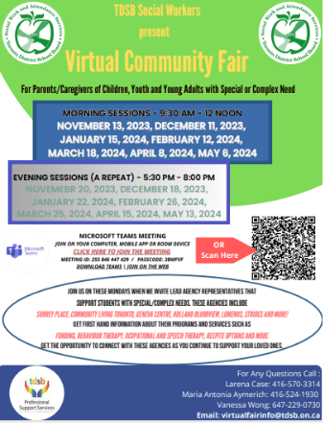
TDSB Social Work and Attendance Services is offering monthly Virtual Community Fair’s that highlight and share resources for the community which support complex and special education students at the TDSB. Find out more here!

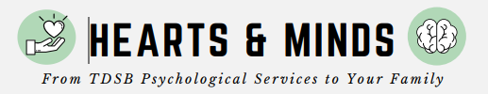
The TDSB Psychological Services team provides updated knowledge and information pertaining to student well being and achievement in their quarterly Newsletter “Hearts and Minds”.

A video series and related resources have been developed by TDSB staff and expert facilitators to offer coping strategies during war and conflict to support the emotional and mental wellness of students, parents/guardians/caregivers, staff, and the broader community. Visit the Affinity Wellness webpage for videos and resources

The preliminary results of the 2023 Student census have been released. Look out for the full report in Early 2024

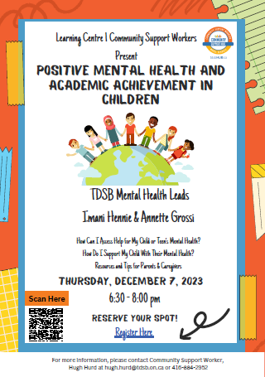

The TDSB Mental Health Leads, in collaboration with TDSB Community Support Workers in learning Centre 1 present a webinar on Positive Mental Health and Academic Achievement. Link here to find out more!

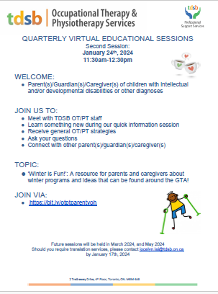
The Occupational Therapy and Physical Therapy Department invite Parent(s)/Guardian(s)/Caregiver(s) of children with intellectual and/or developmental disabilities or other diagnoses to their quarterly sessions. Meet with OT/PT and find out about some of the services they support and how to connect with Community resources. Check Calendar for upcoming dates!

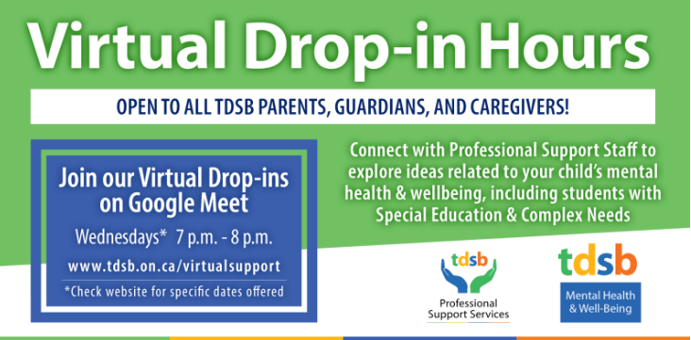
Monthly Virtual Drop in office Hours for Parents/Caregivers and Guardians of TDSB students. Come meet with various Professional Support Services to discuss ways to promote well being for students.

Save the Date for Let’s Connect! The Parent Partnership Committee of TDSB will have their “Let’s Connect - Feel Good February” on February 22, 2024. Look out for registration details here!

TDSB’s Gender Independent Groups (“GIG”) are groups for families with trans, Two Spirit, non-binary and/or gender diverse children in grades K-6.

Supports for Mental Health and Well-Being

Access Culturally Responsive & Relevant Resources compiled by the TDSB MHWB Committee.
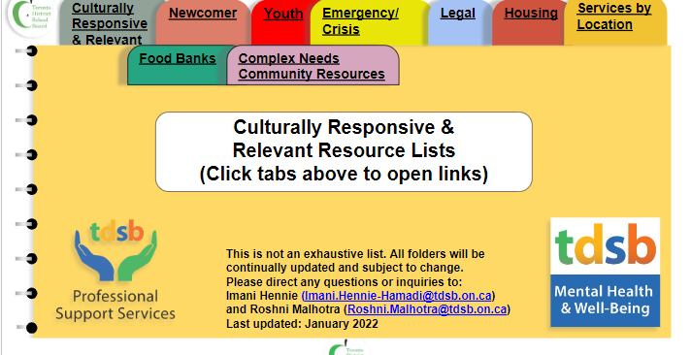

Across Boundaries – Provides equitable, holistic mental health and addiction services for racialized communities.

HelpAhead – Connecting infants, children, youth and families to mental health services in the Toronto community.

Children's Mental Health Ontario – Find resources to help support children and youth mental health.

Daily Bread Food Bank – Search your local area by postal code/location to access food.

Government Financial Supports:
Canada Dental Benefit
Some other benefits which may be available to families

Kids Help Phone – Find youth resources based on where you live.

Lumenus – Mental health, developmental and community services.

Bob Rumball - Mental Health Treatment for Deaf and Hard of Hearing Children/Youth and Families Bob Rumball Canadian Centre of Excellence for the Deaf

SickKids – This hub provides resources to help support your child's mental health and general well-being.

YouthLink – Youth/family counseling, parenting support, shelter/housing, education and community-based programs for ages 12-24 and their families.

211 Central – Find community and government services where you live.
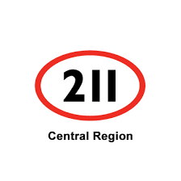
Helping your Child Manage Digital Technology -School Mental Health Ontario
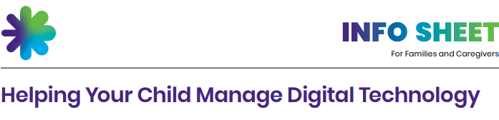

Supports & Resources for Youth:

Helplines and Services In the case of an emergency please call 9-1-1 or visit your local hospital emergency room

9-8-8- Suicide Crisis Helpline - A safe space to talk 24 hours a day, every day of the year. Call: 9-8-8 or Text 9-8-8

Black Youth Helpline – A multicultural helpline and services for children, youth and families. Available from 9am-10pm everyday.
BounceBack® – A free cognitive behavioural therapy (CBT) program that offers mental health self-help support for those 15-17 & older. Toll free: 1-866-345-0224.

Hope for Wellness Helpline – An Indigenous Youth Helpline. 24 Hour / 7 days a week Phone Support.

Kids Help Phone – Find youth resources based on where you live. 24 Hour / 7 days a week Phone/Text/Chat Support.

LGBT Youthline – Confidential, non-judgmental and informed LGBTTQQ2SI Peer Support. (Sunday - Friday) 4pm-9:30pm Text/Chat Support.

Naseeha – Mental health hotline, resources, workshops, web therapy and more for Muslim and non-Muslim youth/individuals. Phone Support daily 12pm-3am.

What’s Up Walk-In Clinic and One Stop Talk – Free virtual and in-person counseling for youth. Follow the link to find locations Monday - Saturday (hours and days can vary by location)

Woodgreen – Offers social, employment and academic support for youth, persons with developmental disabilities, and caregivers/families. Free single session counseling by phone or video for ages 16+ (12-15 years requires parent/caregiver consent).
Available Tuesday in person and Wednesday virtually. Registration from 4:00-6:30 pm. Call (416) 645–6000 ext. 1990

Trans Lifeline – a peer support phone service run by trans people for trans and questioning youth and adults. There will be a two week pause in service and will resume January 1st, 2024 starting with Monday to Friday 1pm-9pm 1-877-330-6366
Youthdale - Community and in-patient services for children, youth, young adults and families struggling with complex mental health needs. Crisis Service Line available 24/7 416-363-9990

Supports and Resources for Youth
Mental Health Info | Self-Care | Social Media and Screen Time | Managing Substance Use | Managing a Crisis
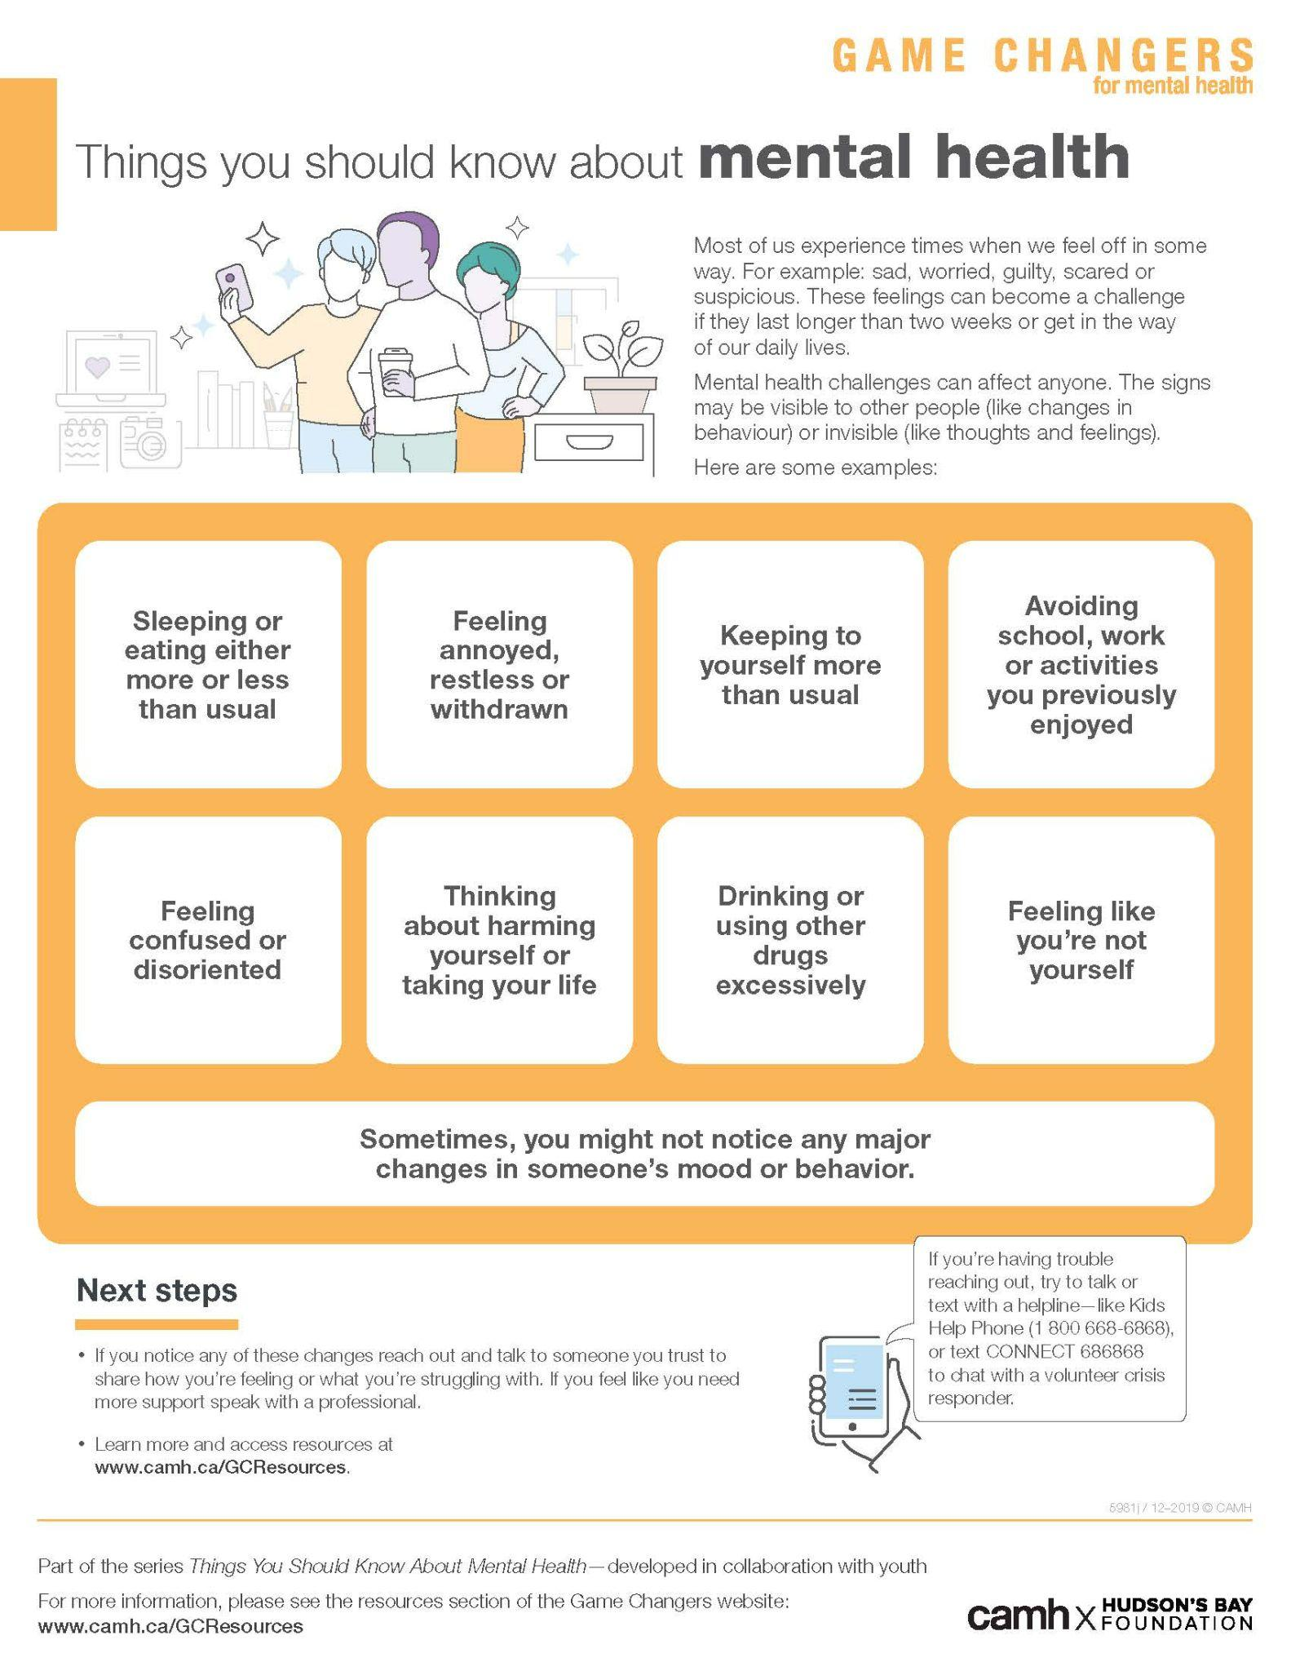  Things you should know | 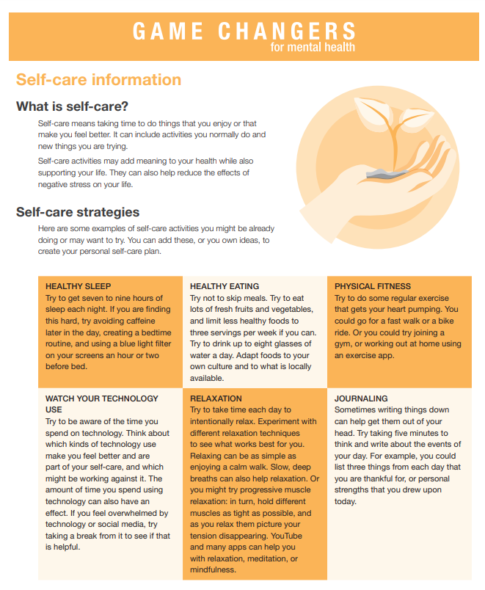  Self-care information | Healthy Social Media Habits | 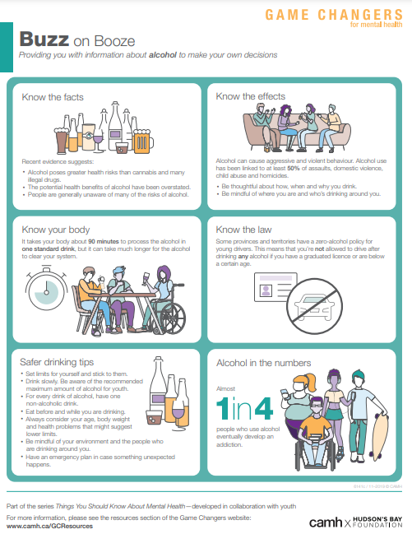  Buzz on Booze | 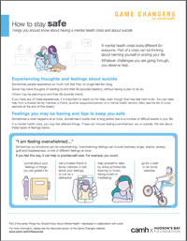  How to stay safe
Sleep and mental health | 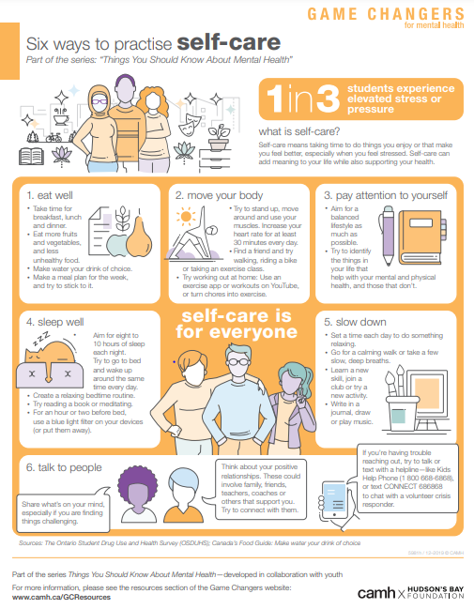  6 ways to practice self-care | A Teen’s Guide to Social Media Safety | 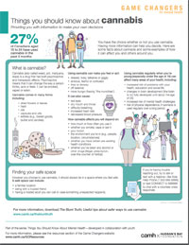  Things you should know about cannabis | 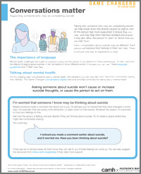  Supporting someone considering suicide
Mental health: Learning Hub | 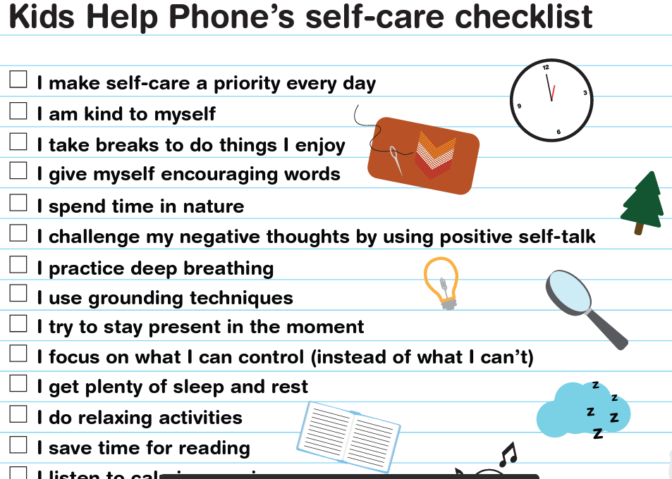  Kids Help Phone: Self-care checklist | 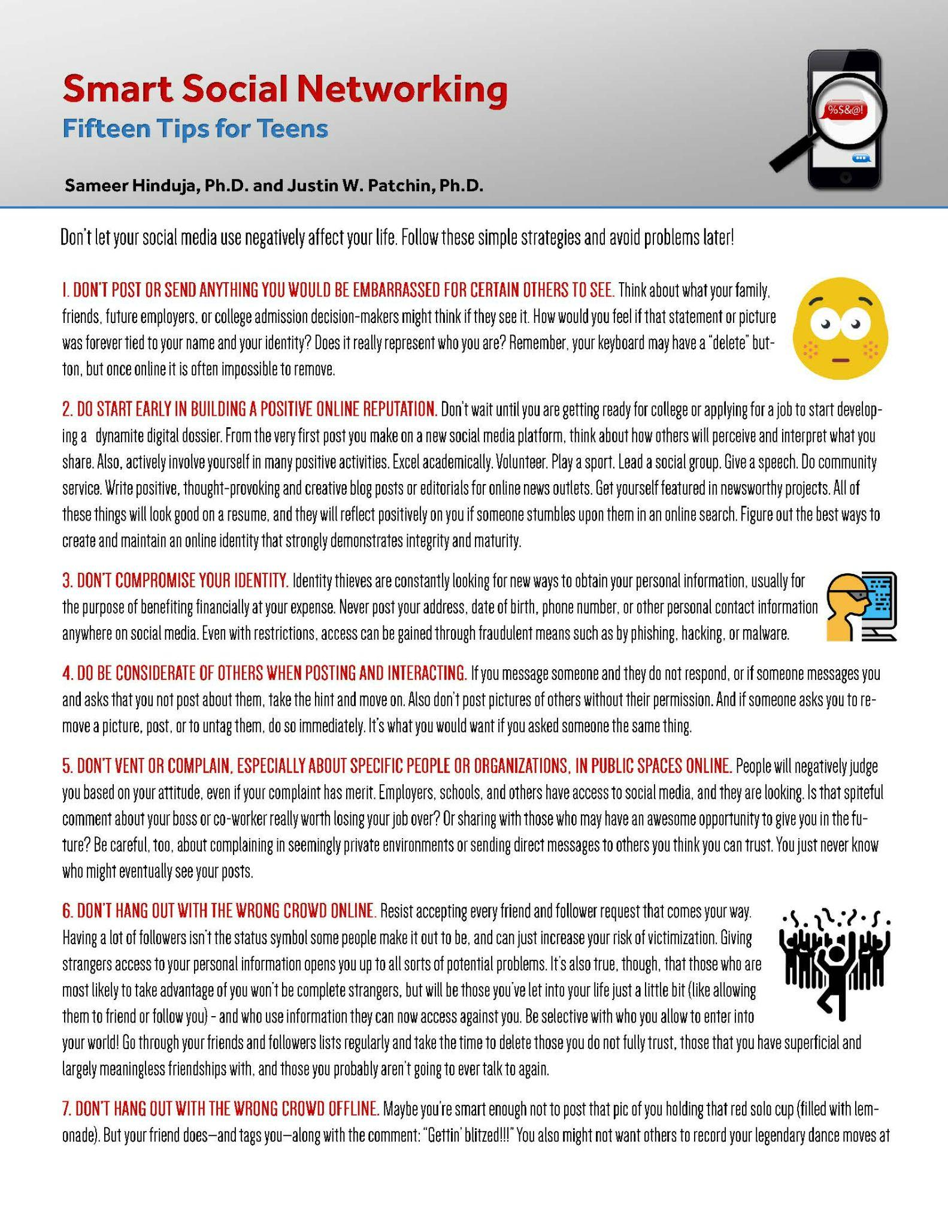  Smart Social Networking | Vaping: What you & your friends need to know | 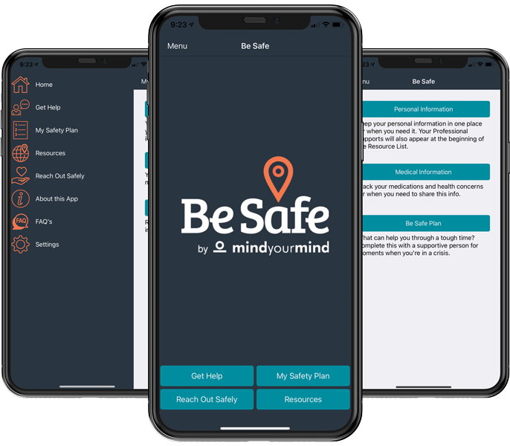  Be Safe App
Coping During War and Conflict  Affinity Wellness Videos | 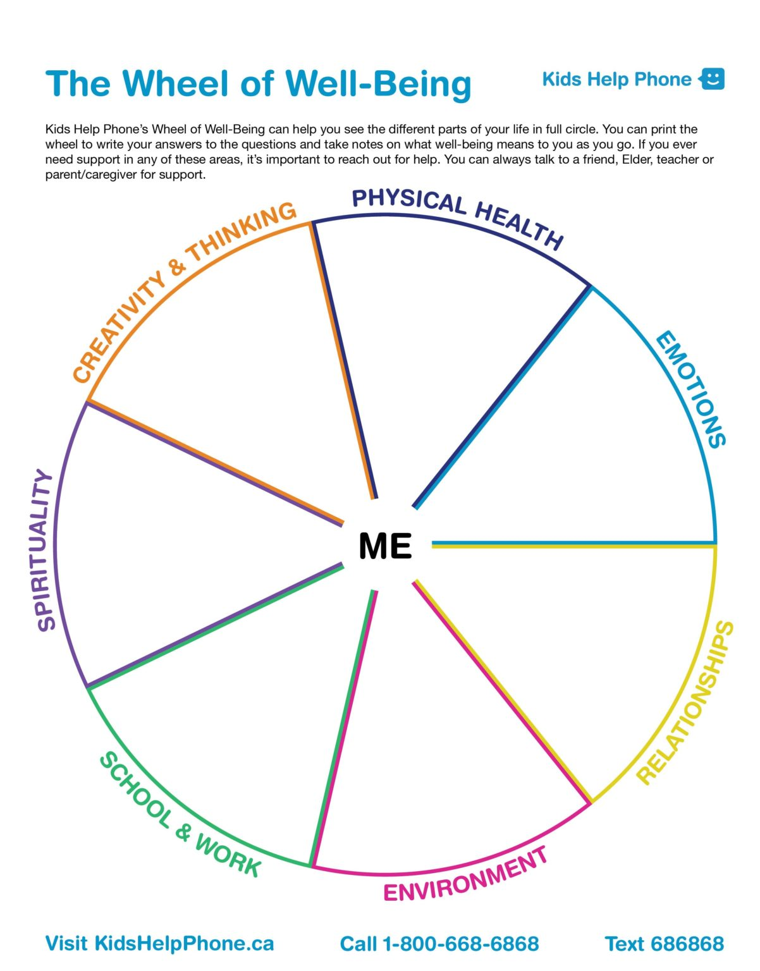  Wheel of Well-Being | Screen time: Overview | 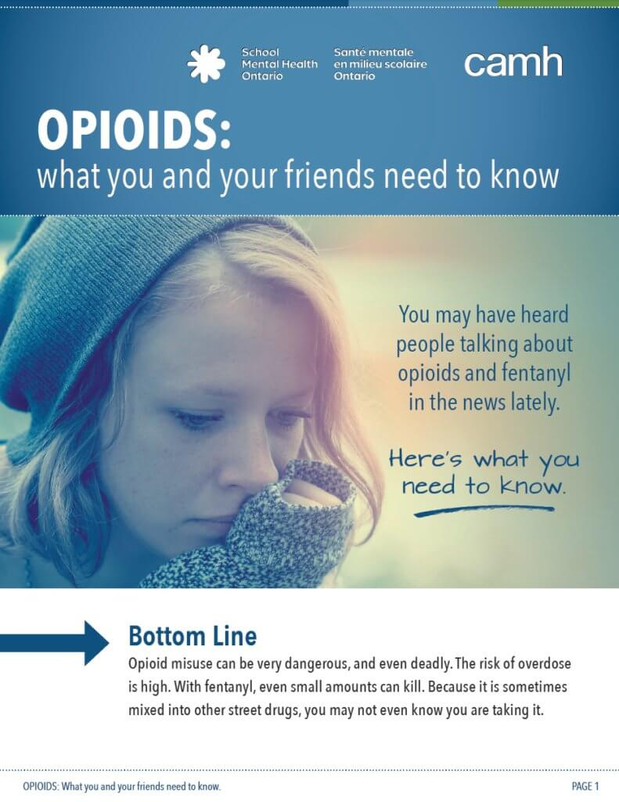  Opioids: What you & your friends need to know | Self-injury: What it is and how to cope
Help for Youth | What is Mindfulness? | 5 online safety tips | Fentanyl facts | 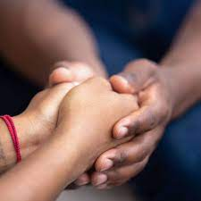  How to help a friend navigate
I Don’t Know What’s Wrong | 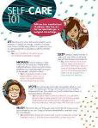  Self-Care 101 | Online gaming | Taking care when using substances | In Crisis

Winter Programs for My Child/Youth
Winter Recreation Programs

Toronto Public Library – Information about programs, classes and events.
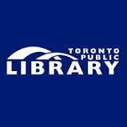

Winter Wonderland at the Toronto Botanical Garden - Winter Camps are offered for campers 4 to 12 years of age. PA Camps are designed for campers 5 to 10 years of age
(November 27, 2023 - April 12, 2024)
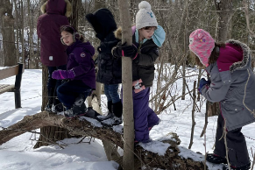

Winter Recreation Programs – Free, high- quality recreation activities for all ages, including CampTO

Kids Out and About.com – Online guide for kids, teens, and families living in Toronto including local events, camps, day- trip ideas and more!

YMCA of Greater Toronto - Programs for people of all ages and life stages including child care and family development, health and fitness, camps and outdoor education and youth programs. These are fees for service with subsidy options.

CNIB Virtual Programs – Free virtual programs available to all Canadians who are blind or partially sighted, as well as their families, friends

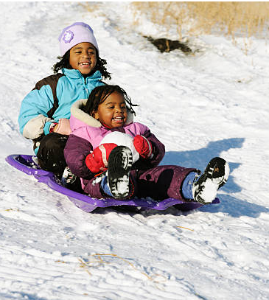

Ideas for Keeping My Child/Youth Active

This Winter

Backyard Camp – Year round activity ideas to do at home.

Cosmic Kids – Free, online yoga and mindfulness for kids

Heart and Stroke – Tips for eating healthy and keeping active.

ParticipACTION – Encouraging Canadians to get healthy by getting active since 1971.

SPAC Learning Library – Online video lessons and activities designed to help you be creative at home.
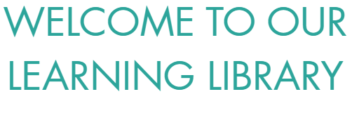

Welcome to Ontario Parks – Information about visiting Ontario Parks.

YGym – Virtual physical activities.

Yoga with Adrienne – Free yoga and mindfulness videos.

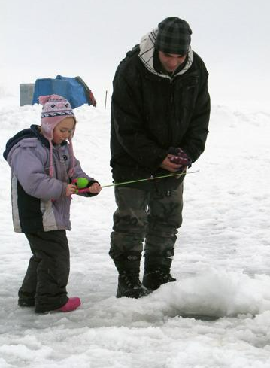

Supports and Resources for Children/Youth with Special/Complex Needs

Community Living Toronto – Offering many programs to support individuals with intellectual disabilities and their families.

Geneva Centre for Autism – Offering groups and programs for children and webinars and support for parents.

Holland Bloorview Family Resource Centre - Access helpful tips and information for caregivers and parents of children with disabilities.

Surrey Place Family Resources - helps people of all ages with developmental disabilities, autism and special needs reach their full potential

Kerry’s Place - has been creating, and providing evidence-based supports and services across the province of Ontario that enhance the quality of life of those with ASD.
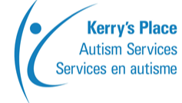

Connectability - A website and virtual community dedicated to lifelong learning and support for people who have an intellectual disability and their families.

Lumenus – Offers a broad range of high quality mental health, developmental and community services for infants, children, youth, individuals and families across Toronto.
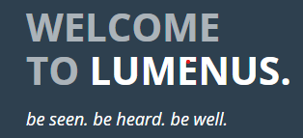

Meta Centre – Offering a wide spectrum of services and personalized supports to help people live inclusive, engaged and enriched lives in the community.

Miles Nadal JCC – Offering programs for children and youth with ASD and other developmental disabilities.

MyCommunityHub.ca – A search engine for activities available in the community for children and youth with developmental disabilities.

Supports and Resources for Children/Youth with Special/Complex Needs continued

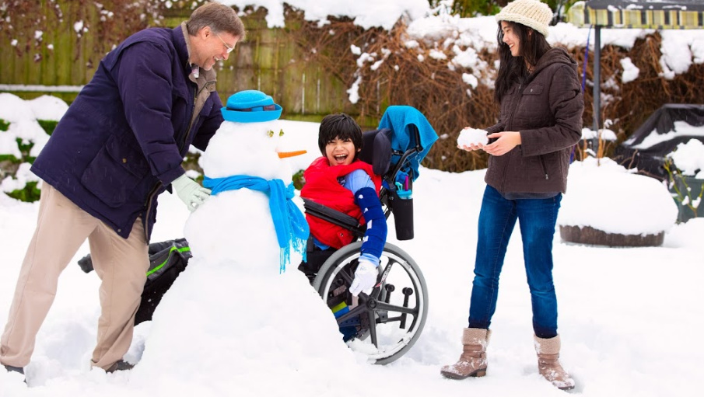
SAAAC Autism Centre – we build inclusive communities through culturally responsive autism practices and accessible programming.

Toronto Parks and Recreation Adapted Programs – To ensure the most enjoyable recreation experience families must first contact the Adapted and Inclusive Recreation Programs central hotline at 416- 395-6128 to apply for and receive a membership.
Variety Village – Variety programming empowers children with disabilities to be seen, participate, and feel included. We bring accessible facilities to life with sports, fitness, activities, camps, skills training and coaching for competitive and Paralympic athletes

Information on accessible parks and camps

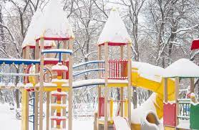
_____________________________________

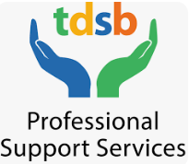

TDSB Occupational and Physiotherapy resources for play and leisure fun at home

TDSB Psychology resources for families of students with complex needs

TDSB Speech Language Pathology tip sheets

TDSB Supports and Resources for Mental Health & Well-Being

Please visit our TDSB Website to access a comprehensive list of resources and supports.
Spend some time exploring our interactive lounges and virtual field trips for Students, Parents & Caregivers, and Staff.

Access our interactive Children's Mental Health Week resource kits for elementary and secondary students, students with complex needs, parents/caregivers and educators.
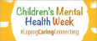

Access Culturally Responsive & Relevant Resources compiled by the TDSB Mental Health and Well-Being Committee.
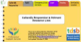

Access our Black Mental Health Week Resources from the March 2023 week of recognition for Black Mental Health Week in Toronto. Look for updates in March 2024
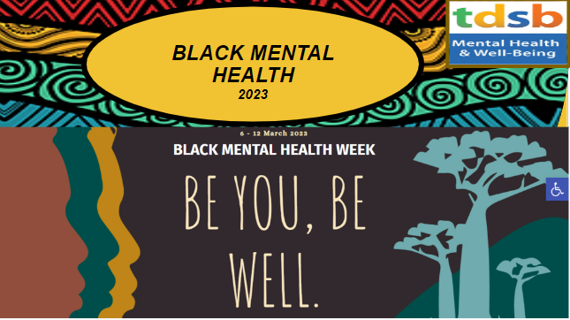

This slide provides access to 2023-24 MHWB resources for all grades.
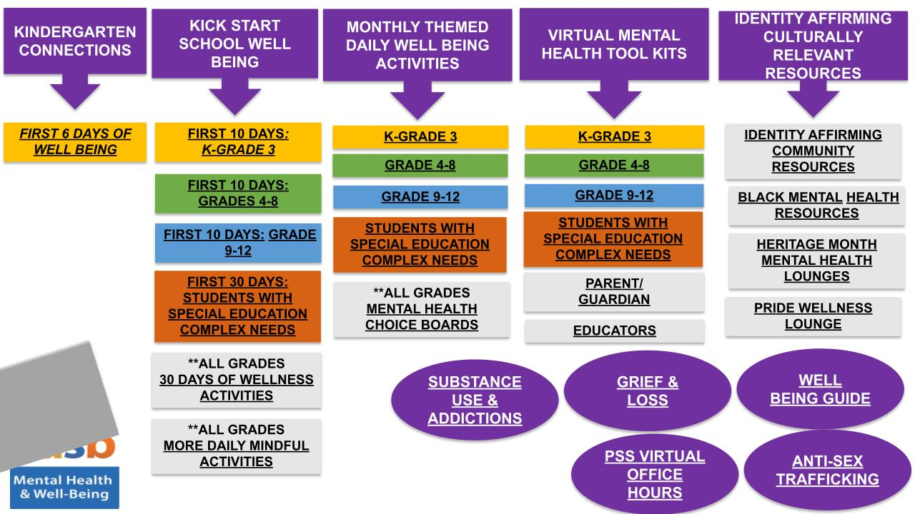

Visit these introductory guides to Mental Health (Elementary and Secondary) on the Virtual Library and other Library Learning Resources.

TDSB Learn4Life – Health & Wellness Programs. (18+ Learning Opportunities)

Find our more about TDSB Professional Support Services Google Sites:
- Child and Youth Services
- Occupational Therapy and Physical Therapy Services
- Psychological Services
- Speech Language Services
- Social Work and Attendance Services

Stay Connected!

Information is always changing. Please be sure to follow us and check back in for the latest updates.

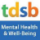 | https://www.tdsb.on.ca/Elementary-School/Supporting-You/Mental-Health-and-Well-Being-Professional-Support-Staff-PSS
 | Email: MentalHealthandWellBeing@tdsb.on.ca
 | @tdsb_mhwb
 | @TDSB_MHWB

If you or someone you know is experiencing a mental health or substance use emergency, call 9-1-1 or go to the emergency room of your local hospital or call 9-8-8 for Crisis Support.

