HOLIDAYSPIRITWEEK!!!

GET READY FOR THE:

Show your school spirit from December 19th-23rd on these different spirit days:

PJ Monday!!!



Jersey Day

Tuesday!

BACKWARDS WEDNESDAY!!!!

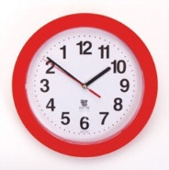

RED AND WHITE FRIDAY!

Crazy Hat& &HairThursday!