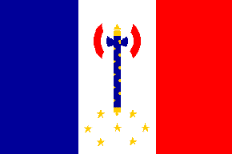
Vichy France
1940 - 1944
By: Carmen Mei

What is Vichy France?

- English name: also known as Vichy Regime or French Regime
- French name: L’État Français Régime de Vichy
- French government from 1940 to 1944 during the Nazi occupation of France in World War II
- The Franco-German armistice divided France into two zones:
- Vichy France
- Occupied France

Flags

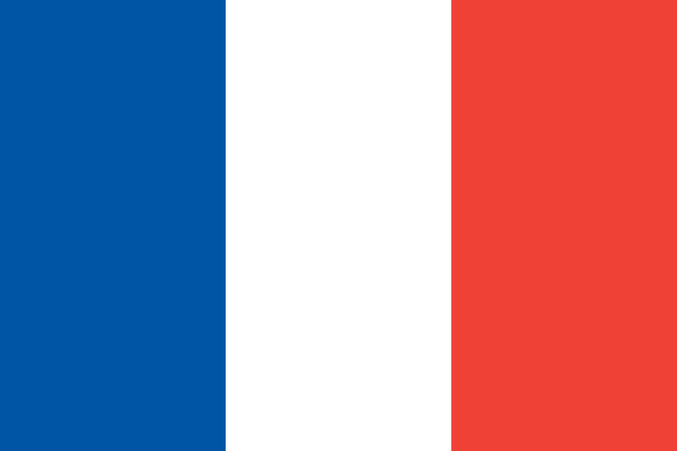
France Vichy France

Where did “Vichy” come from?

- Vichy came from its government’s administrative centre in Vichy, located southeast of Paris
- Paris still remained the capital of France
- Pétain did intend to return the government how it was like before the invasion of the Nazis where it was possible, of course, it wasn’t easy because, the French would first have to go through the Germans

Where did “Vichy France” come from?

- On June 16, 1940, the National Assembly faced imminent military defeat by Germany, so:
  - Full power was given to Marshal Philippe Pétain
  - He suppressed the parliament and immediately turned the regime into a non-democratic government by collaborating with Germany

Who is this Pétain?

- Henri Philippe Benoni Omer Joseph Pétain (April 24, 1856 – July 23, 1951) was a French general, later was Head of State of Vichy France, from 1940 to 1944
- Pétain became the last prime minister of the Third Republic
- He was viewed as a hero in France, due to his military leadership in World War I, but his actions during World War II resulted in a conviction and death sentence for treason

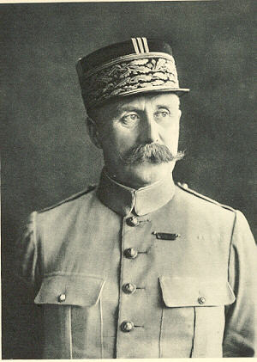

Philippe Pétain or Marshal Pétain

How it all started…

- After Germany defeated France in the Battle of France, French surrendered and collaborated with Germany
- Parts of its land under German occupation and Nazis’ control

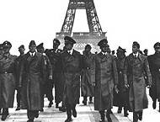
← The Battle of Britain

The Battle France

- Also known as the Fall of France
- Fought on May 19, 1940 and ended on June 22, 1940
- Germans’ goal was to invade France
- France declared war on Germany on September 3, 1939 following the invasion of Poland
- After 8 months of Phony War, the Germans launched their offensive in the west on May 10, 1940
- Within days, it was clear that French forces were overwhelmed and the military collapse was imminent (expected)
- French government and military leaders were so shocked by the debacle, Prime Minister Paul Reynaud, wanted to move the government to French territories in North Africa, and continue the war with the French naval fleet and the resources of the French empire
- Others, particularly the vice-premier Henri Philippe Pétain and the commander-in-chief, General Maxime Weygand, insisted that the responsibility of the government was to remain in France and share the misfortune of its people

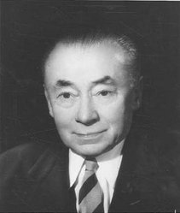
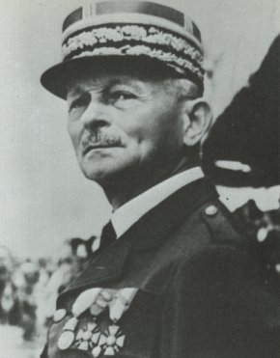
Paul Reynaud Maxime Weygand

Result of the Battle of France

- French surrendered
- Pétain decided to collaborate with the Nazis
- Portion of France was under the Nazis rule
- Occupied France
- Vichy France

Conditions of Armistice

- Armistice divided France into two main zones:
- Occupied zones – northern and western of France (including the entire Atlantic coast) that were under German rule
- Unoccupied zone (zone libre) – remaining 40% of France governed by the French government with the government’s capital at Vichy, under Pétain

German →
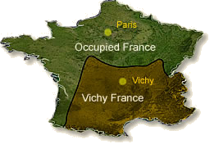
→ Pétain

State collaboration with Nazi Germany

- “Collaborationists” were French citizens eager to collaborate with Nazi Germany
- "Pétainistes“ refers to the French that support Marshall Pétain, no being keen to collaborate with Nazi Germany, but they accepted Pétain’s State Collaboration
- State collaboration was illustrated by the Montoire (Loir-et-Cher) interview in Hitler's train, on October 24, 1940, during which Pétain and Hitler shook hands (photographed) and agreed on this cooperation between the two states
- Nazi propaganda made strong use of this photo to gain support from the civilian population
- October 30, 1940, Pétain officially announced state collaboration, declaring on the radio: "I enter today on the path of Collaboration..."
- June 22, 1942, Laval declared that he was "hoping for the victory of Germany."

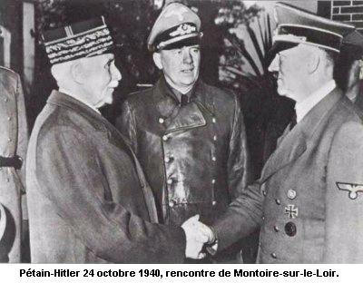
Pétain and Hitler shake hands to welcome new partnership

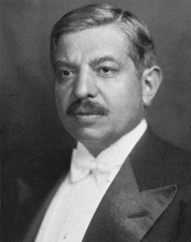
← Pierre Laval was part of Vichy France, previous Prime Minister of France
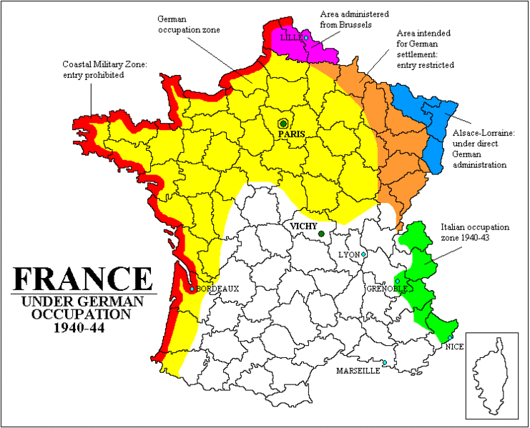
The yellow portion is the land occupied by German, in which Germany had won from the Battle of France.

Conditions of the State Collaboration

- Germans exaggerated how France was in much better shape and disciplinary than the unoccupied area, in spite of all the devastation
- French under the Germans’ rule have fallen into the Nazis’ “sphere” and influence
- Problems were so serious that France was beginning to lose their national identity
- Jews, Gypsies, homosexuals and even random people, were either sent to concentration camps, tortured, or even murdered
- French that opposed or disagreed with the Germans would also suffer the same consequences but even worse, their relatives and friends were being tortured
- Children suffered from seeing the dead bodies of their parents being removed and killed for such innocent reasons
- All French and Germans were to sell out people that did not obey the commands of the Germans, or else, if they were caught protecting their friends or relatives, they too would be punished
- Neighbors were warned to not harm or go against the Germans
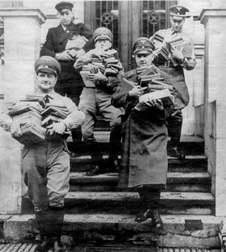 ← Nazis went door–to–door to command new rules.

- Spies were sent to investigate on suspicious French

If one was caught not loyal to the Nazis, he/she would suffer!→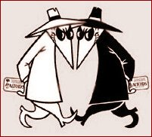

Nazi-German Concentration Camps

- Young children were beaten to death if something was done wrong
- People could just be suddenly killed without a reason
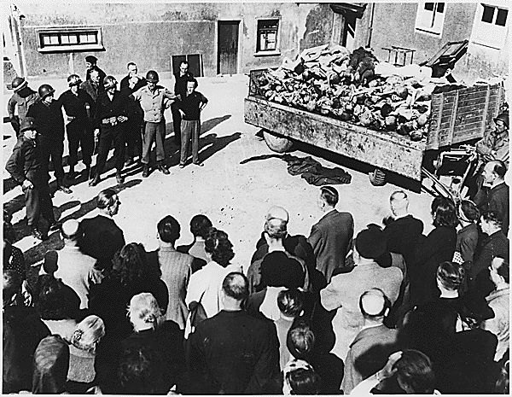
← Even the innocent were sent to concentration camps.

Focus Question:

If the French knew from World War I that Germany was such an irresistible country, why did Pétain still agree with state collaboration?

Why State Collaboration?

- French did not have a choice
- German military was expected to defeat France
- If France did not join with Germany, Nazis would continue to their aggression towards France, so then France would be in danger of attacks and invasion
- Under no other solution, French surrendered to Germany and Pétain agreed to state collaboration because:
- If French did not surrender, Germans would continue to attack France until they surrender
- This ensured that all French were secure and safe from mass destruction from bombing and invasion
- France had primarily thought that Germans would defeat Britain so that it would not be the main power of Europe

Why was Pétain disregarded?

- Many French did not agree with state collaboration, even though it could have saved France from being invaded once again from Germany if they had collaborated with each other
- Germany still invaded France and tortured many French people
- Pétain believed that France would be good “partners” with the Germans, but the Nazis still punished the French for small and stupid reasons
- State Collaboration failed and Germans still killed many innocent French

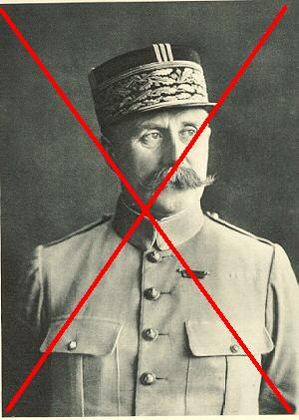
← Pétain was once a hero, but now, he was a disgrace.

Vichy France to an end…

- Ended in 1944
- Pierre Laval and Pétain were both convicted and sentenced to death by firing squad
- Other members of Vichy France were executed or sentenced to death as well
- Turning point of France, where the French were free from German rule

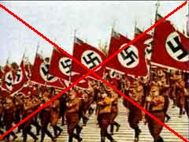
← After the execution of the members of Vichy France, France was free from the Nazis’ rule!

QUIZ TIME!!!! XD

1. How was France divided after the collaboration with Germany?

a) Northern France and Southern France
b) Vichy France and Occupied France
c) France Republic
d) New France

2. Who were photographed shaking hands?

a) Hitler and Pétain
b) Pétain and Paul Reynaud
c) Paul Reynaud and Maxime Weygand
d) Paul Reynaud and Hitler

3. What was another name for The Battle of France?

a) Bomb the Enemies
b) Kill Hitler
c) Fall of France
d) Vichy France

4. Who was the head of the Vichy government?

a) Hitler
b) Mr. Woo
c) Pétain
d) Paul Reynaud

5. Although Vichy France focused on two main zones, which country did the third division of France belong?

a) Australia
b) China
c) Canada
d) Italy

6. What is the meaning of fascism?

a) a government of authority under the rule of a dictator
b) a place where all citizens are commanded to only eat one meal a day
c) a region where no animals are to be killed
d) a government with powers to kill politicians with bad ideas

7. What was Pétain’s full name?

a) Henri Philippe Benoi Joel Pétain
b) Henri Phillio Benjamin Pétain
c) Henri Philippe Benoni Omer Joseph Pétain
d) Henri d’Estragon François Joseph Pétain

8. What is the French name of Vichy France?

a) Le Stat de Vichy France
b) La Revolution de France
c) La Nouvelle Pays de Vichy
d) L’État Français Régime de Vichy

Bibliography: Vichy France

Websites

Eyewitness to History.com
- http://www.eyewitnesstohistory.com/francedefeat.htm
Digger History – Vichy France
- http://www.diggerhistory.info/pages-enemy/vichy.htm
The Algeria Hotel: Frame, Memory and WWII
- http://www.diggerhistory.info/pages-enemy/vichy.htm
BBC.com.uk
- http://www.bbc.co.uk/history/worldwars/wwtwo/launch_ani_fall_france_campaign.shtml
University of Sunderland – State Collaboration
- http://www.sunderland.ac.uk/~os0tmc/occupied/collab.htm
Youtube.com
- http://www.youtube.com/watch?v=RVByTVhxBt8
- http://www.youtube.com/watch?v=Hq2JDa50Y_o
FunTrivia.com
http://www.funtrivia.com/flashquiz/index.cfm?qid=121998

