How Can We Improve Math Test Review?
BY MICHELLE RUSSELL · 11/06/2016
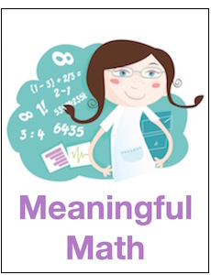One of the goals that I set for myself this year was to try to improve my formative assessment practices. In some ways I feel like I’ve made progress.
I have been incorporating more formative assessment, and I’ve been trying a variety of methods. Overall, I think the results have been positive.
Logically, working on formative assessment has led me to question some of my summative assessment practices too.

To review or not review?
To begin with, I am not sure I know the best way to prepare students for a test. At times, I feel like the valuable classroom minutes I spend reviewing for our class tests are mostly wasted.
I can’t help but wonder, with so many concepts to teach, would it be better to forego reviewing for the test? In fact, a fellow math teacher at my school has decided against spending a day on test review in favor of using those extra days to get to more new material.

“Gallery Walk” for test review
For the last test that I gave, I did provide a day to review. My students completed what I call a gallery walk. There were math problems posted on chart paper around the room that I taped on my whiteboards. Students were put in groups of three, and they walked around the room and worked through each problem together.
Students actually worked the problems on the whiteboard and then erased their work before they rotated to the next problem. I provided students with paper and clipboards if they wanted to make notes along the way.
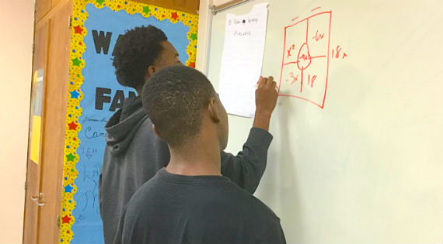
As the students worked the problems, I walked around the room observing and providing hints and suggestions. Some groups wanted me to look at their work before they moved on to see if their answer was correct, but most students were content to reach a consensus within their group.
As students left the room for the day, I provided them with a written copy of the problems (with worked out solutions) so that I could be sure that they had a complete guide to study.

What did the students think of the “Gallery Walk” test review?
After the students took the test, I asked them to fill out a survey discussing the effectiveness of our review strategy and to provide suggestions for future test review. The majority of students stated that the review was helpful in preparing for the test.
Many of the students remarked that it was working with other students that helped them the most. One student said that it helped to have “a group of people that could explain it to me in a way that I could understand.” Another student said that “I liked that I could realize if I didn’t understand something.”

However, some students shared that they did not enjoy “group work for studying.” One student said that it was not helpful because only one person in their group could answer the question and that if you didn’t understand the problem, “you were stuck.”
Another student mentioned feeling rushed and I can’t disagree. Our class periods only last about 50 minutes and it’s very challenging to fit it all in. Another student said that it would have been better if they could have seen the correct answer before moving to the next problem.

Areas for improvement
I noticed that, within the groups of three, one member usually took the lead writing the problem and working it out on the whiteboard. However, many times the students that weren’t writing were coaching or critiquing the work that was being done which produced some good math conversations.
Even so, if I do this again I will stipulate that group members take turns with the dry erase marker, perhaps giving each member a different color marker, and that way I can color code each problem so that students will remember to take turns when working out the problems.
Also, I need to think of a way to let the students see the correct answer before they move to the next station but not before they have had a chance to work on the problem.
In addition, this activity needs a conclusion. The students did have time to cycle through all the problems in our gallery walk, but there was not time for a wrap up or debrief session. Also, students were not given an opportunity for any meaningful reflection.

Other types of test review
I realize that this is not a particularly exciting or “fancy” way to review for a test. I have tried many other review strategies. At times I have had students create their own test, based on our material, and that has yielded good results. However, I generally like to build up to that level of autonomy, and at this point in the school year my students still need help knowing how and what to study.
For our previous test this fall, the students engaged in “speed dating” to review. I have also created Jeopardy games to help students prepare for testing, and I have tried many variations on wastebasket (“trash ball”) review and numerous other review games.
I know for a fact that students do enjoy review games and become engaged in competing with their classmates. In fact, last week one student suggested that we should play a game such as Kahoot with candy as the prize. I will probably review this way again.
However, many times I feel that the students remember more about the game than the content (concepts) I’m trying to reinforce. I prefer to use Kahoot! and similar games for formative assessment as opposed to test review. I also have been thinking about using Kahoot! after students take the test to reinforce questions that the majority of students may have missed.
In math, I have found that Kahoot! works better for problems dealing with concepts or shorter answers.

What’s next?
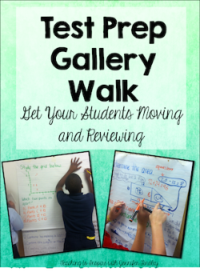
Jennifer Findley’s technique
So, I will continue to try to improve how I prepare my students for a test. I have learned any review which requires students to be the active participants trumps me working the problems on the board with the students just watching.
If you are interested in doing a gallery walk for test review, this is a great resource from Jennifer Findley that I found while looking around for ideas to help me improve!

