SAM News Flash for the Week of October 28, 2019

Dear Parents/Guardians:

We want to share our learning and experiences with you. We are so excited to share what has been happening at SAM this week!

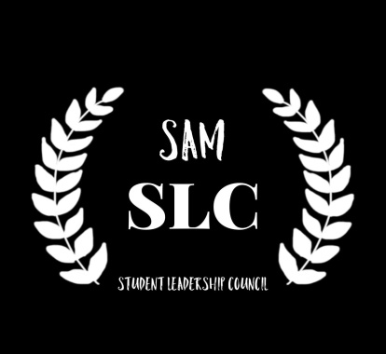 | On Monday, October 28 our student leaders were planning serious and fun activities for our student community. Their first event to organize was the Halloween Dance which would take place on Thursday, October 31, 2019.
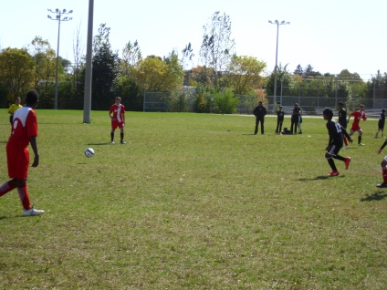 | On Tuesday, October 29, SAM Boys Soccer team played at the TDESAA City Championship. The boys made great progress in becoming the Conference Champions last week. At the Championship they demonstrated their team spirit and sportsmanship. Great job!
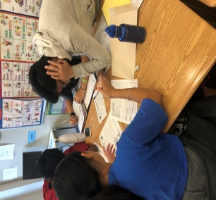 | SAM Eco Warriors Club met on Thursday, October 31, 2019. They kept on getting ready to educate their classmates how to protect the environment and be eco-friendly.
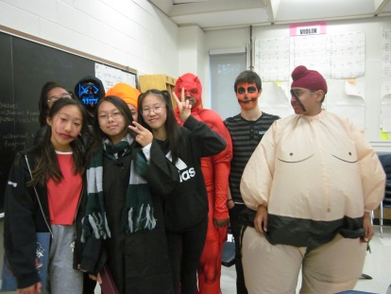 | On Thursday, October 31, our students were celebrating Halloween. They came dressed in different costumes and had fun during the Halloween Dance.
Remember to visit our school website: https://schoolweb.tdsb.on.ca/alexmackenzie/ for more great news!!!

