SAM News Flash for the Week of October 7, 2019

Dear Parents/Guardians:

We want to share our learning and experiences with you. We are so excited to share what has been happening at SAM this week!

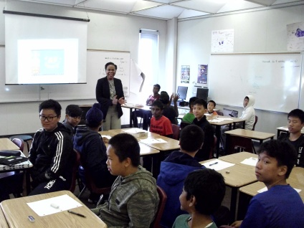 | SAM teachers continue their great job providing the best educational experiences to our students. They go out beyond the expected to ensure that every student receives excellent instruction and learns to the maximum of his/her potential.
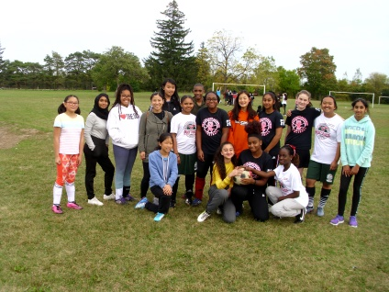 | On Tuesday, October 08, 2019 SAM Girls Soccer Team played at a TDESAA Soccer Tournament. The students demonstrated excellent team spirit and sportsmanship. They now know what it means to be a team.
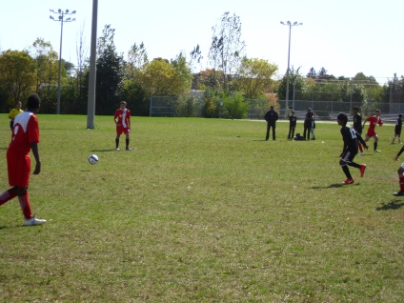 | On Wednesday, October 09, 2019 SAM Boys Soccer Team played at a TDESAA Soccer Tournament. The boys tried hard. All the training that they had worked and the boys won!
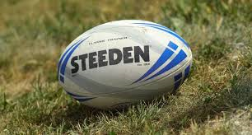 | On Thursday, October 09, 2019 SAM Touch Football Team took part at a TDESAA Touch Football Tournament. The students played well, they demonstrated great team spirit and sportsmanship.
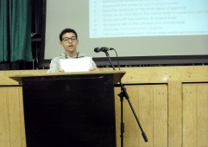  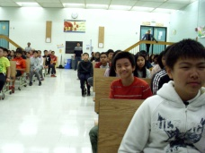 | On Thursday, October 09, 2019 our students participated in the SLC Executive Group Elections. The candidates presented their speeches and the students voted to choose the best one for the position. It was a good lesson for everyone how to exercise their democratic rights and make the correct choice.
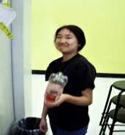  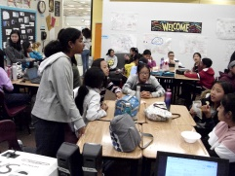 | SAM Eco Warriors Club met on Thursday, October 10, 2019. This time they decided to increase the plastic bottles danger awareness. It is a serious problem and affects everyone.

Remember to visit our school website: https://schoolweb.tdsb.on.ca/alexmackenzie/ for more great news!!!
Please also stay sign up to Eco Warriors Club’s Twitter: @SAM_Ecowarriors

