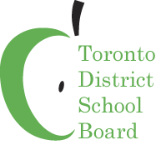


Homework Help & School Support has arrived!

The Ministry of Education and the Toronto DSB have partnered to expand an exciting free online initiative to support all students registered in grades 7-10 at TDSB schools.

Do you have a child registered in grades 7-10 who struggles to understand how to find slope? Maybe your teenager is struggling with ratios? Extra help is now available.

Free Online Math Tutoring Available


In the evening, your child can get math support at Homework Help. Your
child can now log in to Homework Help Sunday-Thursday, 5:30 p.m. to 9:30 p.m., for one-on-one math tutoring. There are interactive discussion rooms for each grade where students can view a current lesson, watch tutors draw on the whiteboard — and then type their own question.

Other math resources on the Homework Help website include videos of teachers leading students through the 20 most commonly asked math problems, interactive math tutorials and highlights of best sessions. All students have a virtual locker, where their work is saved in video format for viewing anytime.

Free Online Curriculum Resources Available To Support Students
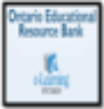
The Ontario Educational Resource Bank is also available to support your child. This databank houses thousands of math resources, including computer activities, lessons, along with tests and quizzes. You may search for resources by grade, subject/course, strand, overall expectations, resource type and/or keywords.

To enter this database:
Username: tdsbstudent
Password: tdsb

Stay Informed…

Check out TDSB Math Matters. This resource is dedicated to keeping teachers and parents informed about what is happening to support students involved in the Homework Help.



