SCIENCE LITERACY DAY AT RYERSON
Article by Jisu Kim Pictures by Anu Bhujel

On September 21, 2017, we were privileged to have the wonderful opportunity to take a trip to Ryerson University. In the morning we heard from two featured Ryerson scientists outlining their research and recent developments in the field of biochemistry. In the afternoon we participated in different activities involving chemicals (they were safe) and had a tour of the main building.

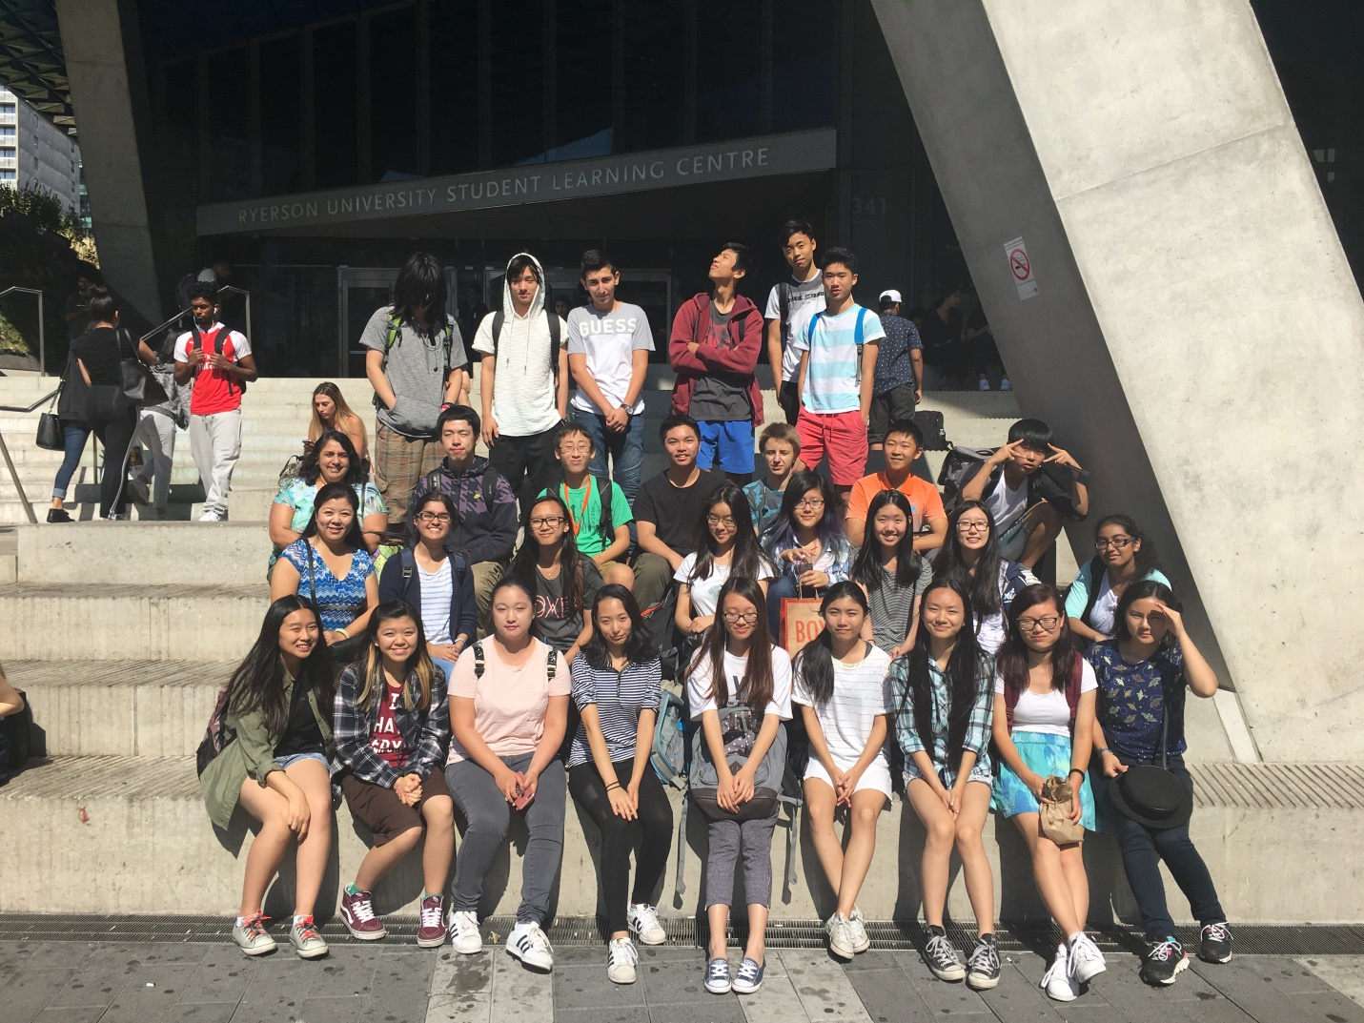

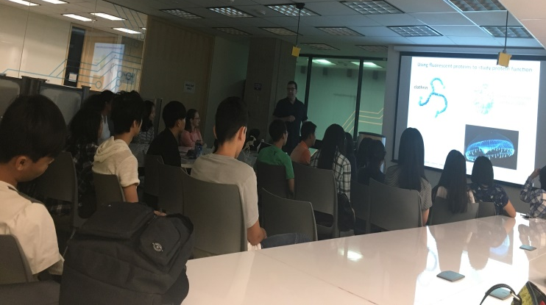
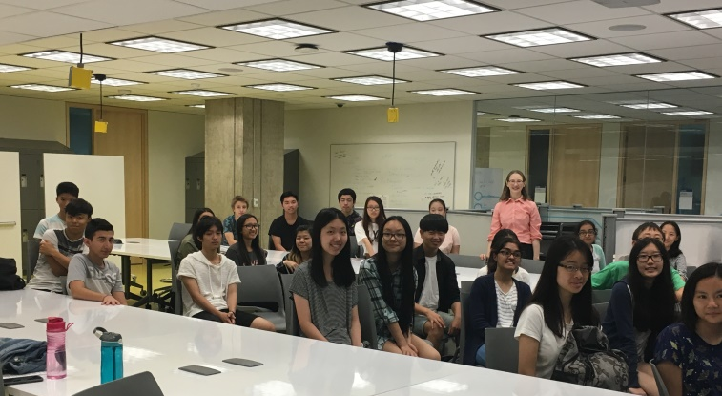
During the first component of trip we had two interesting lectures in the discipline of biochemical study and its effect on our contemporary world.

The second lecturer Dr. Antonescu discussed biochemistry and computer visioning. He discussed how both normal and cancer cells multiplied.

The first lecture was by Dr. Sabatinos on cell cycle checkpoints and imaging. She discussed how to use models with yeast cells to further the study on cancerous cells.

Both of the lectures were intriguing, prompting questions from our class about different possibilities to defeat cancer and potential problems one may confront while using one of the proposed methods. This provided us with a deeper insight and made us think about the relevance of what we are studying in school.

In the afternoon, we had time to explore different workshop booths at Ryerson University and tour the campus.

One of the booths that a lot of students visited was with dry ice creating bubbles. We also scooped soap bubbles created by butane and lit our hand on fire. We even had the opportunity to watch and eat ice cream; ice cream frozen and created with liquid nitrogen. There was a spectacular show where a giant cloud was made by mixing a bucket of liquid nitrogen and hot water.
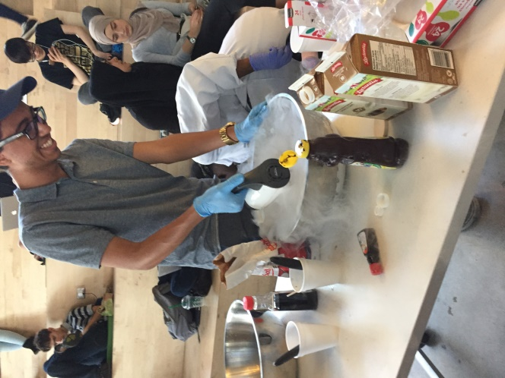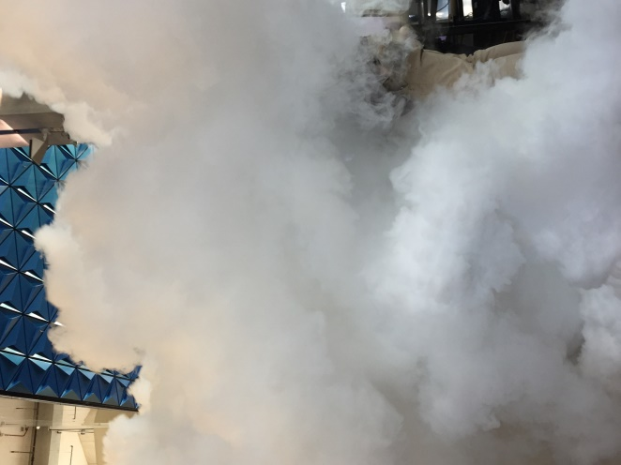
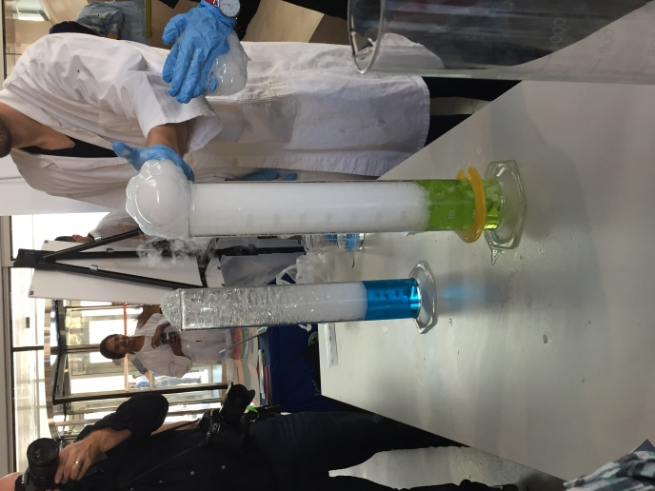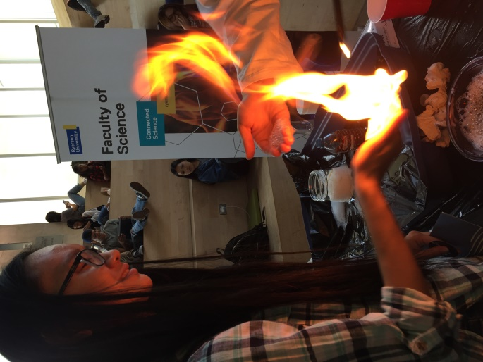
All in all, we had a great educational and entertaining day at Ryerson University.
Highly recommended!

