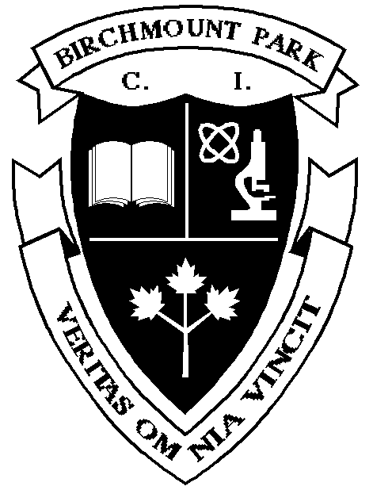
BIRCHMOUNT PARK COLLEGIATE INSTITUTE
SCIENCE DEPARTMENT
2019-2020

SCIENCE: Grade 9 Essential Level SNC1L

Curriculum Leader: Mr. G. Wang Prerequisite: None

Teacher: J. Wong

Course Details
This course helps students to reinforce and strengthen science-related knowledge and skills, including scientific inquiry, critical thinking, and the relationship between science, society, and the environment, to prepare students for success in everyday life, in the workplace, and in the Grade 11 Science Workplace Preparation course. Emphasis is placed on providing opportunities for students to experience success; to engage in hands-on, practical, and relevant activities; to develop and practice Essential Skills; to be reflective about their learning; and to be well supported in their efforts to learn and grow. Students focus on specific social skills such as collaboration, appropriate language in conversations, and respect for other opinions as they engage in their tasks. Development of literacy and mathematical skills is key for student success.

Strands

- Scientific Inquiry: Science in Daily Life – Students will demonstrate scientific investigation skills, as well as learn about a variety of careers related to the fields of science.
- Chemistry: Properties of Common Materials – Students will demonstrate an understanding of properties of common elements and compounds, as well as their various uses in society.
- Biology: Staying Alive – Students will analyze the impact of human activity on various ecosystems. They will also investigate factors that impact ecosystem sustainability.
- Physics: Electrical Circuits – Students will investigate properties of static and current electricity, as well as analyze social, economic and environmental costs of a variety of energy sources.
- Making Personal Decisions – Students investigate a product of their choice and conduct investigations to determine which brand works best.

Assessment & Evaluation
Ongoing assessment will occur to allow students the opportunity to be successful. Students will be evaluated in four categories of the achievement chart (found at the link above). See the Evaluation Plan on the second page for more information. Students will be given an update of their mark regularly (at least once per strand). Please consult the student agenda for the school’s policy on missed term and final evaluations.
Term Work | 70%
Knowledge & Understanding | 20%
Communication | 15%
Thinking/Inquiry | 20%
Applications/Making Connections | 15%
Final Evaluation | 30%
Activity | 15%
Summative | 15%

Teaching & Learning Strategies

In Science, a variety of teaching strategies are used to enhance student learning. These include (but are not limited to): note taking, experiments, cooperative work, research projects, independent learning and study notes.

Resources
There is no textbook for this course. The students will maintain a binder with all of the necessary information.

SNC1L – Evaluation Plan

Term Work: 70%

Unit 1: Scientific Inquiry – Science in Daily Life
Task | Achievement Chart | Due Date

Unit 2: Biology – Staying Alive
Task | Achievement Chart | Due Date

Unit 3: Physics – Electrical Circuits
Task | Achievement Chart | Due Date

Unit 4: Chemistry – Properties of Common Materials
Task | Achievement Chart | Due Date

Cumulative Evaluation: 30%

Task | Achievement Chart | Due Date

Contact Information
Extra help is available from your teacher. All Science teachers can be contacted by phone at 416-396-6704. Department information and links to teacher websites are available through the school website: http://schools.tdsb.on.ca/birchmount

