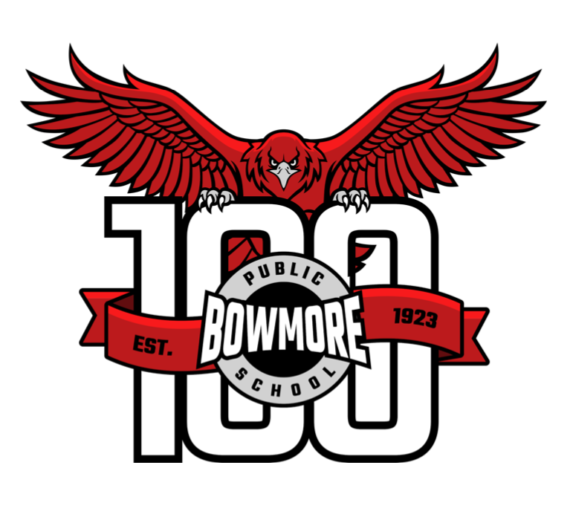

**Code of Conduct Contract**

for Students and Parents

2024-2025

At Bowmore Road, every student deserves a safe environment which is conducive to learning. When any student engages in behaviour that is harmful or hurtful to others, it disrupts the learning and the well-being of the entire school community. The Bowmore Code of Conduct is designed to maintain safe and effective learning spaces for all students.

Parents and guardians, we kindly request that you review Bowmore’s Code of Conduct with your child(ren). In addition to our school’s Code of Conduct, please review the TDSB Parent Concern Protocol and Parent Code of Conduct that are also included in this package.

Following this review, both students and parents are requested to sign below, acknowledging that they have reviewed these documents and understand that the school will engage in progressive discipline to ensure everyone has a safe space to learn.

Thank you for doing your part in keeping Bowmore a welcoming, positive space for all learners!

**I have read and understand Bowmore’s code of conduct.**

Student Name: _______________ Homeroom Teacher: ____________ Parent Name : _______________ ¨Parent Signature : _______________ Student Signature (in their own handwriting): _______________________