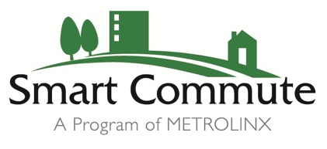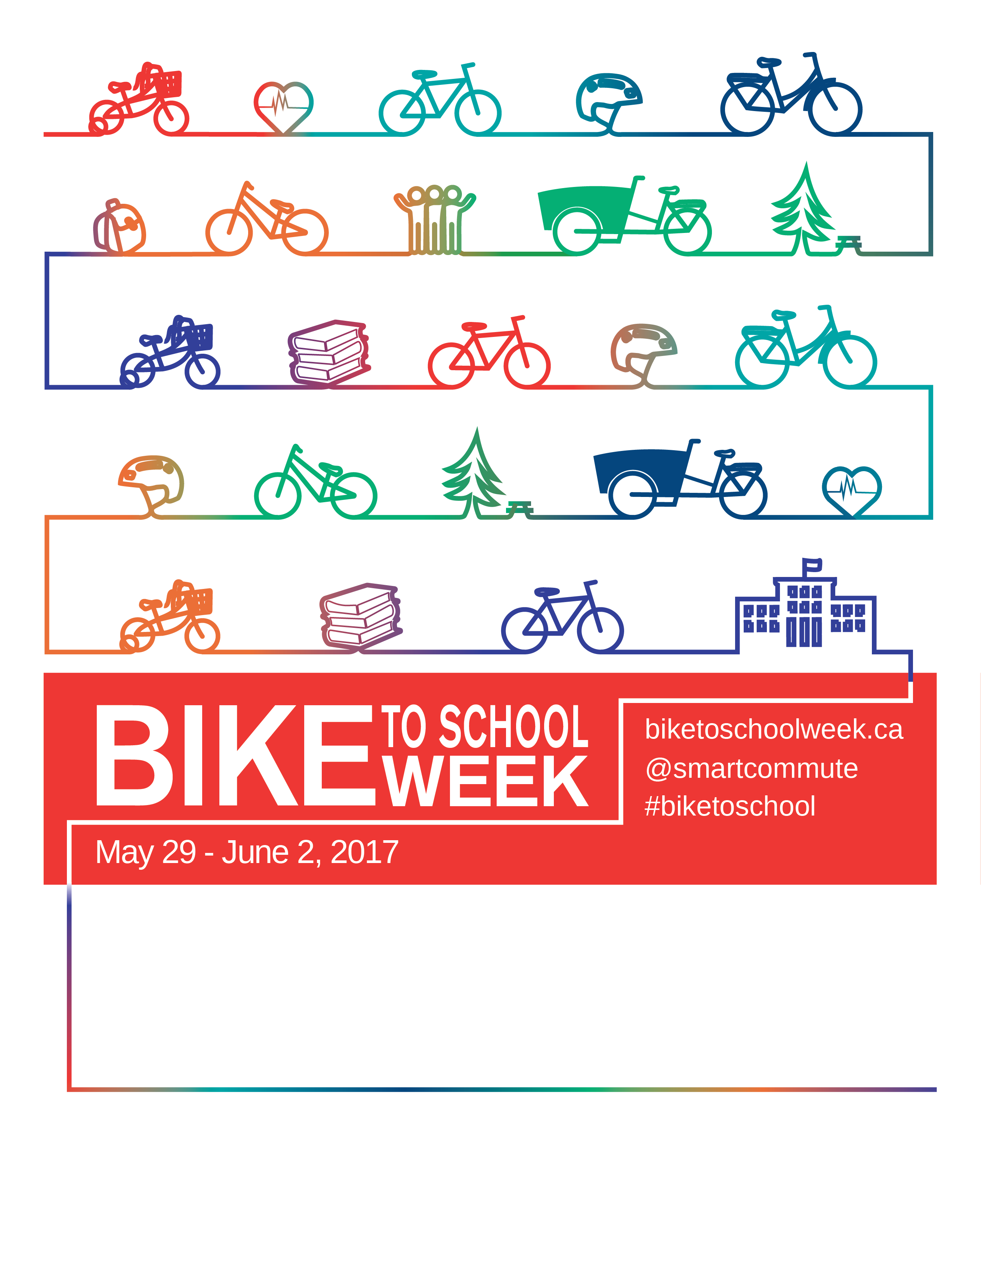

**Monday May 1st** – **Bike/Walk to School Day**! Refreshment table will be set up on pavement before school with draw tickets. Bicycles to be stored outside on racks or in Jr. Gym! During the day, **Pedalheads** will visit classes to present bicycle safety session!

**Monday May 1st – Friday May 5th –** Bicycle/Walk tracking! Track your minutes spent using active transportation. Walk/Bike to school each day to earn one draw ticket for a prize!

**Wednesday May 3rd** – TDSB will be hosting a **Bike Rodeo** at Bowmore! Stations include: helmet fittings, safety check, starting and stopping and more!

**Friday May 5th** –At the end of the day, a prize will be awarded for the most active class throughout the week. Individual prizes will be drawn for those who have used active transportation throughout the week!

Throughout the day, Pedalheads will be providing bicycle safety presentations within the school and classes will begin monitoring their distance travelled for their chance to win a prize!

On Friday May 5ththere will be a bicycle rodeo! There will be local community members and shops set up for all of your bike and bike safety needs.

May 1 – May 5