Briarcrest Banner
September 2021

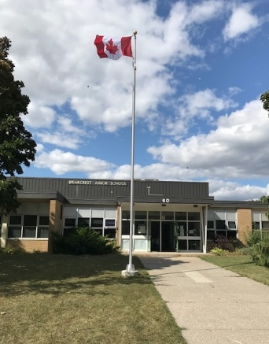
Welcome back, everyone. We have now had our first few days of the new school year, and we are very pleased with how the new school routines are starting to unfold. It will take a few days for everyone to get used to their new class, new friends and being back together, whether your child is in virtual school or bricks and mortar school. While this newsletter will mainly provide information regarding in-person school, we also want to stay connected with our families who have selected virtual learning. Each classroom teacher at Briarcrest will be in touch with you with information specific to their class, student assignments and routines for your child. We are in the process of gathering information from you, about your child, through the Permission Click forms that have come to you by email. Please complete one form for each child with the required medical information, media releases, and permission forms.
Daily Health Check for Students
Thank you to everyone for completing your child’s paper Health Check daily. Students will not be able to go to class until staff have seen your signature and date on your child’s health check. If your child has any of the listed symptoms on the health check form, please keep them home and isolated, and take them for a Covid test before returning to school. The Daily Health check is an extremely important tool for controlling the spread of Covid here at Briarcrest, so please follow the instructions carefully, and err on the side of caution when assessing your child’s health. Here is a link to additional copies, should you need: https://www.tdsb.on.ca/Portals/0/docs/TDSB%20Student%20health%20pass_September%202021.pdf
September Reorganization and Student Attendance
Each September student attendance is carefully tracked on a daily basis. It is important that your child arrive at school on time each day. Morning yard supervision begins at 8:25 a.m. and attendance is taken starting at 8:40 a.m. The TDSB gathers information on class size over the first few weeks of school, to determine staffing for the rest of the year. Any required school reorganization will take place on September 23, 2021 and you will be notified if any changes will impact your child. Please call the attendance line at (416) 394-6180 to report the reason for any absences from school.

Briarcrest Drop-off on Rangoon and Student Transportation
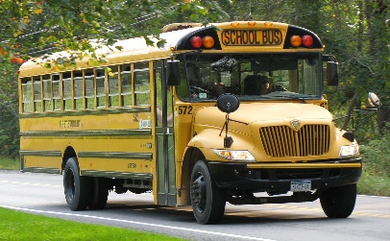
The weather is beautiful in September, and rain or shine we hope families who live close to the school will enjoy the opportunity to walk or ride bikes to school during the warm weather. If you need to drive your child to school, please know that you can park on Rangoon, as long as you avoid the southern section that is set aside for school bus drop-off. Starting this week, two large school buses will require enough space to pull-up on Rangoon, at the corner near Wellesworth. This space is designated for the school buses, and we ask that you not stop/park/drop off students in the bus zone. Parents and caregivers are reminded to wear masks when dropping off and picking up students, and any time you are on the school yard.
This Photo by Unknown Author is licensed under CC BY-SA

Student Agendas Thank you to our School Council Members for providing the funds to purchase agendas to all of our in-school Grade 1 to 5 students. Your child will benefit from having a great tool to learn to organize their work. Parents may also use the agenda to send notes and information to the homeroom teacher. More information will be coming about this year’s school council group, for those who may wish to join.

Briarcrest Terry Fox School Run/Walk Day: Wednesday September 29th, 2021
Briarcrest staff and students will honour the legacy of Terry Fox by participating in a school run/walk event on Wednesday September 29th, 2021. Terry Fox represented the best that Canadians have to offer. He was an example of courage, humility, determination, and perseverance. From a young age he exemplified these attributes that made him an inspiration for not only Canada, but the entire world. You’ve probably been involved in the School Run or Terry Fox Run for a couple of years now, or maybe you are new to the experience. Teachers will spend time speaking with their class about Terry Fox’s legacy. More information will be coming with how families can donate to the Canadian Cancer Society.
This Photo by Unknown Author is licensed under CC BY-SA

Thursday September 30th is Orange Shirt Day
Thursday, September 30th is Orange Shirt Day, it also marks the first annual National Day of Truth and Reconciliation, which was passed by legislation this summer to become a federal statutory holiday.
Established in 2013, Orange Shirt Day was inspired by Phyllis Webstad, who was excited to wear her new orange shirt to her first day of school in 1973. However, when she arrived at St. Joseph Mission Residential School, her shirt was taken and never returned. From that day forward, the colour orange, for Phyllis, reminded her of that moment, how her feelings didn't matter, how she felt like she wasn't worth anything and that no one cared for the children who were crying about it that day.
On Thursday, September 30, 2021 wear orange to participate in Orange Shirt Day.
For more information, visit the Urban Indigenous Education Centre website. To learn more about Phyllis' story and Orange Shirt Day visit http://www.orangeshirtday.org

Other Dates to Note

Monday October 11th, 2021: Thanksgiving Holiday
Friday November 19th, 2021: P.A. Day for Progress Reports
Monday December 20 – Friday December 31st: Winter Break
Friday January 14th, 2022: P.A. Day
Friday February 18, 2022: P.A. Day
Monday March 14 to Friday March 18th: March Break
Friday April 15th and Monday April 18th: Good Friday and Easter Monday Holidays
Monday May 23, 2022: Victoria Day Holiday
Friday June 3, 2022: P.A. Day
Thursday June 30, 2022: Last Day of School for Students

