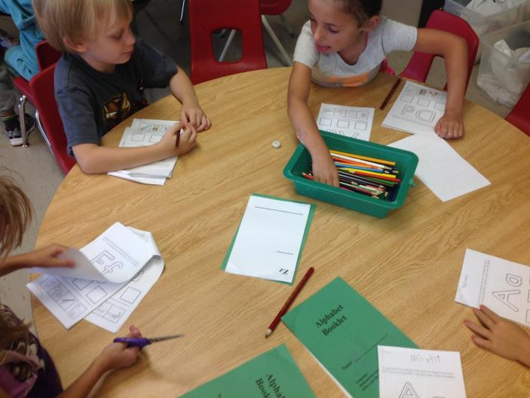
What’s Happening in Kindergarten??

