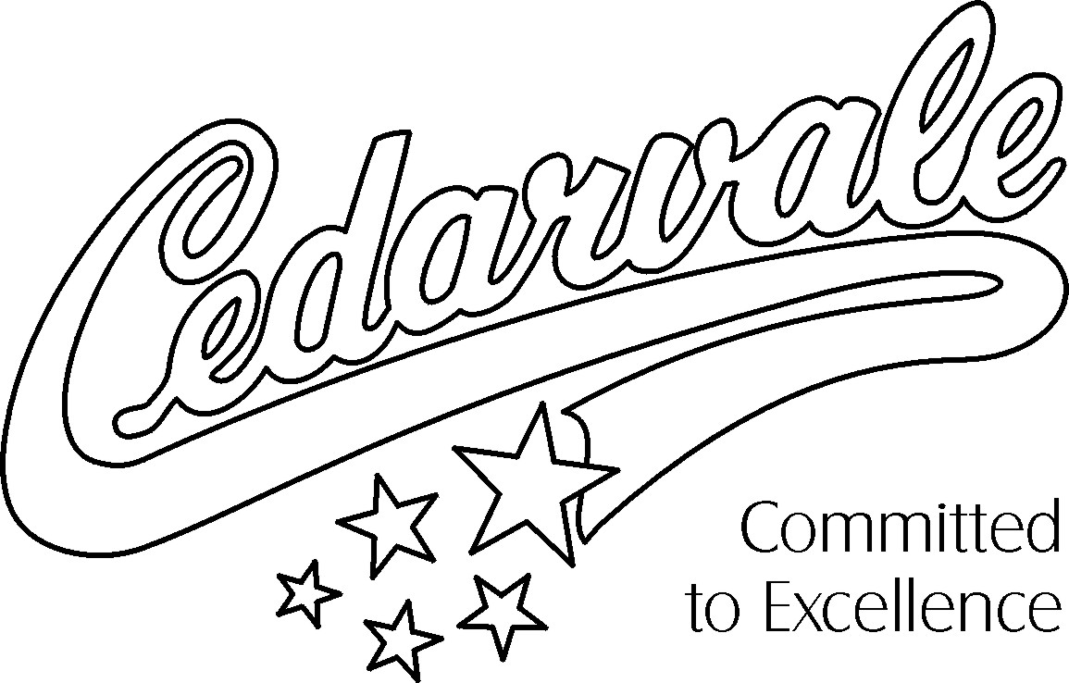

School Motto: Committed to Excellence
School Spirit Logo: Cedarvale “Stars”

A Message from the Principal

Welcome to the start of a great year at Cedarvale Community School! Cedarvale is an accredited International Baccalaureate (IB) World School and our aim is to develop global-minded learners who recognize that a collective global humanity and shared stewardship of the planet creates a healthy, safe and inclusive world.

I look forward to working together as a team with Cedarvale staff and parents to help students to learn and grow by supporting and cheering them onto success this year. Important ways that students can set themselves up for success is to have a growth mindset, demonstrate respect for themselves and others, actively participate, and by working towards achieving their personal best through goalsetting and effort. A strong partnership between home and school, with ongoing communication with your child’s teacher, is another key part of student success.

Along with our school’s commitment to providing Cedarvale students with a solid academic foundation, we encourage students to participate in the wide variety of arts, athletics and academic extra-curricular activities that are offered throughout the school year. These valuable and personal growth opportunities are organized and led by a very talented, energetic and dedicated group of staff members and parents of the School Advisory Council.

If you have any questions, please do not hesitate to contact the school and we will endeavour to answer your inquiries throughout the school year.

On behalf of the entire Cedarvale staff, we wish all students a wonderful year of learning!

Sooky Crljen
Principal

