Student Timetable
Visit the school and see the program in action
OYAP SPECIALIZED TRANSPORTATION

SEMESTER 1

Transportation
B L O O R S T W
4 in school Transportation credits
SEMESTER 2
L E N N O X S T
Art Building
Bathurst Building
Transportation
B A T H U R S T S T
- in school automotive credit

Main Building
BORDEN ST

PLUS 1 compulsory/optional credit (if needed)
Sports Field
Transportation Co-op
- co-op credits
H A R B O R D S T

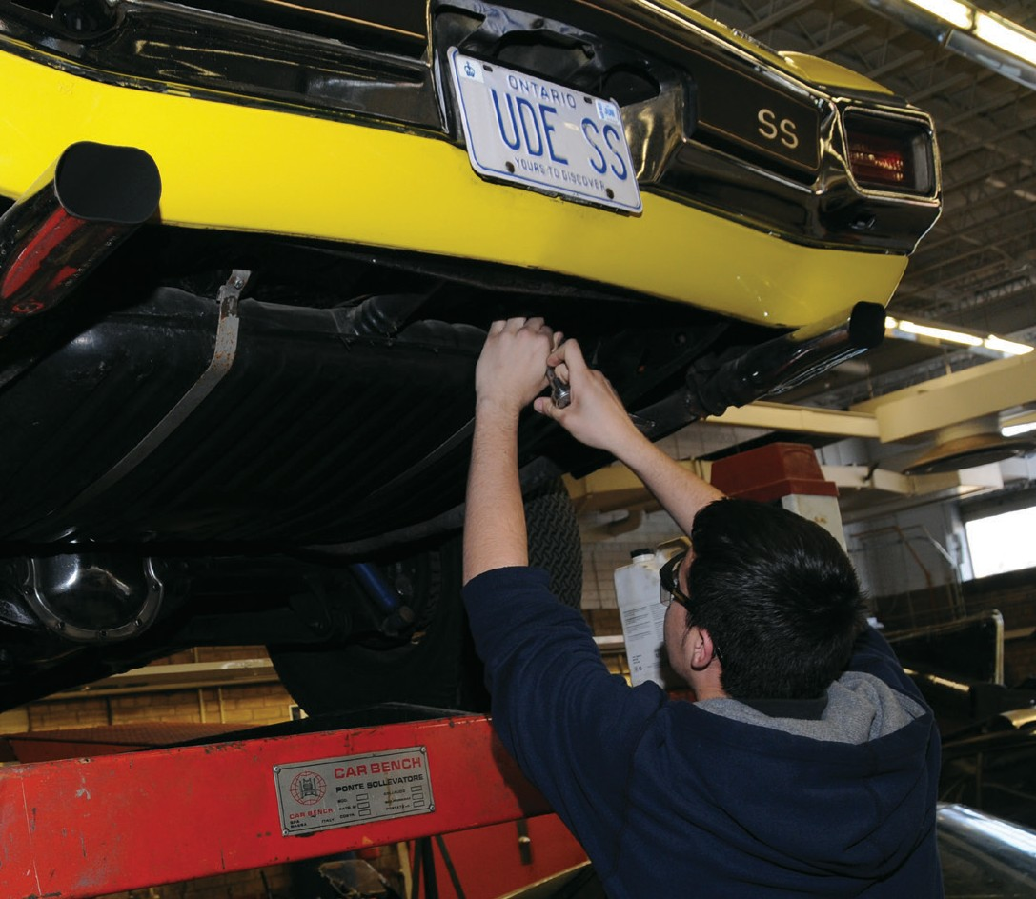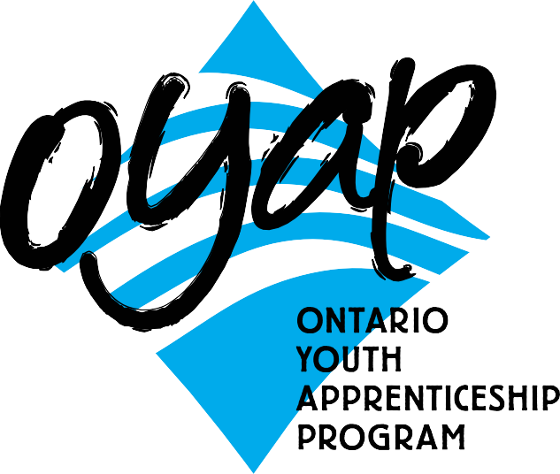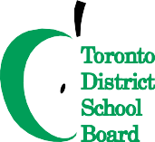NOTE:
Co-op placements will be in Automotive Service,
Small Engine, Recreational Vehicles, Truck and Coach, or Heavy Equipment. Every effort is made to accommodate the student’s individual requests.

To apply or get more information
phone: Don Hann
Curriculum Leader Experiential Learning 416.393.0070 ext. 20062
e-mail: don.hann@tdsb.on.ca by mail: Central Technical School
725 Bathurst Street Toronto, Ontario M5S 2R5

To learn more about the OYAP programs offered at Central Technical School please visit our website at schoolweb.tdsb.on.ca/centraltechnicalschool
and click on the OYAP button

A one-year pre-apprentice program at
Central Technical School

The Transportation Program was launched at Central Technical School in the early 20’s in response to the growing need for trained automotive service technicians. The goal was to provide young people in Toronto with specialized knowledge that would allow them to move directly from secondary school into a career in the automotive service industry.
Since its inception, the Transportation Department has graduated hundreds of service technicians. Many have become automotive service technicians, truck and coach technicians, heavy equipment technicians, and owners of repair facilities,
service managers, parts personnel, parts manu- factures, and some transportation educators. The Transportation Program has a long, suc- cessful history of preparing and introducing young people to a career in transportation and connecting them to employment opportunities.

Why take this program at CTS?
- No tuition fees!
- Students are registered as apprentices under the Ontario Youth Apprenticeship Program (OYAP).
- Semester- long, Co-op work experience in a professional transportation repair facility with hours counting towards the Ontario apprenticeship requirement.
- Many employers hire students as paid employees upon completion of the Co-op placement.
- Course work is taught at a pace that is tailored to meet the needs of the student.
- In-school courses are taught by a teacher with dual College of Teachers Qualifications and Ministry of Training Automotive Service Technician certification.
- The Co-op based OYAP portion is monitored by a teacher with Co-operative Education qualifications and Ministry of Training Automotive Service Technician certification.
- Potential to earn addition safety certifications.
- The opportunity to develop valuable career-related skills and workplace experience.
- Challenge the Level 1 Apprenticeship Exam

Why it works
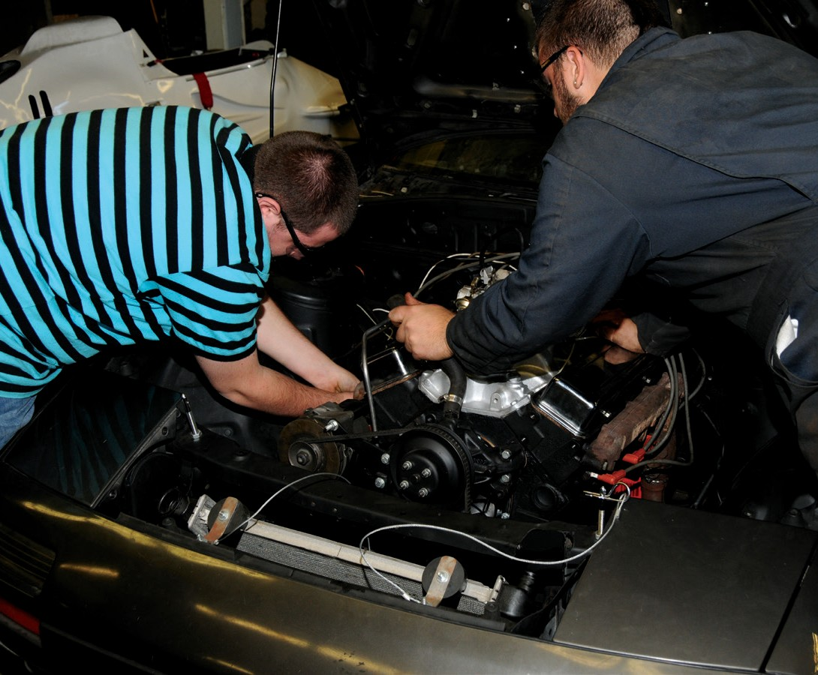
The program offers multiple grade 11 and grade 12 in-school courses which are based jointly on Training Standards for transportation service technicians from the Ministry of Training and the Ministry of Education Technical Studies Curriculum documents.
A large number of employers traditionally accept Central Technical School co-op students and offer them employment as apprentices. The transportation industry wants apprentices
who can take on skilled work immediately. Our program delivers the theoretical and practical instruction that students need and employers want.
Students who meet the required standard of achievement are eligible to write the Level One Transportation exemption exam at no cost. A mark of 70% or better in this exam, exempts candidates from Level One in school apprenticeship training required by the Ministry of Training.

Who is the one-year pre-apprenticeship program for?
The Transportation Program at Central Technical School is organized to match the needs of a broad range of students:
- Students who have a strong interest in learning a skilled trade in the Transportation Industry.
- Students who want to start an apprenticeship as an Automotive Service Technician, a Truck and Coach Service Technician, or Heavy Equipment Service Technician.
- Students who have a keen interest in the diagnosis and repair of machinery.
- Students who may not be ready for college or the world of work.
- Students who plan to go directly into apprenticeship, but need marketable technical skills.
criteria for acceptance
- Qualify for registration as a full-time student at Central Technical School, must be 20 years of age or under.
- Complete a TDSB Co-operative Education Application and submit it by the deadline. Applications are available from the Guidance Department at Central Technical School and at www.centraltechnicalschool.ca
- Be available to attend an interview.
- Bring Credit Counselling Summary and record of attendance.
- Have a serious interest in pursuing an apprenticeship with the goal of becoming an Automotive Service Technician, Truck and Coach Service Technician or a Heavy Equipment Service Technician
- Demonstrate a positive attitude towards
school and work. Have a proven record of
good attendance and punctuality.
Candidate performance in first semester will
determine their eligibility for second
semester.
- Be within 8 credits of an OSS Diploma with no more than 1 compulsory credit to be completed.
- Have a valid Social Insurance Number and card for WSIB purposes.
- Provided by student: all transportation and personal protective equipment.
- It is recommended that candidates have completed Grade 12 College and Apprenticeship Math (MAP4C1) or greater. It may be possible
to earn this credit during Semester 1 at Central
Technical School.

