Student Timetable
Visit the school and see the program in action
OYAP SPECIALIZED CARPENTRY

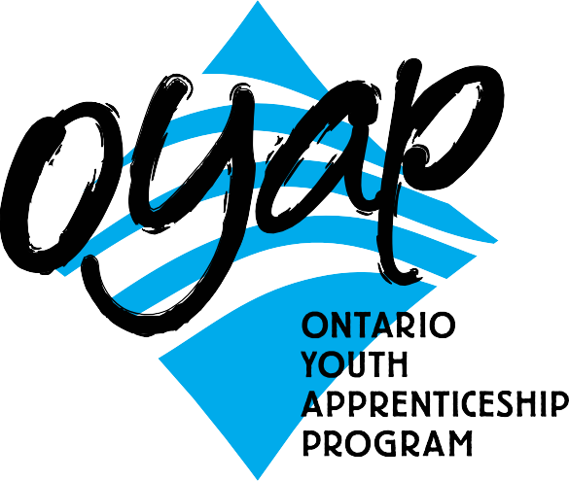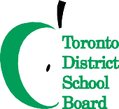SEMESTER 1

Grade 11 Carpentry
3 in school carpentry credits
PLUS 1 compulsory/optional credit (if needed)
SEMESTER 2
Grade 12 Carpentry
1 in school carpentry credits (first half of semester)
Carpentry Co-op
1 co-op credits
(second half of the semester)

NOTE:
Co-op is full time Monday to Friday
for 9 weeks, with a possibility of summer employment and apprenticeship opportunities following..successful completion of the program

B L O O R S T W
L E N N O X S T
Bathurst Building
Art Building

H A R B O R D S T

To apply or get more information
phone: Don Hann
Curriculum Leader Experiential Learning 416.393.0070
ext. 20062
e-mail: don.hann@tdsb.on.ca by mail: Central Technical School
725 Bathurst Street Toronto, Ontario M5S 2R5

To ﬁnd out our Open House dates and to learn more about the OYAP programs offered at
Central Technical School please visit our website at
schoolweb.tdsb.on.ca/centraltechnicalschool
and click on the OYAP button

A one-year pre-apprentice program at
Sports Field

Main Building
BORDEN ST
B A T H U R S T S T
Central Technical School

Central Technical School has a proud tradition of providing students with an excellent academic education combined with solid technological skills. This tradition prepares students for further formal education and for their future role as workers. For many years the Carpentry department has provided students with a cooperative education experience to explore a career in the building industry. Many students return to the school and comment on how the carpentry program has prepared them for a career as carpentry apprentices or helped them to excel in post-secondary programs. The rapid changes taking place in the construction industry are reflected in the continuous enhancement and development of the program. The goal of the carpentry program is to meet the needs of students and industry.

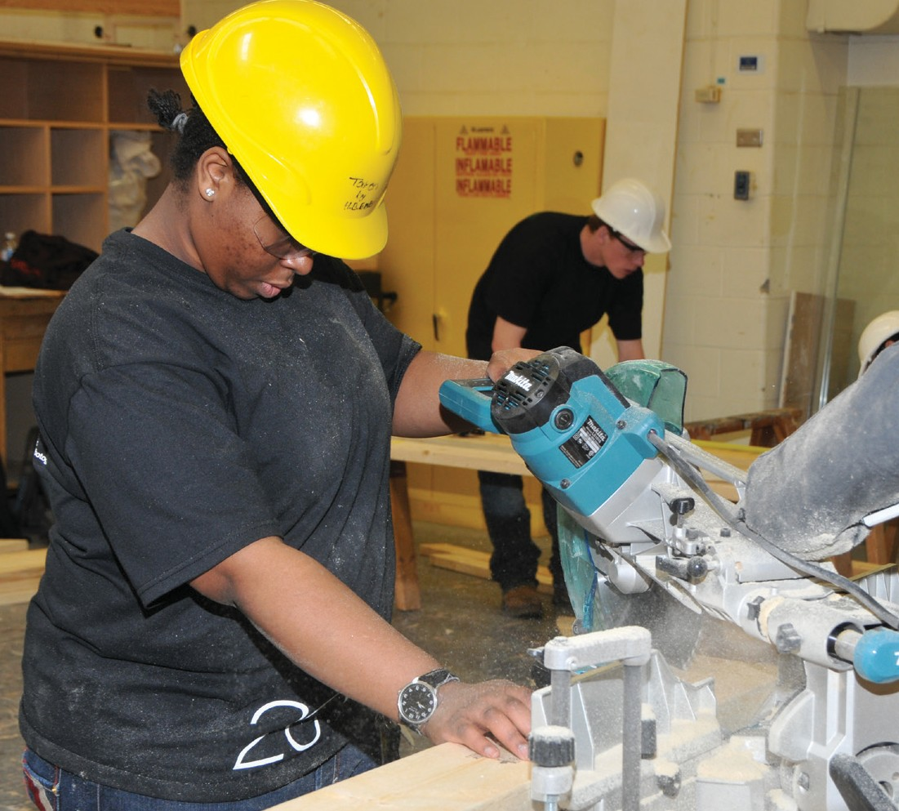
Why take this program at CTS?
- There are no tuition fees.

- Course work is taught at a pace that adjusts to the needs of different students.
- The teachers and TDSB staff are available to facilitate the transition to apprenticeship.
- Have Level One completed (after successfully completing an exemption exam).
- Be able to apply for interest free government loans for tools.
- Save the first year tuition of their apprenticeship.

- Have opportunities for summer and full time employment.
- Be registered as Ontario Youth Apprentices from mid-April to June.
- Teachers with dual College of Teachers Qualifications and Ministry of Training certification as Carpenters teach in-school courses.
- Teachers with Co-operative Education qualifications teach the co-op based OYAP portion.

Co-operative education OYAP
Co-op delivery is a block release period of approximately 9 weeks at the end of the second semester of Grade 12.
Pre-placement workplace preparation is delivered in the first 9 weeks of the semester. Students return to the school alternating Mondays for integration as well as to ensure that in-school assignments are on track and being completed.
This tried and true method has been employed for Carpentry Technology Co-op placements for many years with great success. One reason for a high success rate is that by the time the students attend their Co-op workplace, they have completed a significant number of hours of specialized in-
school instruction and have substantial background preparation for the trade. Our Co-op placements include full day positions working with licensed Carpenters.

Who is the one-year pre-apprenticeship program for?
- Secondary school students who have a strong interest in learning a skilled trade.
- Students who are not ready for college or may have difficulty with the transition.
- Students who want to go directly into the workplace but need marketable technical skills.
criteria for acceptance
- Qualify for registration as a full-time Central Technical School student.
- Complete a TDSB Co-operative Education Application and submit it by the deadline. Applications are available from the Guidance Department at Central Technical School
and at www.centraltechnicalschool.ca
- Be available to attend an interview.
- Bring Credit Counselling Summary and record of attendance
- Have a serious interest in obtaining an apprenticeship with aspirations of becoming a licensed Carpenter.
- Demonstrate a positive attitude to school and work. Have a proven record of good attendance and punctuality. Candidate
performance in first semester will determine their eligibility for second semester.
- Be within 8 credits of an OSS Diploma with no more than 1 compulsory credit to be completed.
- Have a valid Social Insurance number and card for WSIB purposes.
- Provided by student: all transportation, hard hat, and safety shoes.
- It is strongly recommended that candidates have completed Grade 12 College and Apprenticeship Math (MAP 4C1) or higher.
It is still possible to earn this credit during Semester 1 at Central Technical School.
- A G2 drivers permit is recommended in order to facilitate the OYAP placement.
- Must be 20 years of age or under.

