Student Timetable
Visit the school and see the program in action
OYAP SPECIALIZED
Cosmetology
H A R B O R D S T
Sports Field

Main Building
Art Building
Bathurst Building
BORDEN ST
B A T H U R S T S T

SEMESTER 1

Grade 11 Hairstyling
3 in school Hairstyling credits
PLUS 1 compulsory/optional credit (if needed)

SEMESTER 2

Grade 12 Hairstyling
2 in school Hairstyling credits (first half of semester)

Hairstyling Co-op
2 co-op credits
(second half of the semester)

To apply or get more information

phone: Don Hann
To apply or get
more information

NOTE: Co-op is full time Monday to Friday for 9 weeks, with a possibility of summer employment and apprenticeship opportunities
following successful completion of the program
L E N N O X S T
B L O O R S T W
Curriculum Leader Experiential Learning 416.393.0070
ext. 20062
e-mail: don.hann@tdsb.on.ca by mail: Central Technical School
725 Bathurst Street Toronto, Ontario M5S 2R5

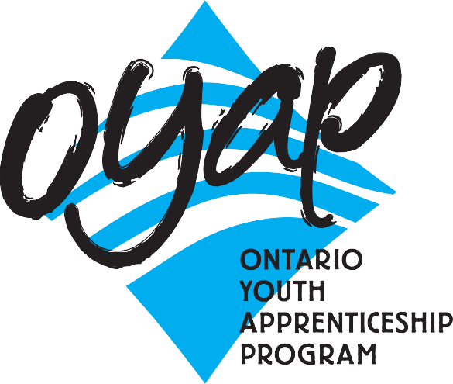

A one-year pre-apprentice program at
Central Technical School
The goal of this program is to provide young people in Toronto interested in hair styling with specialized knowledge and skills that would allow them to move directly from secondary school into a career in the Cosmetology industry.
The rapid changes taking place in the cosmetology industry are reflected in the continuous enhancement and development of the program.
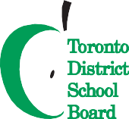
Our Cosmetology program has a long history of partnerships within the Toronto hairstyling community and has provided students with a cooperative education experience to explore a career in the hairstyling and makeup industry. Our graduates are placed in some of the most prestigious salons in the city.
To ﬁnd out our Open House dates and to learn more about the OYAP programs offered at
Central Technical School please visit our website at
schoolweb.tdsb.on.ca/centraltechnicalschool
and click on the OYAP button
Many students return to the school and comment on how the Cosmetology program has prepared them for a career as hairstylist apprentices or helped them to excel in post-secondary programs.

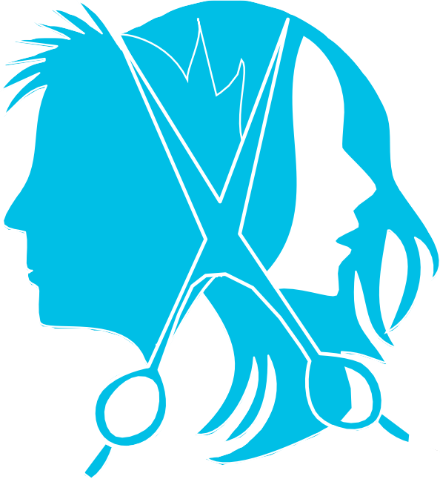program at CTS?

Why take this
- There are no tuition fees.

- Course work is taught at a pace that adjusts to the needs of different students.
- The teachers and TDSB staff are available to facilitate the transition to apprenticeship.
- Have Level One completed (after successfully completing an exemption exam).
- Be able to apply for interest free government loans for equipment.
- Save the first year tuition of their apprenticeship.

- Have opportunities for summer and full time employment.
- Be registered as Ontario Youth Apprentices from mid-April to June.
- Taught by teachers with dual College of Teachers Qualifications and Ministry of Training certification as Hairstylists.
- Teachers with Cooperative Education qualifications teach the co-op based OYAP portion.

Who is the one-year pre-apprenticeship program for?
- Secondary school students who have a strong interest in learning a skilled trade.
- Students who are not ready for college or may have difficulty with the transition.
- Students who want to go directly into the workplace but need marketable technical skills.

Cooperative Education OYAP
Co-op delivery is a block release period of approximately 9 weeks at the end of the second semester of Grade 12.
Pre-placement workplace preparation is delivered in the first 9 weeks of the semester. Students return to the school alternating Mondays for integration as well as to ensure that
in-school assignments are on track and being completed. This tried and true method has been employed for Hairstyling Co-op placements for many years with great success. One reason for a high success rate is that by the time the students attend their Co-op workplace, they have completed a significant number of hours of specialized in-school instruction and have substantial background preparation for the trade. Our Co-op placements include full day positions working with licensed Hairstylists.
Criteria for Acceptance
- Qualify for registration as a full-time Central Technical School student.
- Complete a TDSB Cooperative Education Application and submit it by the deadline. Applications are available from the Guidance Department at Central Technical School
and at www.centraltechnicalschool.ca
- Be available to attend an interview.
- Bring Credit Counselling Summary and record of attendance
- Have a serious interest in obtaining an apprenticeship with aspirations of becoming a licensed Hairstylist.
- Demonstrate a positive attitude to school and work. Have a proven record of good attendance and punctuality. Candidate
performance in first semester will determine their eligibility for second semester.
- Be within 8 credits of an OSS Diploma with no more than 1 compulsory credit to be completed.
- Have a valid Social Insurance number and card for WSIB purposes.
- Provided by student: all transportation.
- 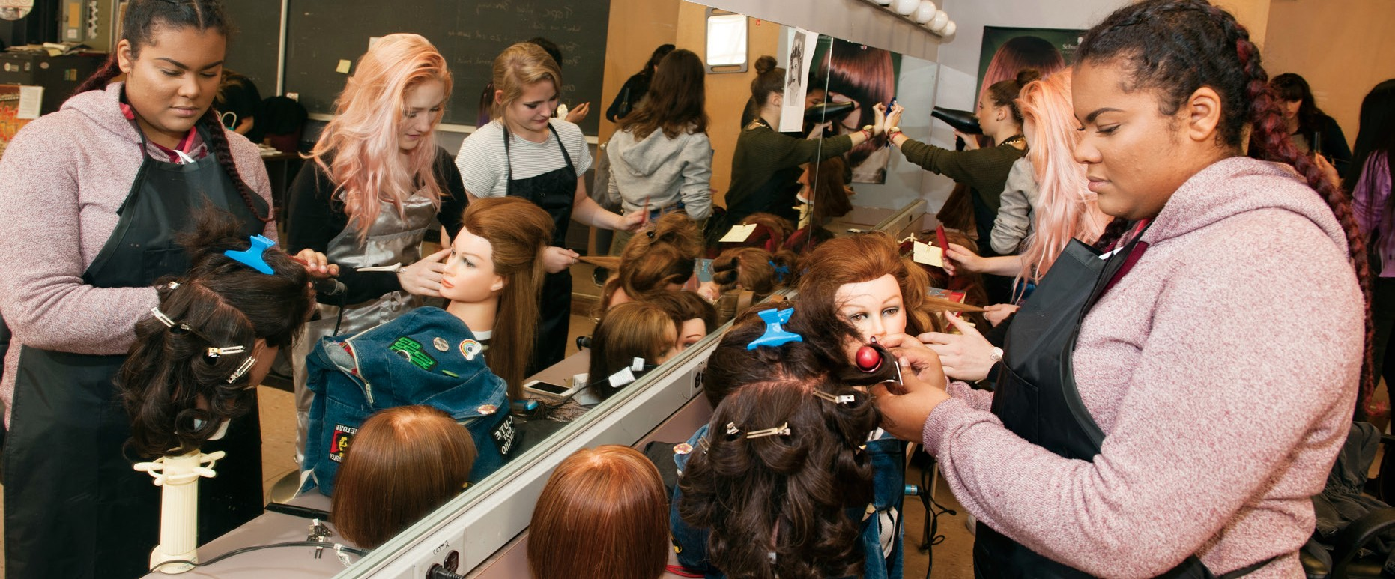Must be 20 years of age or under.

