Student Timetable
Visit the school and see the program in action
OYAP SPECIALIZED ELECTRICAL

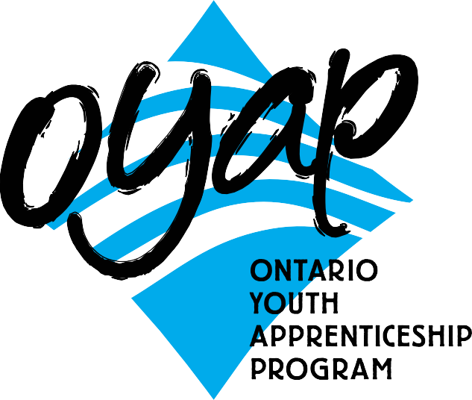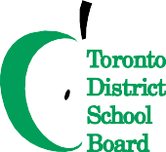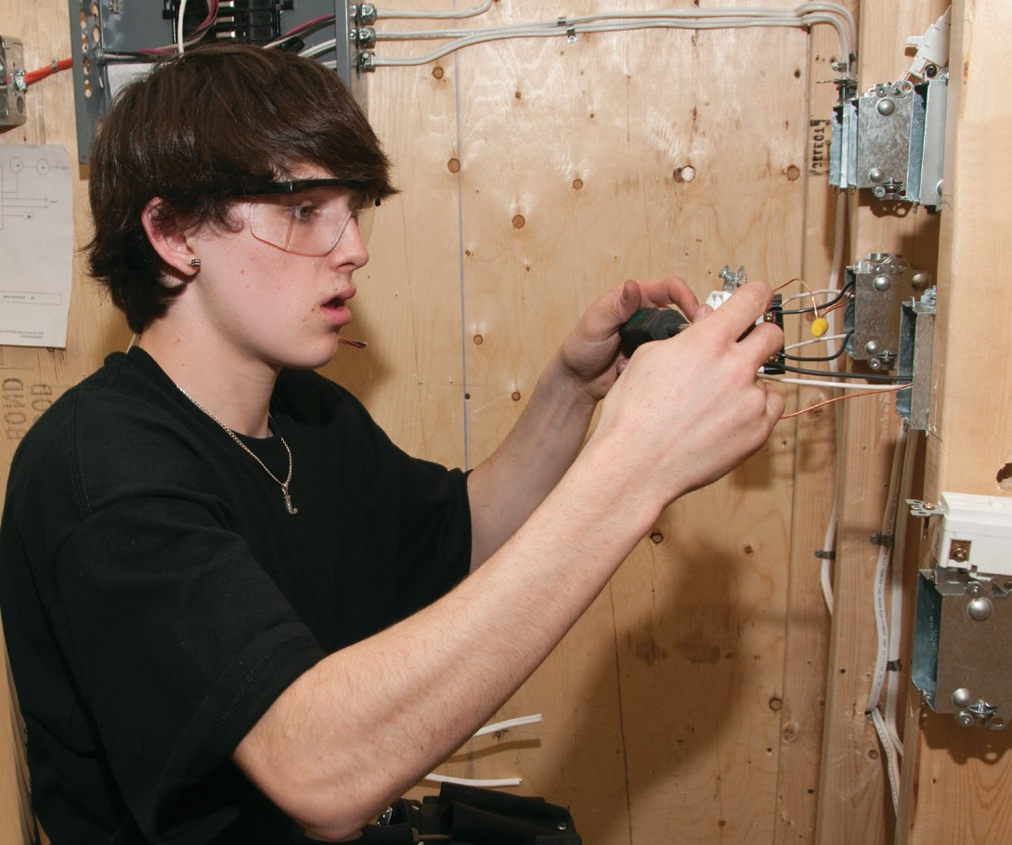SEMESTER 1

Grade 11 Electrical
3 in school electrical credits
PLUS 1 compulsory/optional credit (if needed)
SEMESTER 2
Grade 12 Electrical
1 in school electrical credits (first half of semester)
Electrical Co-op
3 co-op credits
(first half of semester)

NOTE:
Co-op is full time Monday to Friday
for 9 weeks, with a possibility of summer employment and apprenticeship opportunities following successful completion of the program

B L O O R S T W
L E N N O X S T
Bathurst Building
Art Building

H A R B O R D S T

To apply or get more information
phone: Don Hann
Curriculum Leader Experiential Learning 416.393.0070
ext. 20062
e-mail: don.hann@tdsb.on.ca by mail: Central Technical School
725 Bathurst Street Toronto, Ontario M5S 2R5

To learn more about the OYAP programs offered at Central Technical School please visit our website at schoolweb.tdsb.on.ca/centraltechnicalschool
and click on the OYAP button

A one-year pre-apprentice program at
Sports Field

Main Building
BORDEN ST
B A T H U R S T S T
Central Technical School
Central Technical School has a proud tradition of providing students with an excellent academic education combined with solid technological skills. This tradition prepares the student for further formal education and for their future role as workers. For many years the Electrical department has provided students with a cooperative education experience to explore a career in the electrical industry. Many students return to the school and comment on how the electrical program has prepared them for a career as electrical apprentices or helped them to excel in post-secondary programs. The rapid changes taking place in the electrical industry are reflected in the continuous enhancement and development of the program. The goal of the electrical program is to meet the needs of students and industry.

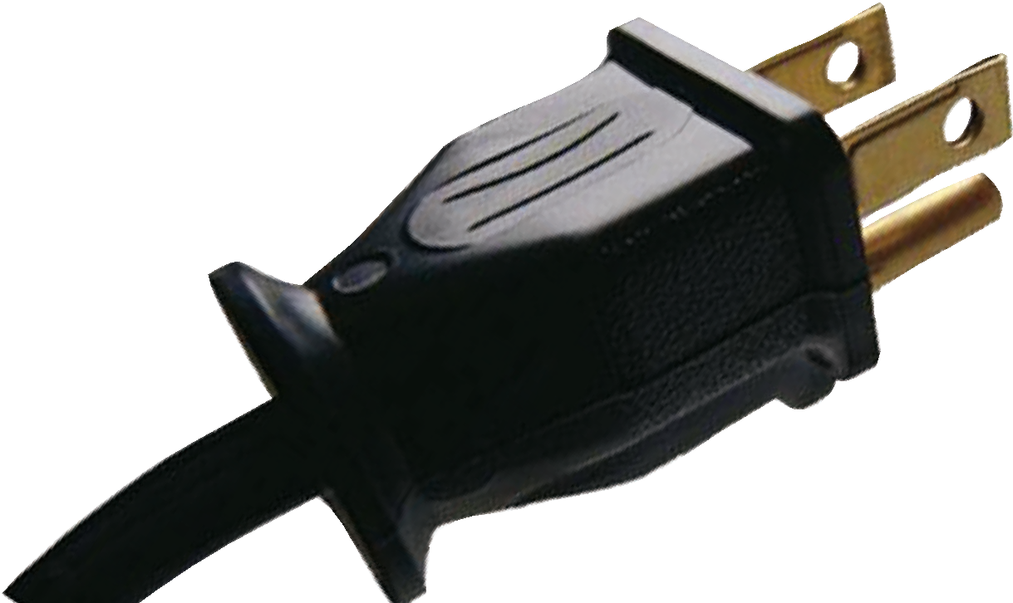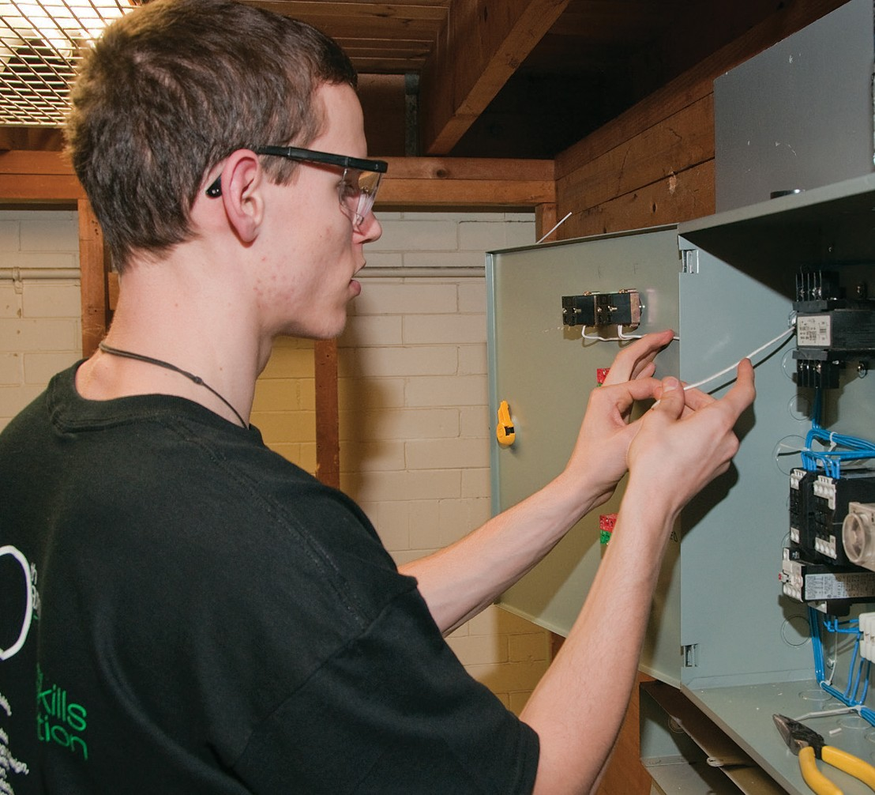Why take this program at CTS?
- There are no tuition fees.
- Course work is taught at a pace that adjusts to the needs of diﬀerent students.
- The teachers and TDSB staﬀ are available to facilitate the transition to apprenticeship.
- Have Level One completed (after successfully completing an exemption exam).
- Be able to apply for interest free government loans for tools.
- Save the ﬁrst year tuition of their apprenticeship
- Have opportunities for summer and full time employment.
- Be registered as Ontario Youth Apprentices from mid-April to June.
- Teachers with dual College of Teachers Qualiﬁcations and Ministry of Training certiﬁcation as Master Electricians teach in-school courses.
- Teachers with Co-operative Education qualiﬁcations teach the co-op based OYAP portion.

Co-operative education OYAP

Co-op delivery is a block release period of approximately 9 weeks at the end of the second semester of Grade 12. Pre-placement workplace preparation is delivered in the ﬁrst 9 weeks of the semester. Students return to the school alternating Mondays for integration as well as to ensure that in-school assignments are on track and being completed. This tried and true method has been employed for Electrical Technology Co-op placements for many years with great success. One reason for a high success rate is that by the time the students attend their Co-op workplace they have completed a signiﬁcant number of hours of specialized in-school instruction and have substantial background preparation for the trade. Our Co-op placements include full day positions working with licensed Electricians.

Who is the one-year pre-apprenticeship program for?

- Secondary school students who have a strong
interest in learning a skilled trade.
- Students who are not ready for college or may
have diﬃculty with the transition.
- Students, who want to go directly into the
workplace, but need marketable technical skills.
criteria for acceptance
- Qualify for registration as a full-time Central Technical School student.
- Complete a TDSB Co-operative Education Application and submit it by the deadline. Applications are available from the Guidance Department at Central Technical School
and at www.centraltechnicalschool.ca
- Be available to attend an interview.
- Bring Credit Counselling Summary and record of attendance
- Have a serious interest in obtaining an apprenticeship with aspirations of becoming a licensed Electrician.
- Demonstrate a positive attitude to school and work. Have a proven record of good attendance and punctuality. Candidate
performance in ﬁrst semester will determine their eligibility for second semester.
- Be within 8 credits of an OSS Diploma with no more than 1 compulsory credit to be completed.
- Have a valid Social Insurance number and card for WSIB purposes.
- Provided by student: all transportation, hard hat, safety shoes and hand tools.
- It is strongly recommended that candidates have completed Grade 12 College and Apprenticeship Math (MAP 4C1) or higher.
It is still possible to earn this credit during Semester 1 at Central Technical School.
- A G2 drivers permit is recommended in order to facilitate the OYAP placement.
- Must be 20 years of age or under.

