Student Timetable
Visit the school and see the program in action
OYAP SPECIALIZED COOK

SEMESTER 1

Grade 12 Hospitality
2 in school hospitality credits
PLUS 2 compulsory/optional credits (if needed)
SEMESTER 2
Hospitality Co-op
4 co-operative education credits or
2 credits in school and 2 co-op credits

B L O O R S T W

L E N N O X S T
Sports Field

Main Building
BORDEN ST
B A T H U R S T S T

Bathurst Building
Art Building

H A R B O R D S T

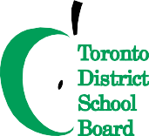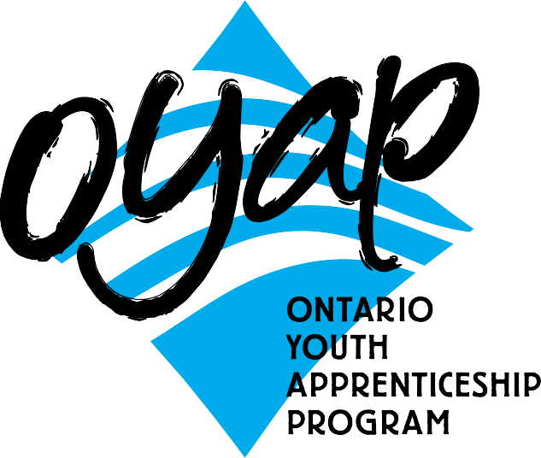
To apply or get more information

NOTE:
For the 4-credit co-op there is a two week co-op preparation course, then placements run all day with an in-school integration day every second Monday.
The 2-credit co-op option is available for students who need additional compulsory credits in order to complete their diploma requirements.
phone: Don Hann
Curriculum Leader Experiential Learning 416.393.0070
ext. 20062
e-mail: don.hann@tdsb.on.ca by mail: Central Technical School
725 Bathurst Street Toronto, Ontario M5S 2R5

To find out our Open House dates and to learn more about the OYAP programs offered at
Central Technical School please visit our website at
schoolweb.tdsb.on.ca/centraltechnicalschool

and click on the OYAP button
A one-year pre-apprentice program at
Central Technical School
Central Technical School has a proud tradition of providing students with an excellent academic education combined with solid techno- logical skills. This tradition prepares the student for further formal education and for their future role as workers. For many years the hospitality department has provided students with authentic experiences for those who wish to pursue a career in culinary arts or baking. Many students return to the school and comment on how the culinary program has prepared them for a career as cook apprentices or helped them to excel in post-secondary programs. The rapid changes taking place in the food service industry are reflected in the continuous enhancement and development of the program. The goal of the hospitality program is to meet the needs of students and the food service industry.

Co-operative education OYAP
criteria for acceptance

Why take this program at CTS?
- There are no tuition fees.
- Course work is taught at a pace that adjusts to the needs of different students.
- The teachers and TDSB staff are available to facilitate the transition to apprenticeship.
- Have Level One completed (after successfully completing an exemption exam).
- Save the ﬁrst year tuition of their apprenticeship.
- Have opportunities for summer and full-time employment.
- Be registered as Ontario Youth Apprentices from mid- April to June.
- Teachers with dual College of Teachers Qualiﬁcations and Ministry of Training certiﬁcation as Cooks teach in-school courses.
- Teachers with Co-operative Education qualiﬁcations teach the co-op based OYAP portion.
Co-op delivery is a block release of the second semester of Grade 12. Pre-placement workplace preparation is delivered in the ﬁrst 2 weeks of the semester. Students return to the school alternating Mondays for integration as well as to ensure that in- school assignments are on track and being completed. This tried and true method has been employed for Foods Co-op placements for many years with great success. One reason for a high success rate is that by the time the students attend their Co-op workplace they have completed a signiﬁcant number of hours of specialized in-school instruction and have substantial background preparation for the trade. Our Co-op placements include full day positions working with licensed Cooks.

Who is the one-year pre-apprenticeship program for?
- Secondary school students who have a strong interest in learning a skilled trade.
- Students who are not ready for college or may have difﬁculty with the transition.
- Students, who want to go directly into the workplace, but need marketable technical skills.

Qualify for registration as a full-time Central Technical School student.
- Complete a TDSB Co-operative Education Application and submit it by the deadline. Applications are available from the Guidance Department at Central Technical School and at www.centraltechnicalschool.ca
- Be available to attend an interview.
- Bring Credit Counselling Summary and record of attendance
- Have a serious interest in obtaining an apprenticeship with aspirations of becoming a licensed Cook.
- Demonstrate a positive attitude
to school and work. Have a proven
record of good attendance and punctuality. Candidate performance in ﬁrst semester will determine their eligibility for second semester.
- Be within 8 credits of an OSS Diploma with no more than 2 compulsory
credits to be completed.
- Have a valid Social Insurance number and card for WSIB purposes.
- Provided by student: all transportation, safety shoes (where needed) and knives.
- It is strongly recommended that candidates have completed Grade 12 College and Apprenticeship Math (MAP 4C1) or higher. It is still possible to earn this credit during Semester 1 at Central Technical School.
- Must be 20 years of age or under.

