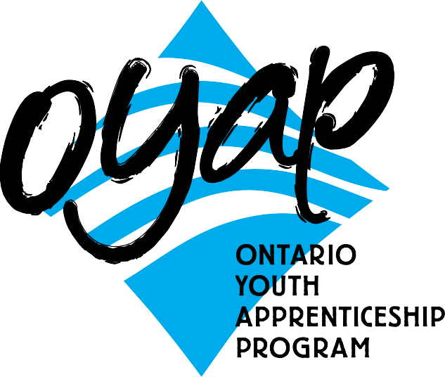Visit the school and see
Student Timetable the program in action
OYAP SPECIALIZED PLUMBING

SEMESTER 1

Grade 11 Plumbing
3 in school plumbing credits
PLUS 1 compulsory/optional credit (if needed)
SEMESTER 2
Grade 12 Plumbing
1 in-school plumbing credits (first half of semester)
Plumbing Co-op
3 co-op credits (second half of the semester)

B L O O R S T W

L E N N O X S T
Sports Field

Main Building
BORDEN ST
B A T H U R S T S T

Bathurst Building
Art Building

H A R B O R D S T

To apply or get more information
NOTE:
Co-op is full time Monday to Friday
for 9 weeks, with a possibility of summer employment and apprenticeship opportunities following successful completion of the program
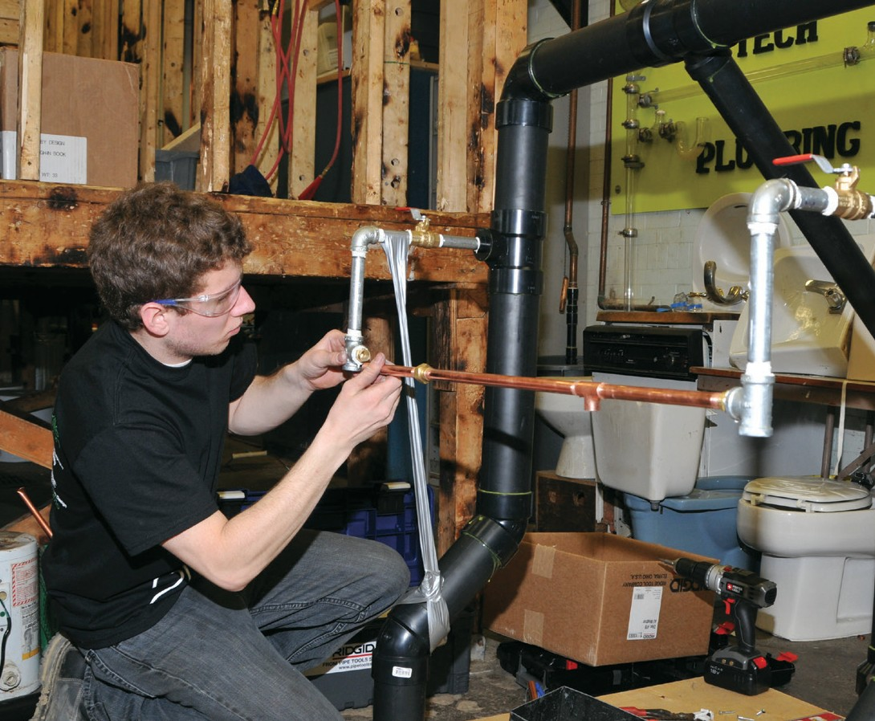
phone: Don Hann
Curriculum Leader Experiential Learning 416.393.0070
ext. 20062
e-mail: don.hann@tdsb.on.ca
by mail: Central Technical School
725 Bathurst Street Toronto, Ontario M5S 2R5

To ﬁnd out our Open House dates and to learn more about the OYAP programs offered at
Central Technical School please visit our website at
schoolweb.tdsb.on.ca/centraltechnicalschool

and click on the OYAP button
A one-year pre-apprentice program at
Central Technical School

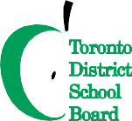The Plumbing Program was launched at Central Technical School in the mid - 1960’s in response to the regulation of the plumbing trade, which occurred at that time. The goal was to provide young people in Toronto with specialized knowledge that would allow them to move directly from secondary school into a career in the plumbing industry.
A large number of graduates have continued in the plumbing trade and became journey persons. Many of those have become owners of plumbing or mechanical contracting businesses and some became plumbing educators. The plumbing Program has a long, successful history of preparing and introducing young Torontonians to a plumbing career and connecting them to employment opportunities.

Why take this program at CTS?
Co-operative education OYAP
criteria for acceptance

- There are no tuition fees.
- Course work is taught at a pace that adjusts to the needs of different students.
- The teachers and TDSB staff are available to facilitate the transition to apprenticeship.
- Have Level One completed (after successfully completing an exemption exam).
- Be able to apply for interest free government loans for tools.
- Save the first-year tuition of their apprenticeship.
- Have opportunities for summer and full-time employment.
- Be registered as Ontario Youth Apprentices from mid-April to June.
- Teachers with dual College of Teachers Qualifications
and Ministry of Training certification as Master Plumbers teach in-school courses.
- Teachers with Co-operative Education qualifications teach the co-op based OYAP portion.
Co-op delivery is a block release period of approximately 9 weeks at the end of the second semester of Grade 12. Pre-placement workplace preparation is delivered in the first 9 weeks of the semester. Students return to the school alternating Mondays for integration as well as to ensure that in-school assignments are on track and being completed. This tried and true method has been employed for Plumbing Technology Co-op placements for many years with great success. One reason for a high success rate is that by the time the students attend their Co-op workplace they have completed a significant number of hours of specialized in-school instruction and have substantial background preparation for the trade. Our Co-op placements include full day positions working with licensed Plumbers.

Who is the one-year pre-apprenticeship program for?

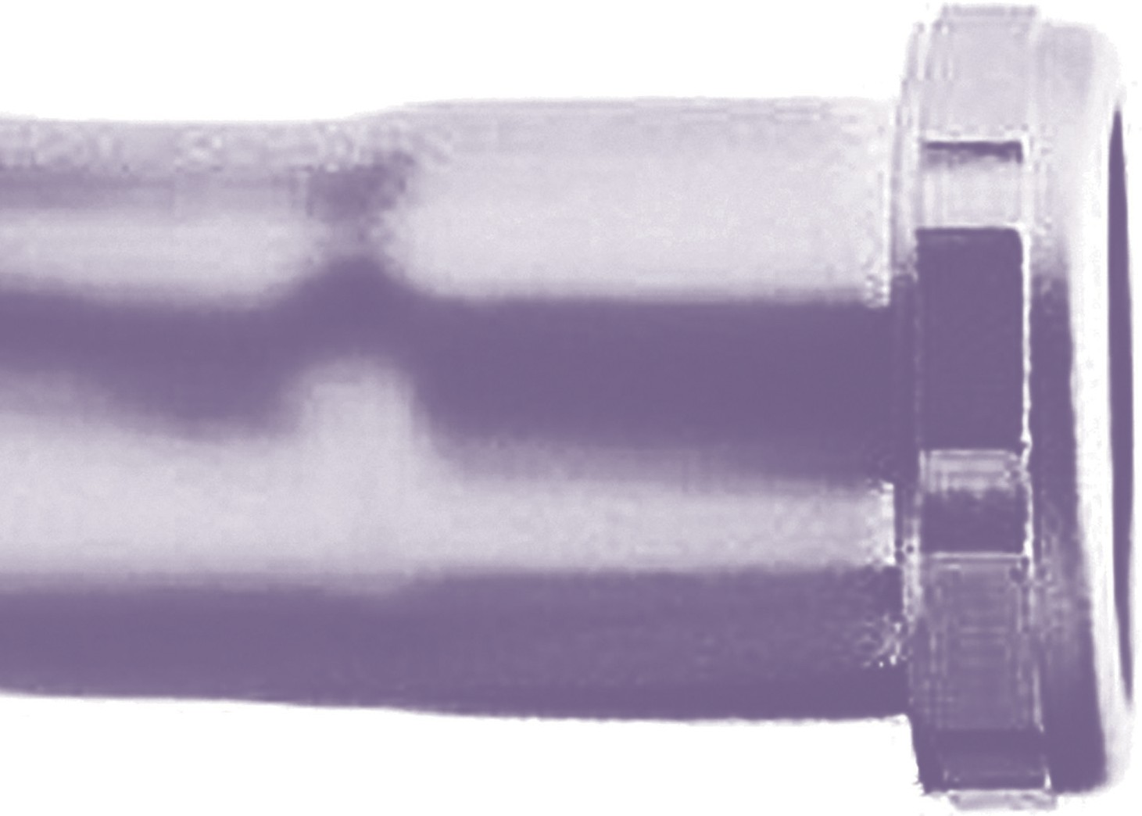
Secondary school students who have a strong interest in learning a skilled trade.
- Students who are not ready for college or may have difficulty with the transition.
- Students, who want to go directly into the workplace, but need marketable technical skills.
- Qualify for registration as a full-time Central Technical School student.
- Complete a TDSB Co-operative Education Application and submit it by the deadline. Applications are available from the Guidance Department at Central Technical School
and at www.centraltechnicalschool.ca
- Be available to attend an interview.
- Bring Credit Counselling Summary and record of attendance
- Have a serious interest in obtaining an apprenticeship with aspirations of becoming a licensed Plumber.
- Demonstrate a positive attitude to school
and work. Have a proven record of good attendance and punctuality. Candidate performance in first semester will determine their eligibility for second semester.
- Be within 8 credits of an OSS Diploma with no more than 1 compulsory credit to be completed.
- Have a valid Social Insurance number and card for WSIB purposes.
- Provided by student: all transportation, hard hat, safety shoes and hand tools.
- It is strongly recommended that candidates have completed Grade 12 College and Apprenticeship Math (MAP 4C1) or higher.
It is still possible to earn this credit during Semester 1 at Central Technical School.
- A G2 drivers permit is recommended in order to facilitate the OYAP placement.
- Must be 20 years of age or under.

