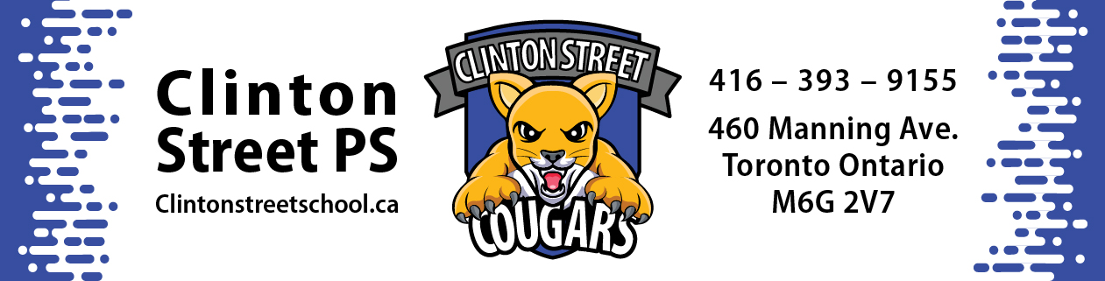

Tuesday, September 6, 2022
Dear Clinton Street PS Community:
On behalf of all the staff, allow me to welcome you to the 2022/23 school year. For those of you experiencing your first year with us, please know that you have joined a wonderful school and a dynamic community. If you and your children are new to our school, and perhaps feeling a bit nervous, please know that I became the Principal at Clinton Street last January, so we are all navigating our first September at Clinton together. You can let your children know that I have been a school administrator for fifteen years in the TDSB and still run the gamut of emotions as opening day approaches. However, I feel energized when I think of the collective strength of the staff we have at Clinton and know that an engaging year waits for our students and families. We are extremely excited about seeing our students and families tomorrow and thought we would provide you a brief update on a few key Clinton points.
School Hours
Morning supervision starts outside at 8:40 a.m.
For all our students from kindergarten to Grade 6, the first bell sounds at 8:50 with classes starting at 8:55.
Lunch for Grade 1 – 6 is from 11:40 to 12:40 with afternoon classes starting at 12:45.
Lunch for kindergarten is from 11:25 to 12:40 and classes starting at 12:45.
Kindergarten dismissal is at 3:15 p.m.
Grade 1 – 6 dismissal is at 3:30.
After school supervision concludes at 3:45 p.m.
First Day of School and Health Expectations
Most of the classes will be meeting their teachers on the field when the bell sounds. Rooms 303 (Ms. Attard) and 305 (Ms. Halligan who is here to start the year in place of Ms. Trinh) will meet at the front yard of the school on the Manning Street side. The homeroom teachers will have signs with their names on them and other staff members will be outside to assist with any students who require some help. During that first day, the students will be presented with their timetable schedules, classroom routines, and either re-connect with friends or meet new ones. Teachers will be sharing the scheduling information with their class’s families as soon as possible. Please keep in mind that all class schedules might require re-examination if we experience an unexpected change in enrolment which requires the school to alter its classroom allotment. We should know if that is required by the end of the second week of school.
With regards to Covid expectations, the TDSB will be following the guidelines as indicated by Toronto Public Health. We will not be cohorting classes this year and we are returning to one recess break and one lunch for all grade-aged students. Due to the gym being out of bounds due to the roof construction, we are planning on the students eating lunch outside to start the year; weather-permitting. Please inform your child’s home room teacher is you have any concerns with your child eating outside. We ask that families continue to screen their children prior to them coming to school. Students and staff are not mandated to wear PPE but it will be available.
Transportation
One of the main reasons why Clinton Street is such an incredibly inclusive school, has to do with the number of Intensive Support Programs (ISPs) that we house. At Clinton we have three classes for students with Developmental Delay exceptionalities, one class for students with Learning Difference exceptionalities, and four classes for students with Gifted exceptionalities. Many of the students in our ISP classes require TDSB transportation services to get to school. Our transportation schedule is still being finalized, but we usually have around a dozen buses servicing our school each day and the drop off and pick up spot is in front of our main doors on Manning Street. Our buses might start arriving 15 minutes prior to the opening bell and dismissal bell. Please be respectful of the bus drop-off location as it is a busy place. If you are a family still waiting for TDSB transportation to connect with you regarding busing for your child, please know that the first few weeks of the school year are the most challenging for the transportation department and they will be in touch soon.
Construction Update
Over the summer, our school began the process of getting a new roof. The construction crew believes that they are ahead of schedule, and they are hopeful of finishing the final piece of the roof (the section above the gym, library, and our kindergarten hallway) during the week of Sept. 12 – 16. When the work is ongoing, the students and staff may not be in those learning spaces. During that second week of school, we will move the two kindergarten classes to other locations in the school and the library and gym will be out of bounds. Ms. Molnar’s Grade One class in room 209, will start the year in room 204. The homeroom teachers will explain all of this to their respective families. All the machinery and trucks for the roofing crew will be staged in our parking lot that is accessed from Clinton Street. For safety, please refrain from walking through the parking lots until we inform you that the work has completed.
School Communication
We are going to strive to respect your family’s evening time and communicate with you during school hours. We will do our best to send you any pertinent information before 4:30 p.m. If possible, we ask that Clinton families also refrain from evening communications with the Clinton staff. Of course, if something crucial needs to be communicated either from school to home or from home to school, then it will happen.

Please feel free to connect with me if you have any questions, comments, or concerns.
We look forward to a great school year.
Sincerely,
Dan Taylor

Principal
Daniel.taylor2@tdsb.on.ca

