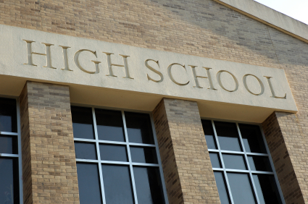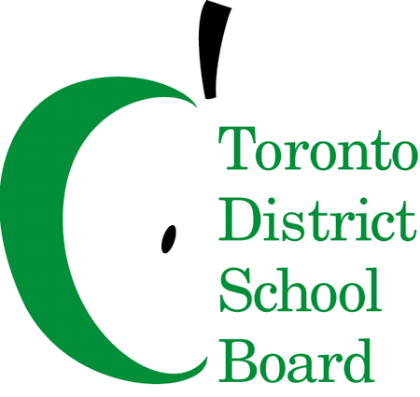

Grade 8 to 9 High School

Information Night for Parents of Students with Special Needs in the TDSB

# Special Education and the Transition to High School

Join us for an informative session on supporting transitions for students with IEPs, presented by Guidance and Special Education (Laurie Jantzi, Sharon Petipas, Kelley Miller-Caise, and Lori Campbell). Learn about the programs available in the TDSB, important timelines, and how you can support your child’s transition to high school.

**Date: Wednesday, November 5th**

**Time: 6:30pm – 8pm**

**Location: Bowmore School (80 Bowmore Road)**

**Childcare: Will be provided, upon request**

**RSVP: Please RSVP via email to your school’s guidance counsellor:** [**lori.campbell@tdsb.on.ca**](mailto:lori.campbell@tdsb.on.ca) **OR** [**kelley.miller-caise@tdsb.on.ca**](mailto:kelley.miller-caise@tdsb.on.ca)**. Please indicate if you need childcare. Include “November 5th” in the subject line.**

## Grade 7 and 8 families welcome to attend!