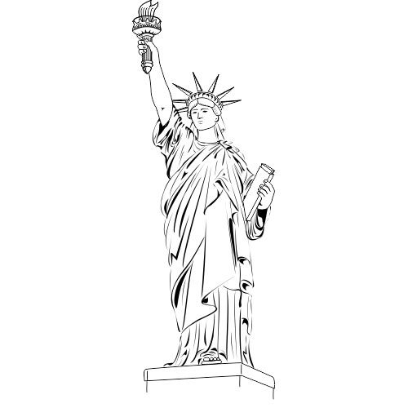
East York C.I. Department of the Arts
is pleased to announce the
2017 Spring Trip to
New York City
Student Information Meeting
Room 233 at 12:00
Wed. Nov. 16, 2016
Parent Information Meeting
EYCI Library at 6:00 pm
Thursday Nov. 24, 2016
Please email jen.maus@tdsb.on.ca to indicate your interest in the meeting.
East York C.I. Department of the Arts
is pleased to announce the
2017 Spring Trip to
New York City
Student Information Meeting
Room 233 at 12:00
Wed. Nov. 16, 2016
Parent Information Meeting
EYCI Library at 6:00 pm
Thursday Nov. 24, 2016
Please email jen.maus@tdsb.on.ca to indicate your interest in the meeting.

