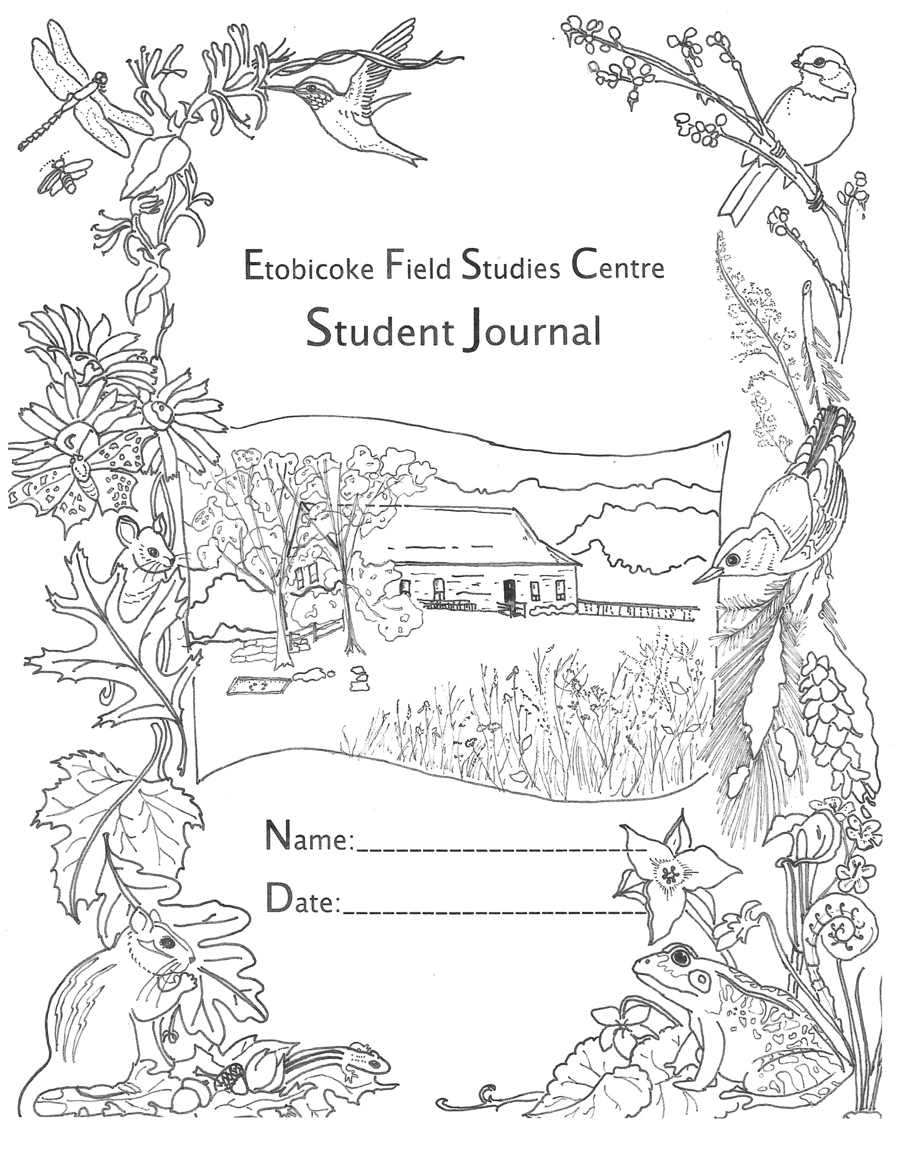

**Etobicoke Field Studies Centre**

**Student Journal**

**Grades 4-6**

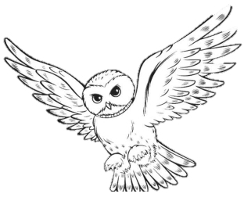

**NATURE EXPLORER LOG:**

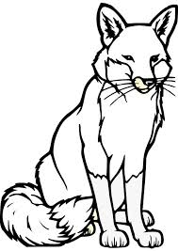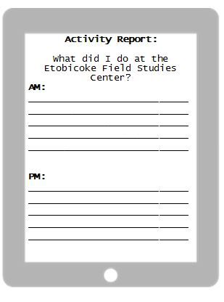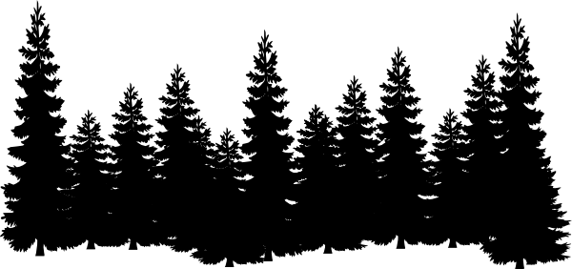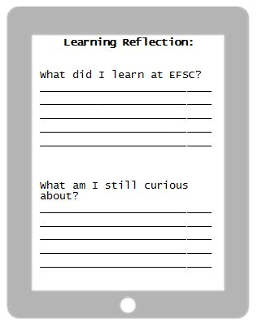   
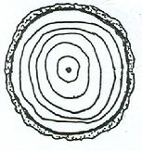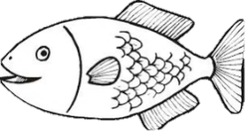

­­­­­­­­­­­­­

_____________________________

What did you learn at EFSC?

**SUPER SCRAMBLE!**

Unscramble the phrase:

**DIWL BTUOA LRNIGAEN!!**

_____________________

­­­­­­­­­­­­­

_____________________________

**­­­­­­­­­­­­­PM:**

_____________________________

­­­­­­­­­­­­­

_____________________________

Did you hear, see or touch any animals while at EFSC?

Explain your experience:

_________________________________

_________________________________

What are you still curious about?

What did you do at the Etobicoke Field Studies Centre?

**Help Toby find his way back to the Centre!**

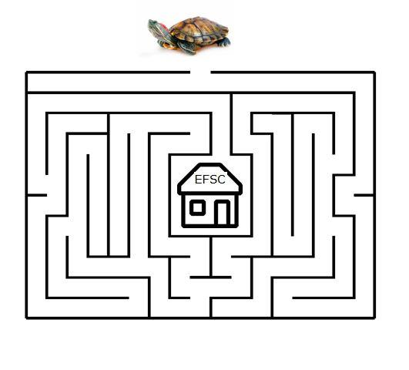

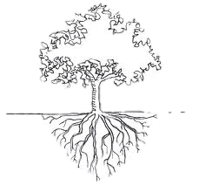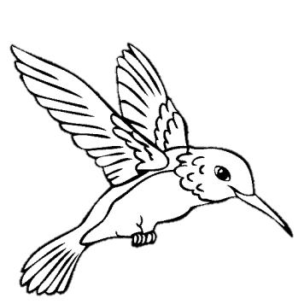

**Design a habitat for an animal of your choosing!**

Make sure to include sources of shelter, food, and water.

**Joke Time:**

Q: What type of flower grows on your face?

A: Tulips (Two lips)

**DID YOU KNOW?**

Trees can live for hundreds of years. You can determine the age of a tree by counting the growth rings found on the inside of the tree.



**Become a Nature Explorer:**

* Explore your backyard or local park; look for animal homes (habitats) with an adult.
* Check out books about the environment from your local library.
* Explore fun ways to recycle, such as reusing materials for crafts!
* Write a news article for your classroom or school newspaper.



**Wild Word Search:**

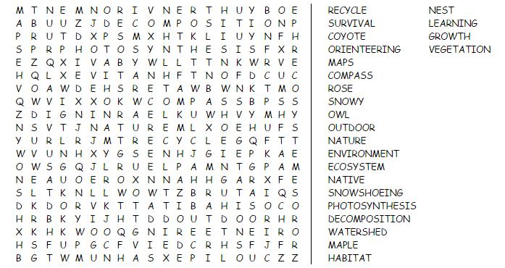

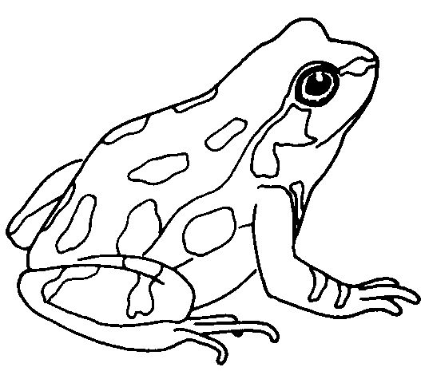

**Poetry Corner:**  
  
Earth is our dear Mother, don't pollute it,  
She gives us food and shelter, just salute it  
  
Trees are precious, preserve it,  
Water is a treasure, reserve it  
  
Grow more trees, make Mother Earth green,  
Reduce pollution and make her a Queen

**Joke Time:**

Q: How do trees get on the internet?

A: They log in!

**Interesting Insect Sudoku!**

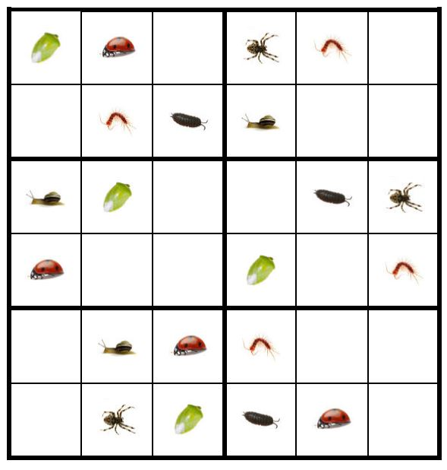

Fill up the grids so every row, column and block of six contains one of each insect.

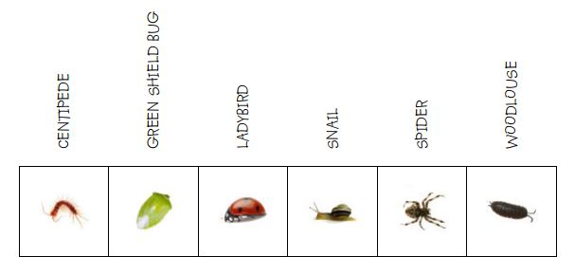

**Joke Time:**

Q: What did the cloud say to the lightning bolt?

A: You’re shocking



**Lend a Hand!**   
  
On the palm, write one thing you already do to help our environment. Then, on each finger, list one thing you plan to do to help our environment in the future!

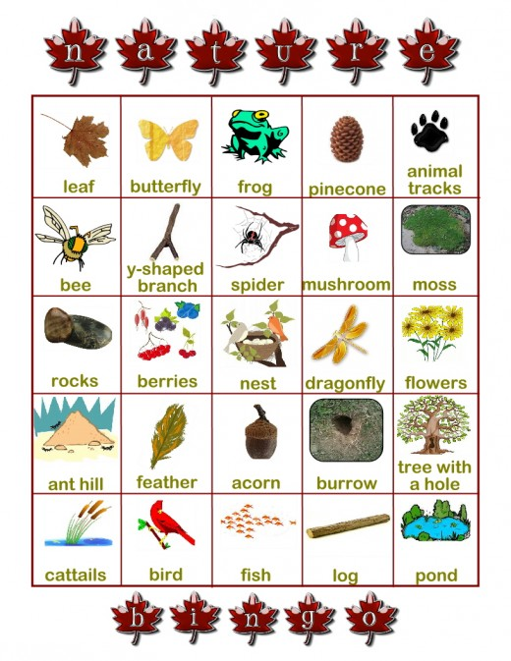

**Nature Bingo!**

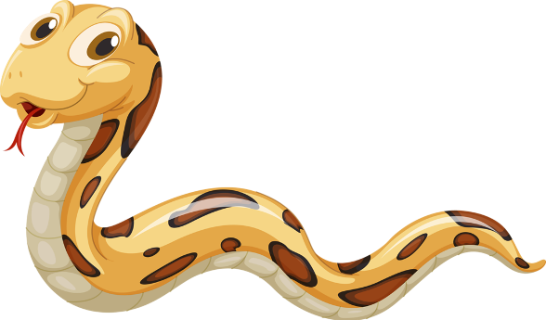



*Answer Key: 1. Yes, 2. Yes, 3. No, 4. Yes, 5. Yes, 6. No*

While you were at the EFSC how many of these did you see? Check them off of your BINGO card!

**For more information, check out our website:**

**http://toes.tdsb.on.ca/**

Can this be recycled?

Use your knowledge to decide if each of these objects

can be recycled in the City of Toronto.

Indicate you answer with either a ‘yes’ or ‘no’ on the line!

1. A Styrofoam cup __________
2. Newspaper __________
3. Bread bags __________
4. Pop cans __________
5. Wrapping paper __________
6. Waxed paper _________